

**PROPOSAL: MOCCE**

**Ministry of Climate Change and Environment**

**Submitted by**

Verbanet Technologies LLC  
27/03/2020

**DIRECTORY.**

**1** **KEY DETAILS** 9

**2** **STRATERGIC OBJECTIVES** 10

**3** **PROJECT SCOPE** 11

3.1 Definition and Terminology 11

3.2 USER CHARACTERISTICS 11

3.2.1 Business Users 11

3.2.2 Individual Users 12

3.2.3 Admin user 12

3.3 PROPOSED SOLUTION MODEL 12

3.4 FUNCTIONAL REQUIREMENTS 14

3.4.1 Web Development 14

3.4.2 Web App Integration Requirements 20

3.4.3 Mobile App Requirements 21

3.4.4 Mobile App Integration Requirements 22

4 DETAILED REQUIREMENT SPECIFICATIONS 23

4.1 Licensing Requirements 23

4.1.1 Renew Fishing boat service 23

4.1.2 Accreditation of food establishment to export outside UAE 23

4.1.3 Add or Replace Fishing Boat's Engine 24

4.1.4 Agricultural Extension Request 25

4.1.5 Change Fishing Method 26

4.1.6 Issuance of Aquaculture Farm Establishment License 26

4.1.7 Issue a License for Manufacturing a Fertilizer/Soil Conditioner 27

4.1.8 Issue a license of practicing animal activity 29

4.1.9 Issue a Plant Nursery License 31

4.1.10 Issue Temp License of Practicing the Profession for Veterinarians 32

4.1.11 Issue a Veterinary Establishment License 32

4.1.12 Issue an Agricultural Activity License 34

4.1.13 Issue an Export License (Local Aquatic Organisms’ Products) 35

4.1.14 Issue an Import Permit of Agricultural Consignment 36

4.1.15 Request to issue Import License (Brood stock and Larvae/ Fishing Tools and Equipment) 38

4.1.16 Issuing a license for animal production farm 39

4.1.17 Issuing a license for practicing the profession for veterinarians and assisting veterinary professions 40

4.1.18 Modification or Cancellation of Basic Data of Agricultural Holdings 41

4.1.19 Preliminary approval to license an animal production farm 45

4.1.20 Primary approval on licensing a veterinary facility 46

4.1.21 Registration of agricultural holdings 47

4.1.22 Renew Aquaculture Farm Establishment License 49

4.1.23 Renew Import License (Brood stock and Larvae/ Fishing Tools and Equipment) 50

4.1.24 Renew issuance license of practicing the profession for veterinarians and for the assistant vet 51

4.1.25 Renew Plant Nursery License 52

4.1.26 Renew Veterinary Establishment License 54

4.1.27 Renew Vice-Captain's Card 55

4.1.28 Renewal a License for Manufacture Fertilizers and Soil Conditioner 56

4.1.29 Renewal of agricultural activity license 58

4.1.30 Renewal of Slaughterhouse Accreditation outside UAE 61

4.1.31 Renewal of the license of an animal production farm 61

4.1.32 Replacement of Fishing Boat 62

4.1.33 Request ٍSubsidies for Farmers 63

4.1.34 Request ٍSubsidies for Fishermen’s 64

4.1.35 Slaughterhouse Accreditation Outside UAE 67

4.1.36 Transfer Fishing Boat Ownership 67

5.1.1 Transfer Fishing Boat's Ownership to Heirs 69

5.1.2 Veterinary Extension Request 70

5.1.3 Vice-Captain Card Issuance 71

5.2 Permit Requirements 72

5.2.1 Adopting Veterinary Raw Materials for Importation 72

5.2.2 Apply for Release Permit (Fishing Tools and Equipment) 74

5.2.3 Approve Disinfectants, Veterinary Equipment and Supplies, and Animal Care Supplies for Distribution 75

5.2.4 Issuance Import permit for Semen or Embryos 75

5.2.5 Issuance of Re-export of Vegetable Feed Permission 77

5.2.6 Issue a Permanent or Temporary Horse import permit 78

5.2.7 Issue a Permit to Import Ozone Depleting Substances (ODS) 79

5.2.8 Issue a Permit to Import Pesticides 79

5.2.9 Issue a permit to re-export ozone depleting substances (ODS) 81

5.2.10 Issue a Re-Export Permit (Aquatic Organisms Products) 81

5.2.11 Issue an agricultural consignment release 83

5.2.12 Issue an Export Permit (Local Aquatic Organisms’ Products) 84

5.2.13 Issue an Export Permit of Hazardous Waste 85

5.2.14 Issue an Import Permit (Broodstock or Larvae) 86

5.2.15 Issue an Import Permit for Animal Products or By-Products 87

5.2.16 Issue an Import Permit for Feed and Processed Animal Feed 88

5.2.17 Issue an Import permit for live animals, Birds and Ornamental fish 90

5.2.18 Issue an Import Permit for Pets - Cats or Dogs 91

5.2.19 Issue an Import Permit of Fertilizers or Soil Conditioners (Restricted) 94

5.2.20 Issue an Import Permit of Fertilizers or Soil Conditioners (Unrestricted) 95

5.2.21 Issue an Import permit of Pheromones, Attracting materials, Extruding materials, Additives and Materials with mechanical or physical in pest control 98

5.2.22 Issue import permit for non-manufactured feed for aquatic organisms 99

5.2.23 Issuing an Import Permit for Disinfectants, Veterinary Equipment and Supplies, and Animal Care Supplies 101

5.2.24 Issuing export permit of animal samples 103

5.2.25 Issuing import permit of animal samples 105

5.2.26 Issuing Import Permit of Veterinary Raw Materials 106

5.2.27 Release of Locally Manufactured Fertilizers 108

5.3 CITES 109

5.3.1 Cancellation of Species Ownership Listed in CITES Appendices 109

5.3.2 Issue a CITES Export/Re-export Certificate 110

5.3.3 Issue a CITES Import Certificate 111

5.3.4 Issue a Falcon passport in accordance with the Federal Law on CITES 114

5.3.5 Issue a to whom it may concern letter in accordance with the federal law on CITES 116

5.3.6 Ownership Registration of Species Listed in CITES Appendices 117

5.3.7 Request for Falcon Identification Rings 119

5.3.8 Transfer Species Ownership Listed in CITES Appendices 121

5.4 CERTIFICATES 122

5.4.1 Approved of Phermions, Attracting materials, Extruding materials, Additives and Materials with mechanical or physical in pest control 122

5.4.2 Issuance of Good Manufacturing Certificate GMP 124

5.4.3 Issue a license to practice the profession of agricultural engineer and occupations related to agricultural activities 125

5.4.4 Issue a Registration Certificate for a Fertilizer or a Soil Conditioner 126

5.4.5 Request for a Veterinary Health Certificate for Exporting Equine Semen 128

5.4.6 Issue a Veterinary Health Certificate for Exporting or Re-Exporting Animal and Fish Products or byproducts and Manufactured Feed 129

5.4.7 Issue a Veterinary Health Certificate for Exporting or Re-Exporting Horses 131

5.4.8 Issue a Veterinary Health Certificate for Exporting or Re-Exporting Live Animals 133

5.4.9 Issue an Phytosanitary Certificate for Export or Re-Export 135

5.4.10 Issue certificate of heat treatment facility approval 136

5.4.11 Issue license to re-export aquatic organisms 137

5.4.12 Issue Pesticide Registration Certificate 138

5.4.13 Issue Registration Certificate of Veterinary Product Companies 142

5.4.14 Issuing a Free Sale Certificate for a Veterinary Product 143

5.4.15 Issuing Registration Certificate of Veterinary Products 145

5.4.16 Renew license to re-export aquatic organisms 147

5.4.17 Renewal registration certificate of veterinary product 148

5.4.18 Renewal a license to practice the profession of agricultural engineer and occupations related to agricultural activities 150

5.4.19 Renewal of Good Manufacturing Certificate GMP 151

5.4.20 Renewal Registration Certificate of Veterinary Product Companies 152

5.5 Features Considered for Development 154

6 APPLICATION ARCHITECHURE 159

6.1 Service Classifications 159

6.2 Application Workflow 161

6.3 Technical Architecture 162

6.3.1 Performance boost considerations 164

6.4 Network Topology 166

6.5 Security Architecture 167

6.6 Quality Assurance 168

6.7 Release and Deployment Process 169

6.8 NON-FUNCTIONAL REQUIREMENTS (OTHERS) 170

6.9 Design Phases 171

6.10 TECHNICAL CONFIGURATIONS 173

6.10.1 DEVELOPMENT ENVIRONMENT 173

6.10.2 RECOMMENDED WED HOSTING PACKAGE - DEDICATED 173

6.10.3 BROWSER 174

6.10.4 HARDWARE DEVICES 174

6.10.5 TECHNICAL STANDARDS 175

6.10.6 TECHNICAL GUIDELINES 175

6.11 PROJECT DELIVERY 177

6.11.1 Agile Methodology 177

6.11.2 PROJECT MANAGEMENT 179

6.11.3 ROLES & RESPONSIBILITIES 180

6.11.4 DELIVERY ACTIVITY SUMMARY 181

6.11.5 PROJECT IMPLEMENTATION PLAN 182

6.11.6 DELIVERABLES 182

6.11.7 ESTIMATED DELIVERY TIME 183

6.11.8 DEPLOYMENT DETAILS 185

6.11.9 RELEASE PLANNING 185

6.11.10 RISK CONTINGENCY PLANNING 185

6.12 PROJECT ASSUMPTIONS 187

6.12.1 OBJECTIVES 187

6.12.2 DESIGN 187

6.12.3 DEVELOPMENT 187

**7** **OUT OF SCOPE** 189

**8** **CHANGE MANAGEMENT** 191

8.1 MAINTENANCE & SUPPORT 192

**9** **TERMS AND CONDITIONS** 193

9.1 ACCEPTANCE CRITERIA 193

9.2 WARRANTY 193

9.3 SOURCE CODE & INTELLECTUAL PROPERTY RIGHTS 194

9.4 GENERAL TERMS AND CONDITIONS 194

9.5 GENERAL ADMINISTRATIVE, TECHNICAL & FUNCTIONAL ASSUMPTIONS 196

**10** **FINANCIALS** 197

10.1 Curriculum Management Application 197

10.2 PAYMENT TERMS 197

10.2.1 MODE OF PAYMENT 198

# **KEY DETAILS**

**PROJECT NAME CLIENT**

Website Redesign MoCCaE

**CLIENT CONTACT PROPOSAL ID NO.**

Blah Blah AD/BP/23032020/2609/1

Blah@verbat.com

+91 8086517455

**PROPOSAL SUBMISSION ANTICIPATED START DATE**

27/03/2020  TBD

**PROPOSAL VALID UNTIL PROPOSED TECHNOLOGY**

27/03/2020 .Net, MSSQL, CSS3, HTML5

**PROPOSAL SUBMITTED BY APPLICATION TYPE**

Responsive Web Application

Verbanet Technologies L.L.C

Dubai, U.A.E

+971 4 297 3236

Mohi.karim@verbat.com

# **STRATERGIC OBJECTIVES**

Ministry of Climate Change and Environment – MOCCAE (here after referred to as the client) has floated an RFP that is focused on revamping the end to end journey and experience of the customer as they navigate the cloud of Digital services offered by the client. The client intends to redesign and reengineer its existing digital service offerings as well as revamp MOCCAE Mobile app.

By doing so the client expects to achieve the following milestones

* Provide a better and smoother services to customers.
* Increase customer & employees satisfaction
* Enhance the performance of the services
* Improve customer satisfaction through better service
* Enhance the process of employee performance evaluation
* Reduce Employee wasted time

# **PROJECT SCOPE**

The purpose of this project is to redesign & reengineer the digital licensing service offering of the client, so that they can be integrated with government partners depending on the customer journey. A secondary objective is to redesign the client’s Mobile App platform using native mobile app technologies.

## Definition and Terminology

|  |  |
| --- | --- |
| Acronym | Description |
| MOCCAE | Climate change and Environment Ministry |
| ITD | Information Technology Department |
| RFP | Request for Proposal |
| Business | Ministry of Climate change and Environment departments / Business users |
| Employees | Ministry of Climate change and environment Employees who will use the digital services |
| BRD | Business Requirement Document |
| FRS | Functional Requirement Specification |

## USER CHARACTERISTICS

### Business Users

The main classes of business users are

* Agricultural companies
* Animal companies
* Environmental companies
* Fishery companies
* Veterinary companies

Users can obtain the following services from the site

* Licenses
* Permits
* CITES
* Certificates

### Individual Users

* Individual users are of the following types
* Animal Breeders
* Farm Owners
* Pet animal avocation
* Endangered animal species avocation
* Fisher
* Falconry avocation
* Horse avocation

These users can obtain the following services from the site

* Licenses
* Permits
* CITES
* Certificates
* Can perform generic user functions indicated above
* Can view course and program proposals that have been cancelled, withdrawn, rejected, or approved

### Admin user

* Approve Workflows
* Mitigate workflow issues
* Approve / Manage users
* Verify documents
* Manage roles
* Manage packages
* Assign roles to packages
* Assign users to roles

## PROPOSED SOLUTION MODEL

Verbat will be following a stand–alone fixed bid solution delivery model. Verbat’s solution architects have conducted a thorough research on the requirements and have come to the conclusion that our proposed solution, which is detailed further in this document, will meet the requirements put forth by the client.

**Key Strengths of Our Solution**

* Strong and Scalable platform accommodating to future enhancements.
* A framework which acts as a solution accelerator with building blocks that can be re-used in the future for building new components and features.
* Our light weight framework consumes fewer system resources thereby making the application perform faster.

## FUNCTIONAL REQUIREMENTS

### Web Development

The overall functional requirements of the application are listed below

* Collect the business requirements of each service form the business owner, analyze it and recommend new designs for each service based on customer journey.
* This could include reducing the steps required, eliminating extraneous attributes, reducing the number of attachments etc.
* The vendor would compile the information to prepare a Business Requirement Document that will cover the business objectives, business rules, business workflow, related business processes and process owners of each service or groups of services.
* Vendor shall identify all related processes so that a customer with already verified records in one business process should not have to re-verify the same records while pursuing another related business process with similar requirements
* The services shall be designed to be responsive in order to render contents and perform optimally on most modern browsers (Chrome, Mozilla, IE, Safari etc.).
* The mobile interfaces shall be uniform across other devices with varying form factors
* Information entered to obtain licenses should be modifiable and updateable. Additionally the customer may request license cancellation.
* All documents issued with an expiration date shall have an auto renewal policy implemented such that auto reminders shall be send to all concerned parties.
* The application (Mobile & Web) shall integrate Emirates ID to prevent the collection of data that is already available in the system neither by the customer or the staff
* The client has requested special consideration in managing the following services as they cater solely to individuals
  + Issue / Renew a license to practice the profession of agricultural engineer and occupations related to agricultural activities
  + Issue / renew a license for practicing the profession for veterinarians and assisting veterinary professions
* Merge following services
  + Issue a license for practicing the profession for veterinarians and assisting veterinary professions
  + Issue a temporary license of a practicing the profession for veterinarians
* Table and Pagination- System wide, all tables shall display a fixed number of records, which the user can change based on his preference i.e. the number of records per screen should be configurable. For additional records, pagination feature needs to be provided. It is important to note that the system should not load the entire data in the browser while performing pagination. Rather while performing the pagination, the system should fetch the new records from the backend at runtime on every new page is request. Tables must have “Select All” checkbox wherever applicable to select all the records displayed per screen. System must provide provision to sort search result based on column headers.
* Merge related services into one service. Example, issue and renewal of same service and consider
* Implement auto assignment based on workload equally or based on percentage, this feature can be turn on/off per service
* Ability to sort services requests in the dashboard by profile type (Company/Individual)
* The vendor shall apply design and development practices that are customer centric (UCD, UDD) viz.
  + **Specify the context of use:** Identify the people who will use the product, what they will use it for, and under what conditions they will use it.
  + **Specify requirements**: Identify any business requirements or user goals that must be met for the product to be successful.
  + **Create design solutions**: Incrementally build the solution from a rough concept to a complete design using multiple stages of iteration and design
  + **Evaluate designs:** Make use of usability testing with actual users as this is an integral part of developing mature applications

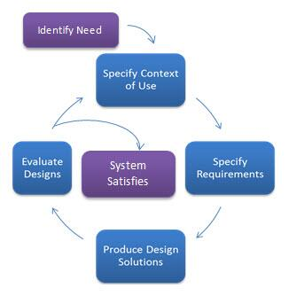

* Packages shall be assigned to roles and users to roles. Dashboard shall be provided based on roles
* Dashboards to display status of applications. Applications shall be filtered based on status, packages and services
* Applications shall be classified based on status



* Applications shall be saved as draft automatically. In case of a system failure or time out applications saved copies of drafts shall be available so that the user can continue to work on their application.
* Create new request based on existing request
* Dashboard shall provide functionality to save frequently accessed services (Favorites)
* Develop workflow engine that will encapsulate the functionality of related services
* Services should implement the calculation of fines for expired permits, licenses etc.
* Workflow shall implement SLA and turnaround times for each step in the activity. Turnaround controls to ensure the timely completion of activities. In case of failures the system should send reminders to concerned party. System should also have provision to automatically escalate to authorities in case of delays.
* Service pages that collect data shall be designed such that data collection into steps (if it requires the collection of data using more than 5-10 fields). It shall be made user friendly by making using the following strategies
  + Prefill whenever possible
  + Be smart. Always keep in handy the information the user had supplied for some other service offerings
  + Offer field focus
  + Validate errors as you go
  + Do not mask passwords in mobile applications
  + Auto everything – auto capitalization, Auto correction, autosuggestion when required
  + Use progress bars, bread crumps etc. to let the user know the progress status of their application.
  + Provide input constraints when required
  + Provide clear action buttons
  + Use multi-step forms when necessary
  + Create in-line field labels and in-line error messages (as appropriate)
  + Attachment types & size should be indicated



* Include google captcha for application submissions
* Forms should include editable drop downs (LOV controls)
* Page load times shall be approximately 2.5 seconds
* Vendor shall provide 3 sample designs for digital services
* Ability to change site logo and service name
* Digital services to be provided in Arabic, English & Urdu. Content for Arabic and Urdu need to be updateable.
* Vendor to recommend dashboard design
* Separate dashboards to be provided for admin, individuals and & businesses
* Advanced search shall include multiple options (To be decided at requirement gathering phase)
* Reports shall include statistical data that are up to 6 months old
* Five Tabs shall be available for “Completed requests with number of requests”, “Rejected with number of requests”, “draft” and “Waiting Actions” and “All requests” or it can be on tab with request status filtration, vendor should provide best design for this section
* In each tab mentioned above, the request information should be displayed like request ID, date, service name, status, company name, trade license id and rejected/return reason with Edit & view comments if required and request ID is hyper link as example
* Audit Trail feature of each action on the request must be available
* Recently request submission section should be displayed as section in dashboard webpage
* Dashboard reports to be designed using tableau
* Old transaction shall be migrated to new digital services database and these transactions can be processed successfully in new platform if it is open transaction additional to that closed requests also shall be migrated too, vendor should provide the support to MOCCAE IT team for mapping, data cleansing and providing required views / data that required for data migration

### Web App Integration Requirements

* Dubai Economic Department for licenses issued related to MOCCAE activities to auto trigger the workflow of licensing services based on the activity and issue facility license or license to practice the profession
* Sharjah Economic Department for licenses issued related to MOCCAE activities to auto trigger the workflow of licensing services based on the activity and issue facility license or license to practice the profession
* Abu-Dhabi economic development for licenses issued related to MOCCAE activities to auto trigger the workflow of licensing services based on the activity and issue facility license or license to practice the profession
* Ministry of Human Resources and Emiratization MOHRE regarding below service to get all & latest information about the labor card & which company he/she has resident visa
  + Renew issuance license of practicing the profession for veterinarians and for the assistant vet
  + Issue a license to practice the profession of agricultural engineer and occupations related to agricultural activities
* MOCCAE smart inspection internal application regarding inspection step in the workflow of some services under licensing group (please check the services detail on the MOCCAE.GOV.AE website/portal
* MOF e-DHS payment getaway to allow the user to pay service fees/charges
* Critical Infrastructure and Coastal Protection Authority for Fisher services for NOC letter
* Mail / Exchange Server for sending SMS & email as template to the customers /staff based on configuration in the new digital services like event, Arabic & English SMS and Email , message title ,etc.
* Emirates ID as currently this integration is available for current eservices
* Integration with current e-service regarding user profiles & logged users (SSO) and information/views required for other existing services like import requests, etc.
* MOCCAE GIS integration related to location (store and display the map)

### Mobile App Requirements

Redesign & reengineer MOCCAE mobile app based on following point and not limited to:

* Verbat shall use Flutter technology to develop the app using one source code
* Verbat shall Study, Redesign & Reengineer current MOCCAE mobile
* New Mobile app to be designed base on customer journey end to end
* MOCCAE online services shall be implemented on the app
* Verbat shall provide 3 samples common design for the new mobile app and considering the TRA, PMO and UN accessibility standards & guidelines. MOCCAE team shall choose one out of 3 and vendor must use it in the implementation of all the services as unified platform. The Vendor shall be flexible to accommodate the design changes. This entire process shall be carried out on the client’s onsite.
* Login using UAE pass and MOCCAE account feature must be available on new app
* Create MOCCAE account feature should be available on new app
* Services Requests tracking feature shall be available
* Dashboard feature shall be implemented on the app for the customers based on type of the profile.
* Happiness meter of PMO shall be implemented on the app and API shall be provided by the client
* Verbat shall implement Push notification when request status is changed in the backend application
* Most used services feature shall be available on the app
* Omni-channel approach/experience shall be considered in the design of the digital services and new mobile app
* Event & news section shall be available on new app (use content of the portal). Client shall provide the API to access the content
* Live chat and Chabot of MOCCAE should be available on the new app. (client to provide guidance in integration)
* Rate the app, share the app (tell friend) , MOCCAE other apps should be available on new app
* Help and support include (FAQ, Feedback, and live chat) shall be available on new app
* Push notification feature shall be available to push request status and any important information to the customer
* Customer center location, working hours and services shall be available
* Welcome message shall be pushed as push notification once to the nearby customer center (within 100M range)
* Contact us feature shall include (Vision & mission about the minister,), privacy, terms and conditions
* Costumers shall be able to create incident related to food safety, animal health, animal legislation violation and agricultural pets. MOCCAE team shall provide API required to create the incident as well as to get the status of created incidents

### Mobile App Integration Requirements

* MOF e-DHS payment getaway to allow the user to pay service fees/charges
* Mail / Exchange Server for sending SMS & email as template to the customers /staff based on configuration in the new digital services like event, Arabic & English SMS and Email, message title ,etc.
* Emirates ID as currently this integration is available for current eservice
* Integration with current eservice regarding user profiles & logged users (SSO) and information/views required for other services like import requests, etc.
* Integration with Bio-security to create incident related to food safety, animal health, animal legislation violation and agricultural pets in modern design and use image processing feature to identify type of incident and MOCCAE team will provide API required to create the incident in the Bio-Security MOOCAE system and get the status of created incidents
* Integration with qmatic system to display list of services per center and create token ticket now or in certain time
* Integration with portal CMS for events and news

# DETAILED REQUIREMENT SPECIFICATIONS

## Licensing Requirements

### Renew Fishing boat service

**Service Description**

Through this service the fisher can request the renewal of the fishing boat license and the expired captain card. A boat license and a captain card will be issued valid for 2 years from the date of renewal.

**Steps**

1. Fill out e-form
2. Review application completes procedures
3. Issuance of fishing boat license and captain card

**Required Documents**

1. Technical Inspection report issued by CCIPA
2. Personal photo

### Accreditation of food establishment to export outside UAE

**Service Description**

Through this service, food establishment inside UAE is approved for exporting its products outside UAE (valid for one year starting from the issuing date)

**Steps**

1. Create application electronically
2. Evaluate application and complete procedures electronically
3. E-payment
4. Carry out evaluation visit by competent authorities

**Required Documents**

1. Reports of inspection from the competent local authority which prove that the establishment meets required hygienic regulations of the imported country

### Add or Replace Fishing Boat's Engine

**Service Description**

Through this service the fisher can add or replace or delete fishing boat's engine(s) registered under his/her name in the general registry of the Ministry. A boat license and captain card will be issued valid for 2 years from the date of issuance after amending the engine’s information

**Steps**

1. Fill out E-form
2. Evaluate application and complete procedures electronically
3. Issuance of fishing boat license and captain card

**Required Documents**

1. Technical inspection report issued by CICPA
2. Delisting certificate of marine engine issued by CICPA
3. Copy of the purchase invoice of the engine certified by the relevant local authority OR the delisting/deletion certificate of the engine intended for registration issued by CICPA or the Ministry OR the engine selling contract issued by the Ministry or the court.



### Agricultural Extension Request

**Service Description**

Agricultural extension services are provided to farms registered with the Ministry. The services in the fields of: plant protection, irrigation, fertilization, farming systems, Control of palm tree pests

**Steps**

1. Fill out E-form
2. Inspection Visit
3. Close the request by documenting the service in the electronic system
4. Required documents: None

**Required Documents**: None

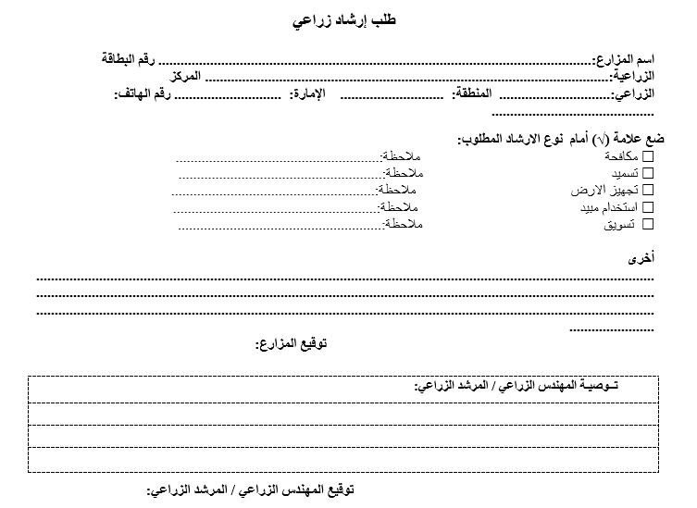

### Change Fishing Method

**Service Description**

This service allows fishers to change their fishing methods/gears in accordance with the relevant legislations. A boat license and a captain card will be issued with the same validity of the previous boat license and captain card.

**Steps**

1. Fill out E-form
2. Review the application and complete the procedures electronically
3. Issue the boat license and captain card

**Required Documents**: None

### Issuance of Aquaculture Farm Establishment License

**Service Description**

Through this service aquaculture license is issued for the establishment and operation of an aquaculture farm valid for one years from the issuance date

**Steps**

1. Fill e-form
2. Electronic payment of fees
3. Review the application and complete the procedures electronically
4. Inspection
5. Issuance of license

Required Documents

1. Copy of valid trade license or approval of trade name from the local competent authorities
2. Environmental license or approval from the environmental competent authority



### Issue a License for Manufacturing a Fertilizer/Soil Conditioner

**Service Description**

Through this service, a license is obtained and to be valid for a year to manufacture fertilizers/soil conditioners within the UAE

**Steps**

1. Fill e-form
2. Make payment
3. Review the application and complete the procedures electronically
4. Conduct an inspection visit
5. Issue license electronically

**Required Documents**

1. A copy of the environmental permit issued by the competent authority (valid)
2. A copy of the industrial license from the Ministry of Economy or the concerned local authorities (valid)





### Issue a license of practicing animal activity

**Service Description**

Through this service a license is obtained for practicing animal activity valid for one year from the date of issue

**Steps**

1. Fill e-form
2. Make payment
3. Review the application and complete the procedures electronically
4. Conduct an inspection visit
5. Issue license electronically

**Required Documents**

1. Copy of valid trade or industrial license or preliminary approval from the competent authority. For all establishments except those specialized in trade activities, the following additional documents are required:
2. The presence of a veterinarian licensed by the Ministry or a veterinary supervision contract with a government veterinary authority or a veterinary establishment licensed by the Ministry.
3. An environmental permit issued by the competent authority in accordance with the provisions of Federal Law No. 24 of 1999 on the protection and development of the environment
4. Data and documents of technical personnel that will work in the establishment and take into account the necessary licenses. For all establishments except those specialized in trade activities, feed factories and veterinary medicines, the following additional documents are required:
5. A plan approved by the competent authority for the site of the establishment and a detailed breakdown of its various buildings and facilities, including food stores, processing sites, animal isolation and administrative buildings.
6. A document stating the purpose of the establishment of the facility and clarifying the methods, methods and techniques that will be used for breeding animals in the event that this is among the objectives of the establishment of the facility.
7. A list of the types to be acquired in the establishment and the capacity of the center with respect to parents and newborns
8. Documents explaining the disposal methods
9. A document explaining the routine behavior of animals
10. Insurance policy from one of the insurance companies licensed in the State against the dangers of dangerous animals
11. A record showing the animal data (species, breed, sex, color and any other distinctive markings and identification data) and purchase and sale movement data including animal sources and buyers, with copies of the relevant evidence.
12. A detailed drawing showing the location, area and details of the facilities with an indication of the types to be dealt with.

### Issue a Plant Nursery License

**Service Description**

A license is obtained for the production of seedlings of vegetables, fruit, forest, shade plants and ornamentals within the country valid for one year from the date of issue

**Steps**

1. Fill e-form
2. Make payment
3. Review the application and complete the procedures electronically
4. Conduct an inspection visit
5. Issue license electronically

**Required Documents**

1. Commercial license or professional license or trade name or preliminary approval issued by the competent local authority
2. Nursery map showing the area and location
3. ****Copy of a valid lease site activity or proof of ownership of the site

### Issue Temp License of Practicing the Profession for Veterinarians

**Service Description**

Through this service, establishments can apply for a temporary practice license for an unlicensed veterinarian or a visiting veterinarian for 3 months from the date of issue

**Steps**

1. Fill e-form
2. Make payment
3. Review the application and complete the procedures electronically
4. Conduct an inspection visit
5. Issue license electronically

**Required Documents**

1. Attested Certificate of academic qualification
2. Certificates of experience attested by the UAE embassy
3. Approval of the Ministry of Human Resources and Emiratization, excluding UAE nationals
4. Personal photo ( jpg, png )
5. In addition to the above documents, the resident veterinarian who is not licensed must submit the following documents: A copy of the equivalence of scientific certificates from the Ministry of Education.

### Issue a Veterinary Establishment License

**Service Description**

Through this service, obtained the license of a veterinary establishment including (veterinary hospital, veterinary clinic, veterinary laboratory, veterinary scientific advisory office, veterinary drug store, veterinary pharmacy, artificial insemination center) valid for one year from the date of issue

**Steps**

1. Fill e-form
2. Make payment
3. Review the application and complete the procedures electronically
4. Conduct an inspection visit
5. Issue an initial approval for license electronically
6. Complete application electronically
7. Issue License electronically

**Required Documents**

**To issue initial approval:**

1. Adopting a trade name from the local authority concerned
2. Copy of the lease or ownership contract of the veterinary establishment

**For veterinary hospitals, add the following documents:**

1. Copy of a permit / environmental license from the competent local authority
2. The image of the site plan and the installations on it

**To issue the license:**

1. Copy of valid trade license

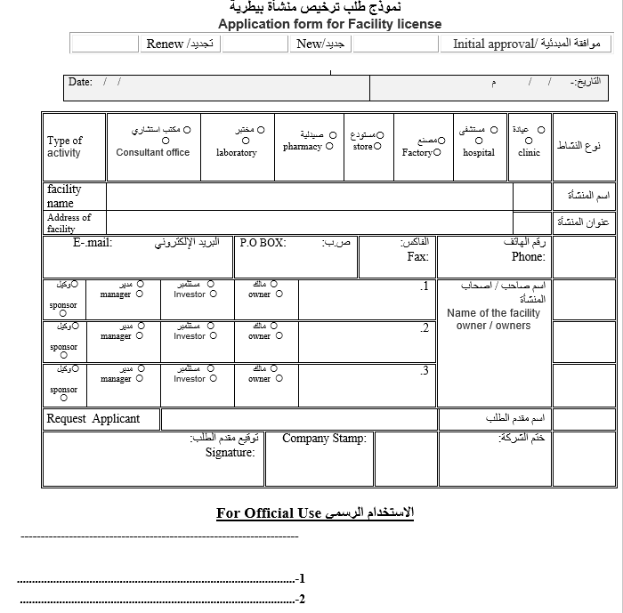

### Issue an Agricultural Activity License

**Service Description**

Approval is obtained for a valid agricultural activity for one year from the date of issue. These activities include: (Agricultural Engineering Consultancy / Agricultural Pest Control Services / Wholesale and Retail Pesticide Trade / Wholesale and Retail Fertilizer & soil conditioners Trade/ Wholesale seeds & tubers trade/ wholesale of different plants and cut flowers trade/ wholesale bee trade / wholesale OUD (Agarwood) trade)

**Steps**

1. Fill e-form
2. Make payment
3. Review the application and complete the procedures electronically
4. Conduct an inspection visit (For pesticides & fertilizers)
5. Issue license electronically

**Required Documents**

1. Commercial license OR trade name and partners annex
2. Copy of Lease OR ownership of the activity site
3. Copy of owner passport

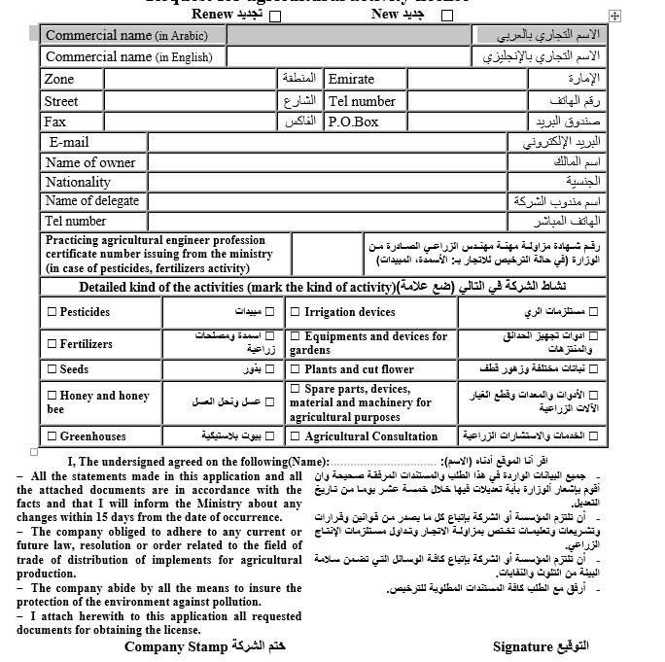

### Issue an Export License (Local Aquatic Organisms’ Products)

**Service Description**

Through this service, an export license is issued for the purpose of exporting local aquatic organisms extracted from the UAE waters or farmed in the UAE which includes fresh/frozen/smoked/dried/salted fish as well as other aquatic organisms such as crustaceans and mollusks (Valid for 1 year from the license’s issuance date)

**Steps**

1. Fill e-form
2. Make payment
3. Review the application and complete the procedures electronically
4. Issue license electronically

**Documents Required**

1. Copy of a valid trade license
2. Declaration or a certificate issued from the competent authority declaring that the applicant has the necessary means to store, preserve, and transport aquatic organisms which meet the health requirements determined by the competent authority in the concerned emirate
3. Additional documents for fishers’ co-op associations: Copy of the association’s declaration



### Issue an Import Permit of Agricultural Consignment

**Service Description**

Through this service, approval is obtained to import an agricultural consignment including (seeds & tubers, seedlings & plants & palm seedlings, and honey bees), import authorization is valid for six months from the date of issue, and inspection to these consignments will be done upon their arrival at the entry point and are released after ensuring that they comply with the all import requirements.

**Steps**

**For import permit**

1. Create application electronically
2. Pay fees electronically
3. Issue import permit electronically

**Release consignment**

1. Create application electronically
2. Pay fees electronically
3. Visual inspection & laboratory test
4. Issue import permit electronically

**Documents Required**

**Import: (Seeds and tubers importing for the first time):**

1. A letter of authorization from Production company or Exporter company stating that “No objection from the registration and trading of seeds & tubers in UAE.”
2. Certificate issued by Production Company certified by the competent authority in the country of origin to prove that the seed & tubers are not genetically modified.
3. Certification by the competent authority in the country of origin to prove that the Production Company is licensed for the purposes of seeds & tuber production.
4. A technical Sheet issued by the Production company, including the following information:
   1. Name and address of the Production Company or the company that owns his agency.
   2. The scientific name of the variety (Genus, species and varieties.)
   3. Origin of seed
   4. Group followed by the product (F1 hybrid is a hybrid or plain)
   5. Resistant for pests.
   6. Germination and Purity percentages
5. In the event that the facility wants to import seeds and tubers as organic agricultural production inputs, a valid certificate issued by the Emirates Authority for Standardization and Metrology or a certification body applying the organic agricultural production standards of European, American, Japanese, Saudi Arabia, Tunisian, Indian, New Zealand, Australian, Canadian, must be attached.

**RELEASE:**

1. For all consignment (Seedlings, plants, Palm seedlings, Seeds & tubers, bees):
2. Origin certificate
3. Phytosanitary certificate issued by the competent authority in the country of export
4. Copy of the customs manifest, bill of lading or delivery authorization
5. Invoice or product list
6. For seed consignments (in addition to the above documents, you must attach):
7. Germination and purity examination certificate designed and approved in accordance with the International Seed Inspection System (ISTA) or a certificate issued by a government laboratory in the country of origin or from a laboratory approved by the competent authority in the country of origin.



### Request to issue Import License (Brood stock and Larvae/ Fishing Tools and Equipment)

**Service description**

Through this service an import license is issued for the purpose of importing fish Broodstock, larvae, and live fish or for importing fishing tools and equipment (Valid for 1 year from the issuance date)

**Steps**

1. Fill e-form
2. Make payment
3. Review the application and complete the procedures electronically
4. Issue license electronically

**Documents Required**

1. Copy of a valid trade license
2. Official letter or a certificate from the competent authority declaring that the facility meets the technical requirements to practice the activity



### Issuing a license for animal production farm

**Service Description**

Through this service, commercial production farms are licensed to keep domesticated productive animals for commercial purposes, including cows, sheep, goats, camels, rabbits and domestic birds (valid for one year from the date of issue)

**Steps**

1. Fill e-form
2. Make payment
3. Review the application and complete the procedures electronically
4. Issue license electronically

**Required Documents**

**To issue initial approval:**

1. Adopting a trade name from the concerned local authority
2. Copy of the lease or ownership contract of the veterinary establishment
3. The image of the site plan and the installations on it
4. Copy of a license / environmental license from the competent local authority

**To issue the license:**

1. Copy of valid trade license



### Issuing a license for practicing the profession for veterinarians and assisting veterinary professions

**Service Description**

Through this service, the license for practicing the profession is issue for veterinarians and assisting veterinary professions in the country, including (veterinarian / veterinarian assistant / Veterinary nurse / laboratory technician) (Valid for one year from the date of issue)

**Steps**

1. Fill e-form
2. Make payment
3. Review the application and complete the procedures electronically
4. Examination of Veterinarian

**Documents Required**

1. A copy of passport
2. Personal photo of the vet
3. A copy of the scientific certificates to be attested by the embassies or consulates of the State
4. A copy of the practical experience to be attested by the embassies or consulates of the State in case the experience is from outside the State, or the license issued by the Ministry in the case of Associate Veterinarian
5. A copy of the equivalence of the certificate from the Ministry of Education
6. A copy of the employment contract approved by the competent authority in the State



### Modification or Cancellation of Basic Data of Agricultural Holdings

**Service Description**

The basic data of the pre-registered agricultural holdings shall be modified or canceled from the register for any reason at the request of the owner

**Steps**

1. Fill e-form
2. Make payment
3. Modification or cancellation of agricultural holdings electronically

**Required Documents**

1. Documents showing change on the basic data

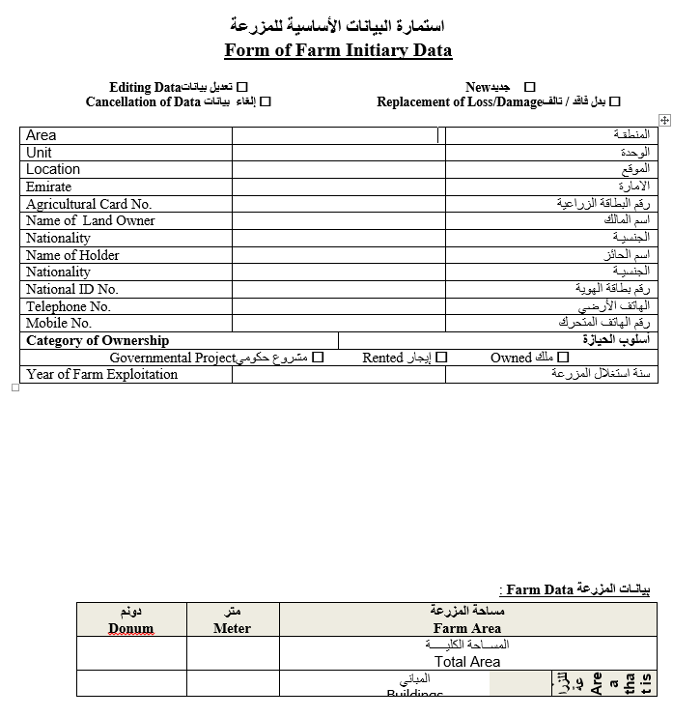

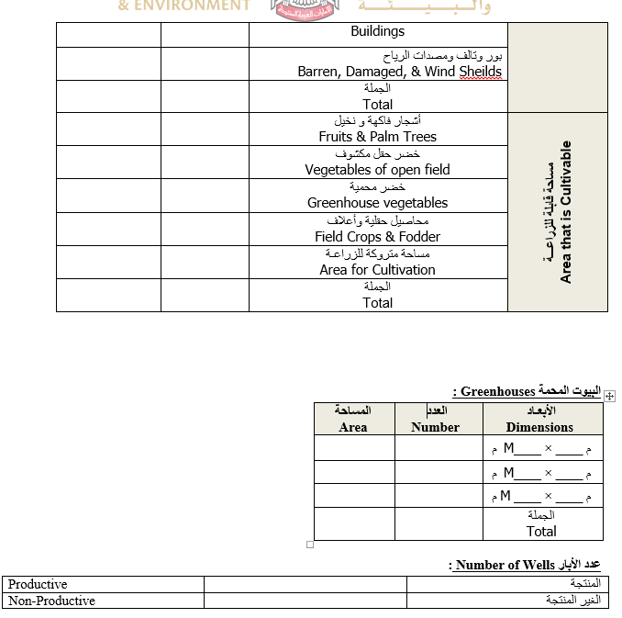

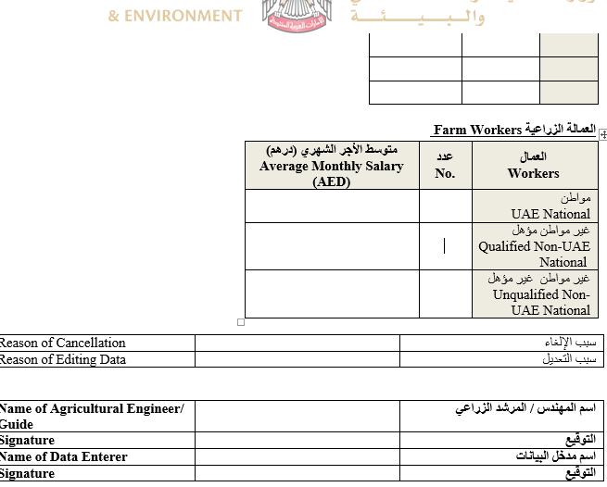

### Preliminary approval to license an animal production farm

**Service Description**

Preliminary approval given to Animal Production farm to license it until the completion of all procedures

**Steps**

1. Fill out e-form
2. Pay the fees
3. Audit on demand

**Required Documents**

1. A copy of the identity card (for individuals)
2. A copy of the commercial brand name (for companies)
3. A copy of the site lease contract or proof of ownership
4. Environment evaluation(Environmental Clearance)

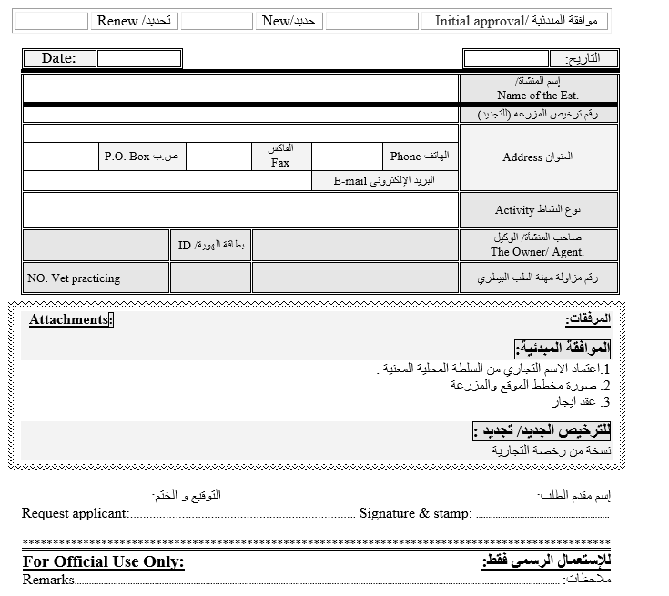

### Primary approval on licensing a veterinary facility

**Service Description**

Issuance of non-objection letter to the local authority to issue a commercial license for the veterinary facilities (Clinics, Laboratories, Hospitals, Stores, Pharmacies, manufacture and consultation offices)

**Steps**

1. Fill e-form
2. Make payment
3. Review the application and complete the procedures electronically
4. Issue license electronically

**Required Documents**

1. Approval of commercial name by the local authority
2. A copy of lease contract or a copy of the ownership deed

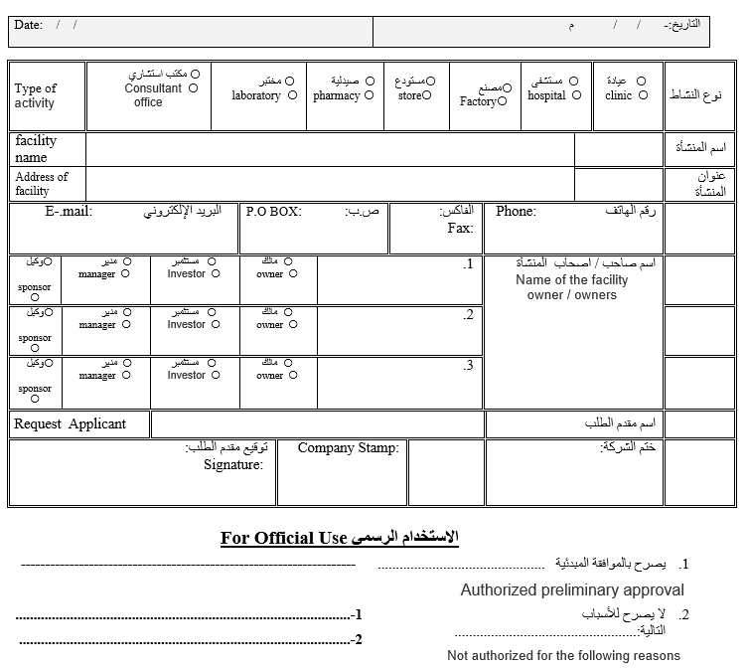

### Registration of agricultural holdings

**Service Description**

The farm data of the citizen holder is recorded in the electronic system to benefit from the services provided by the ministry to the farmers

**Steps**

1. Fill out form
2. Inspection Visit
3. Registration of agriculture holdings electronically

**Required documents**

1. Copy of ID card
2. Copy of the farm ownership
3. Copy of land chart showing its area

**Additional documents (for the lessee):**

* Lease contract from the owner of the farm to the holder

**Additional documents (for heirs):**

* Confiscation of inheritance issued by a court of Emirate
* Power of attorney on behalf of the holder by all the heirs

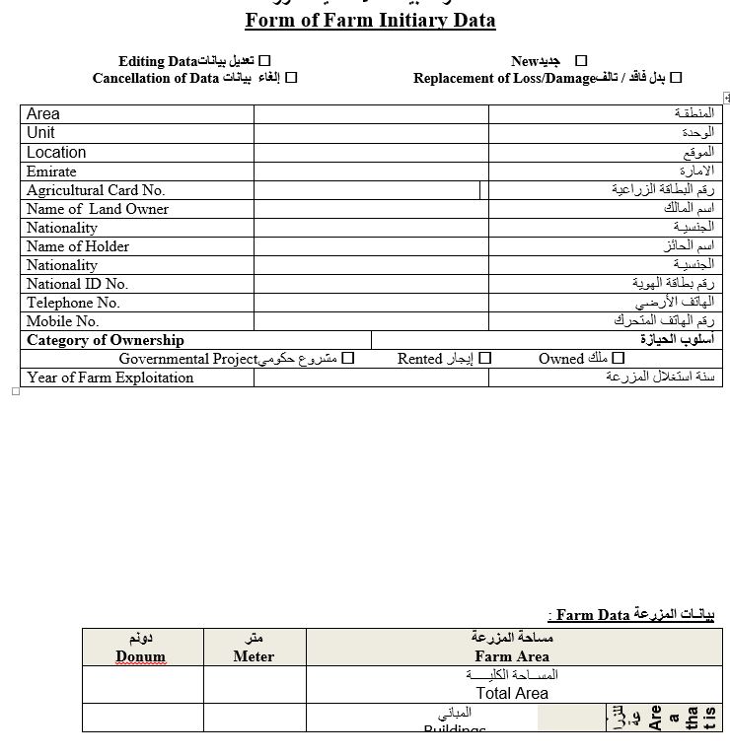

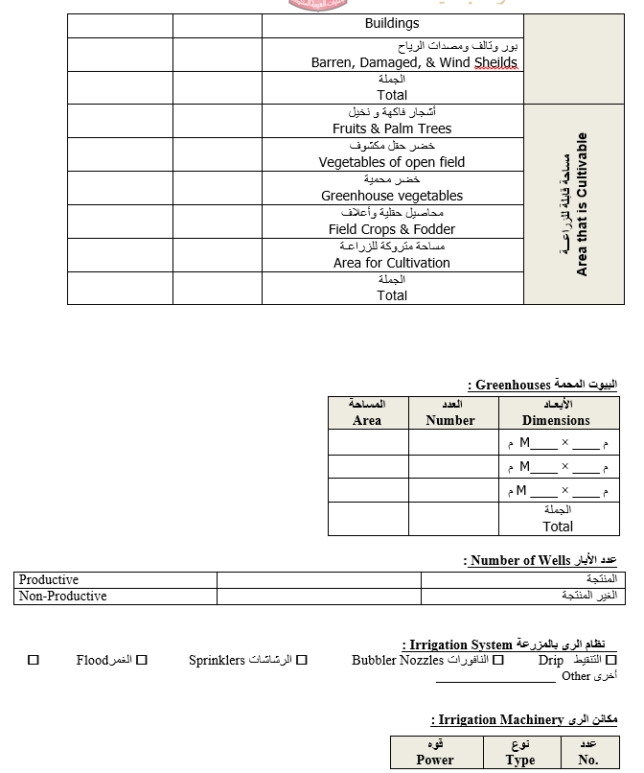

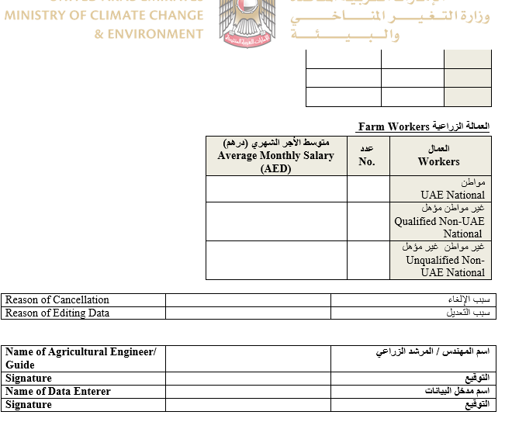

### Renew Aquaculture Farm Establishment License

**Service Description**

Through this service aquaculture license is renewed for the establishment and operation of an aquaculture farm valid for one years.

**Steps**

1. Fill out the form
2. Electronic payment of fees
3. Review of application and complete procedures
4. Issuance of renewed license

**Required Documents**

1. A copy of valid trade license



### Renew Import License (Brood stock and Larvae/ Fishing Tools and Equipment)

**Service Description**

Through this service an import license is renewed for the purpose of importing fish Brood stock, larvae, and live fish or for importing fishing tools and equipment (Valid for 1 year from the previous license’s expiry date )

**Steps**

1. Fill out the form
2. Electronic payment of fees
3. Review of application and complete procedures
4. Issuance of renewed license

**Required Documents**

1. Official letter or a certificate from the competent authority declaring that the facility meets the technical requirements to practice the activity.



### Renew issuance license of practicing the profession for veterinarians and for the assistant vet

**Service Description**

Through this service, the license for practicing the profession is renewed for veterinarians and veterinary professions in the country for one year, including (veterinarian / veterinarian assistant / Veterinary nurse / laboratory technician)

**Steps**

1. Fill out the form
2. Electronic payment of fees
3. Review of application and complete procedures
4. Issuance of renewed license

**Required Documents**

1. A copy of the passport with valid residence for the same establishment in case of expiry of the previous residence
2. 

### Renew Plant Nursery License

**Service Description**

A license is renewed for the production of vegetable, fruit, forestry or shade plants and ornamental within the country (valid for one year from the date of expire)

**Steps**

1. Fill out the form
2. Electronic payment of fees
3. Review of application and complete procedures
4. Issuance of renewed license

**Required Documents**

1. Copy of the commercial license
2. Copy of the lease site activity or proof of ownership of the site



### Renew Veterinary Establishment License

**Service Description**

Through this service, obtained the renewal of license for a veterinary establishment including (veterinary hospital, veterinary clinic, veterinary laboratory, veterinary scientific advisory office, veterinary drug store, veterinary pharmacy, artificial insemination center) valid for one year

**Steps**

1. Fill out the form
2. Electronic payment of fees
3. Review of application and complete procedures
4. Issuance of renewed license

**Required Documents**

None



### Renew Vice-Captain's Card

**Service Description**

Through this service the fisher can appoint a local vice-captain to operate his/her boat and work on it on his/her behalf. A vice-captain card will be issued valid for 2 years from the date of renewal.

**Steps**

1. Fill out the form
2. Review of application and complete procedures
3. Issuance of renewed license

**Required Documents**

1. Personal photo (optional)
2. Copy of a valid passport for those who carry UAE passports
3. Valid boat sailing license



### Renewal a License for Manufacture Fertilizers and Soil Conditioner

**Service Description**

A license is renewed for the manufacture of fertilizers and agricultural soil conditioners within the country valid for one year from the date of expire.

**Steps**

1. Fill out the form
2. Electronic payment of fees
3. Review of application and complete procedures
4. Issuance of renewed license

**Required documents**

1. Copy of valid industrial license
2. Copy of valid environmental declaration issued by the competent authority



Renewal Issue a license of practicing animal activity

**Service Description**

Through this service a license is obtained for renewal practicing animal activity for one year from the date of issue

**Steps**

1. Fill out the form
2. Electronic payment of fees
3. Review of application and complete procedures
4. Issuance of renewed license

**Required Documents**

1. Establishments continue to comply with their licensing requirements



Renewal of Accreditation of food Establishment to Export outside UAE

**Service Description**

Through this service, food establishment inside UAE is renewed for exporting its products outside UAE (valid for one year starting from the issuing date)

**Steps**

1. Fill out the form
2. Electronic payment of fees
3. Review of application and complete procedures
4. Issuance of renewed accreditation

**Required Documents**

1. Reports of inspection from the competent

### Renewal of agricultural activity license

**Service Description**

A license is renewed for the agricultural activity (valid for one year from the date of renewal). These activities include: (Agricultural Engineering Consultancy /Agricultural Pest Control Services / Wholesale and Retail Pesticide Trade / Wholesale and Retail Fertilizer & soil conditioners Trade/ Wholesale seeds & tubers trade/ wholesale of different plants and cut flowers trade/ wholesale bee trade / wholesale OUD (Agarwood) trade)

**Steps**

1. Fill out the form
2. Electronic payment of fees
3. Review of application and complete procedures
4. Issuance of renewed license

**Required Documents**

1. Copy of valid commercial license and partners annex

**In case of request of new license**

1. Trade license or trade name
2. Tenant contract (shop or office)
3. Inspection report (from the agricultural region office)
4. In case of pesticides, fertilizers activity

**In case of request of renew license**

1. Trade license

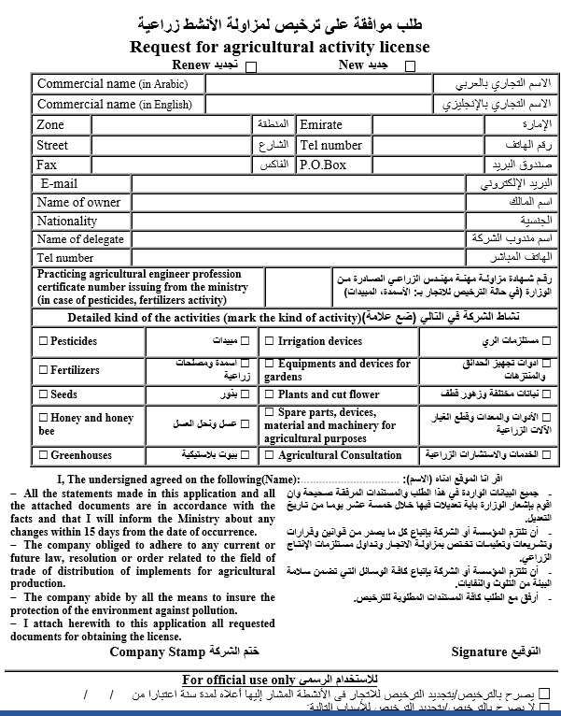

Renewal of an Export License (Local Aquatic Organisms’ Products)

**Service Description**

Through this services, an export license is renewed for the purpose of exporting local aquatic organisms extracted from the UAE waters or farmed in the UAE which includes fresh/frozen/smoked/dried/salted fish as well as other aquatic organisms such as crustaceans and mollusk. (valid for 1 year from the previous license’s expiry date

**Steps**

1. Fill out the form
2. Electronic payment of fees (For delays exceeding one month AED 100, else no fees)
3. Review of application and complete procedures
4. Issuance of renewed license

**Documents Required**

1. Declaration or a certificate issued from the competent authority declaring that the applicant has the necessary means to store, preserve, and transport aquatic organisms which meet the health requirements determined by the competent authority in the concerned emirate.



### Renewal of Slaughterhouse Accreditation outside UAE

**Service Description**

Through this service, the accreditation of a slaughterhouses outside UAE are renewed for slaughtering animals and poultry includes meat shredding and storage facilities in order to allow the export of animal meat and poultry meat slaughtered to UAE (valid for one year starting from the renewal date)

**Steps**

1. Fill out the form
2. Electronic payment of fees
3. Review of application and complete procedures
4. Issuance of renewed accreditation

**Required Documents**

1. Certificate of registration / license of the slaughterhouse issued by the relevant veterinary and / or food control authorities in the country of origin
2. Valid Certificate of application of food safety management system & quality management system issued by nationally accredited institution in the country of origin

### Renewal of the license of an animal production farm

**Service Description**

Through this service renewed the licensed of commercial production farms to keep domesticated productive animals for commercial purposes, including cows, sheep, goats, camels, rabbits and domestic birds (valid for one year from the date of issue)

**Steps**

1. Fill out the form
2. Electronic payment of fees
3. Review of application and complete procedures
4. Issuance of renewed license

**Required Documents:** None



### Replacement of Fishing Boat

**Service Description**

Through this service the fisher can replace the body of the fishing boat registered under his/her name in the general registry of the Ministry. A boat license and Captain card will be issued valid for 2 years from the date of issuance after adding the new boat information.

**Steps**

1. Fill out the form
2. Review of application and complete procedures
3. Issuance of renewed license

**Required Documents**

1. Delisting certificate of a Maritime Transport issued by CICPA
2. Copy of the purchase invoice certified by the relevant local authority OR the delisting/deletion certificate of the fishing boat intended for registration issued by CICPA or the Ministry OR fishing boat selling contract issued by the Ministry or the court.
3. Technical inspection report issued by the CICPA

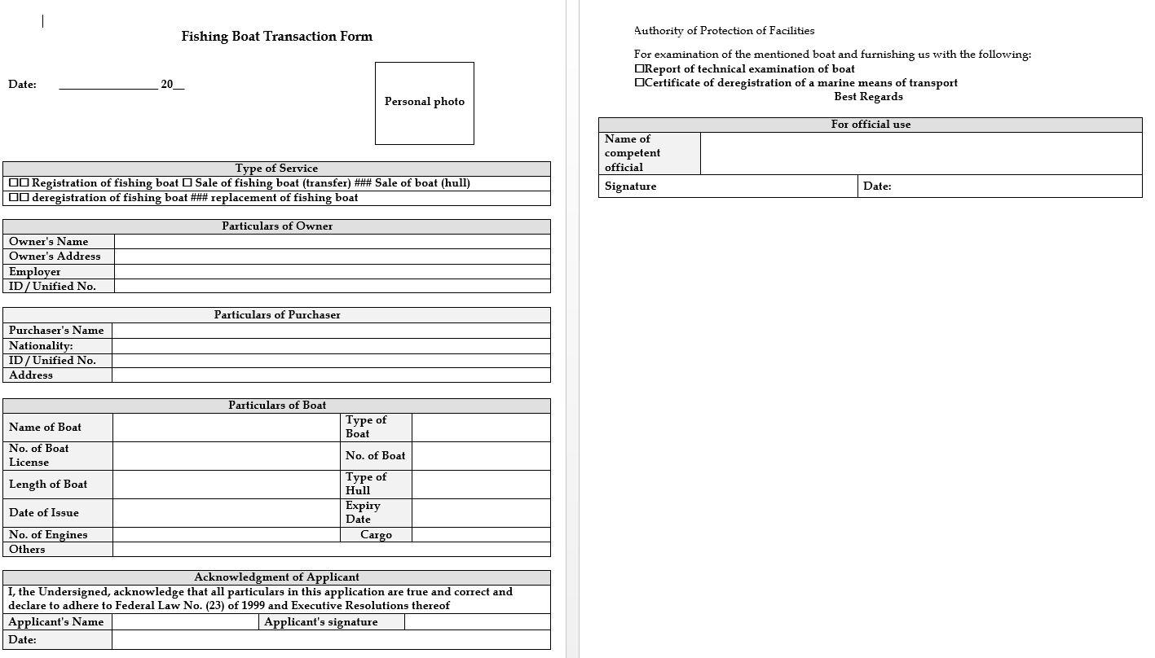

### Request ٍSubsidies for Farmers

**Service Description**

The subsidy (agricultural production materials) provided by the Ministry to the Local farmers who has agricultural holdings registered with the ministry at half their purchasing cost

**Steps**

1. Fill out e-form
2. Payment of materials (50% of purchase value)
3. Issuance of electronic order
4. Delivery of materials

**Documents Required**

Stamped salary certificate or a court certificate declaring that the applicant is unemployed.

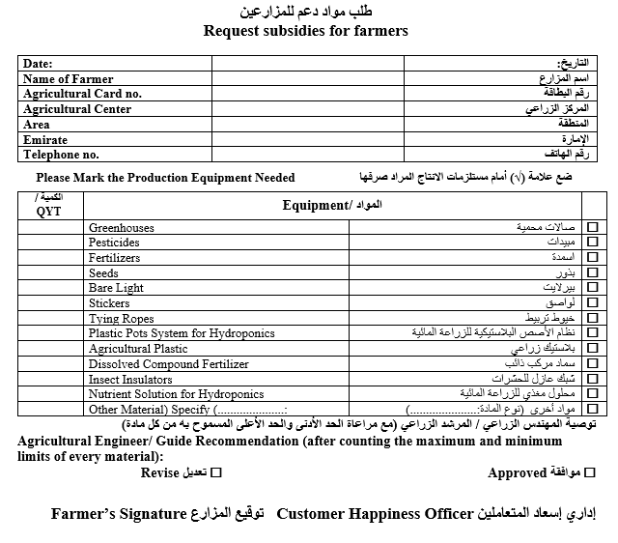

### Request ٍSubsidies for Fishermen’s

**Service Description**

Through this service the fisher can obtain the annual support materials (fishing boats’ engines) provided by the Ministry to the local fishers on the basis of specific requirements.

**Steps**

1. Fill out e-form
2. Payment of materials (50% of purchase value)
3. Issuance of electronic order
4. Delivery of materials

**Documents Required**

1. Stamped salary certificate or a court certificate declaring that the applicant is unemployed.

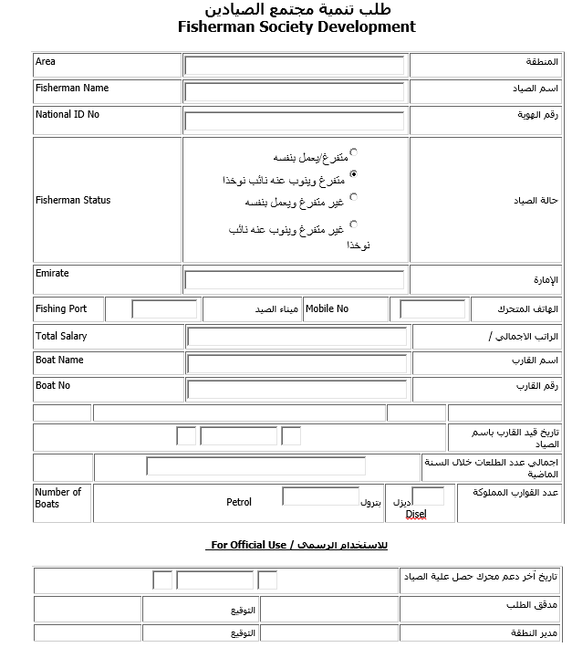

Sale of Fishing Boat's Body

**Service Description**

Through this service the fisher can sell the body of his/her fishing boat that is registered in the general registry at the Ministry. A boat license and a captain card will be issued valid for 2 years from the date of issuance after providing the new boat body.

**Steps**

**For application Approval**

1. Fill out the form
2. Review of application and complete procedures
3. Issue a deletion certificate of fishing boat & fishing boat contract

**For boat replacement certificate**

1. Attach required documents
2. Review of application and complete procedures
3. Issue boat license and captains card

**Required Documents**

**For application approval:**

1. Written undertaking to provide a new boat within six months from the date of the sale of the body of the fishing boat

**For the boat replacement license:**

1. Technical certificate of the inspection results of the fishing boat

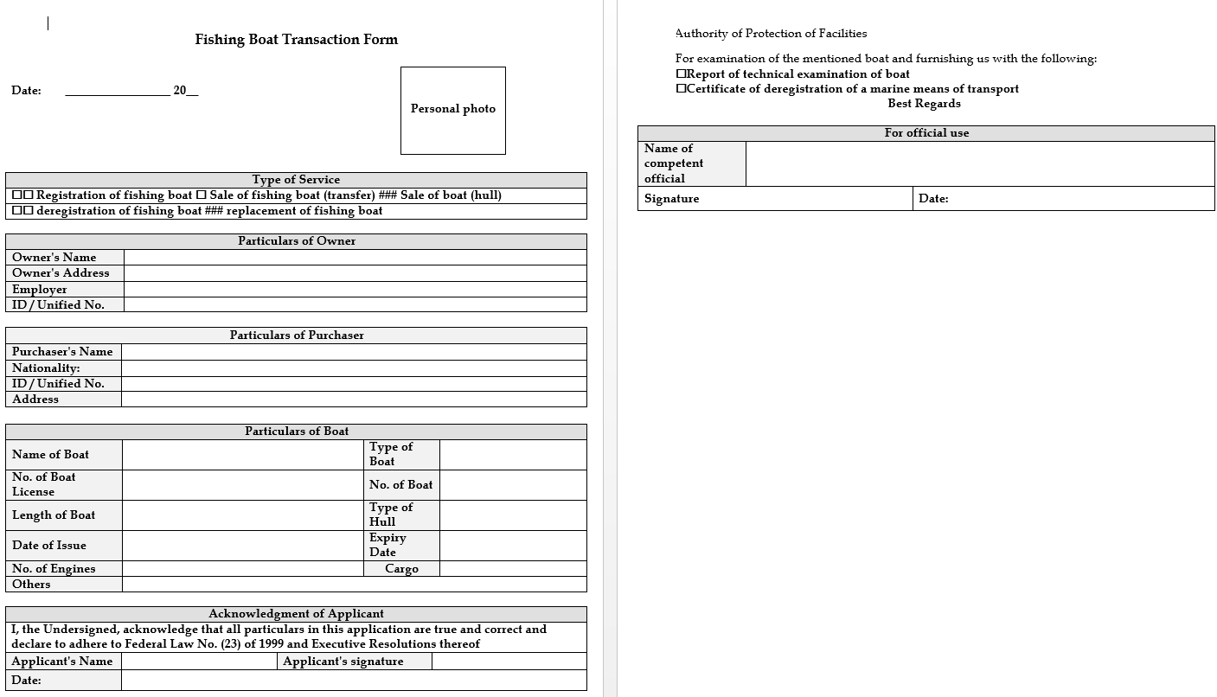

### Slaughterhouse Accreditation Outside UAE

**Service Description**

Through this service, slaughterhouses outside UAE are approved for slaughtering animals and poultry after ensuring their applying with food safety systems and legislations based on the risk analysis approved by UAE. This includes meat shredding and storage facilities in order to allow the export of animal meat and poultry meat slaughtered to UAE (valid for one year starting from the issuing date)

**Steps**

1. Make e-payment
2. Review of application and complete procedures
3. Carry out evaluation visit with coordination of competent authority
4. Issue the accreditation

**Required Documents**

1. Certificate of registration / license of the slaughterhouse issued by the relevant veterinary and / or food control authorities in the country of origin
2. Valid Certificate of application of food safety management system & quality management system issued by nationally accredited institution in the country of origin
3. Certificate of registration / license/ accreditation/ recognition of the Certification body of food safety management system & quality management system Certificates by the relevant authorities in the country of origin or in the UAE (only)

### Transfer Fishing Boat Ownership

**Service Description**

Through this service local fisher can sell and transfer the ownership of his/her fishing boat (license and boat body) which is registered with the ministry to another person who meets the requirements for enrollment in the general registry at the Ministry. A boat license and a captain card will be issued valid for 2 years from the date of transferring the fishing boat ownership

**Steps**

1. Fill out e-form
2. Review of application and complete procedures
3. Issue license, captain card, deletion certificate, fishing boat sales contract

**Required Documents**

1. Copy of emirates ID card
2. Copy of the full family book (compare it with the original)
3. Passport copy
4. Personal photo
5. Certificate of Good Conduct and behavior
6. Fishing license issued by the competent local authority
7. Medical fitness certificate to operate and sail a fishing boat
8. Salary certificate / pension or a certificate from the competent court stating that the applicant is unemployed and does not receive a pension
9. Technical inspection report issued by the CICPA
10. Delisting certificate of a Maritime Transport issued by Coast Guard

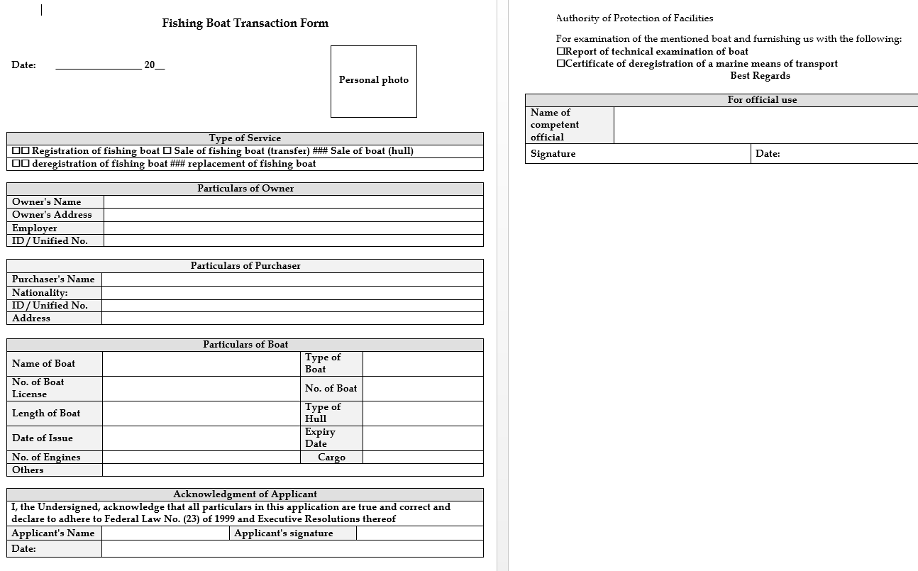

### Transfer Fishing Boat's Ownership to Heirs

**Service Description**

Through this service the agent of the fisher’s heirs can modify the information of the boat owner in the general registry of the Ministry and transfer the ownership to the heirs. A boat license will be issued valid for 2 years from the date of transferring the fishing boat's ownership to heirs.

**Steps**

1. Fill out e-form
2. Review of application and complete procedures
3. Issue lf boat license

**Required Documents**

1. Notification of inheritance
2. An agent appointment certificate issued by the Sharia Court
3. Copy of the family book to be compared with the original (for hires)
4. 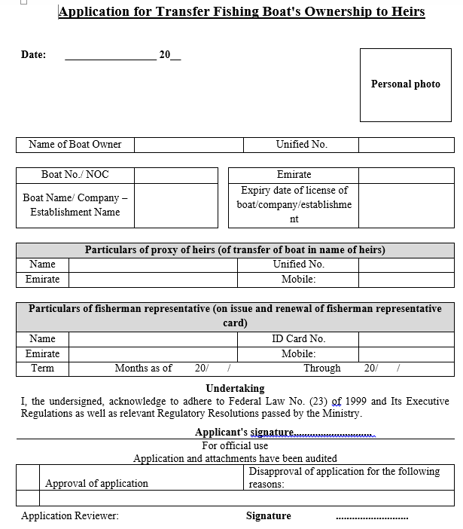Technical inspection report issued by CICPA

### Veterinary Extension Request

**Service Description**

Through this service, veterinary services are provided to livestock breeders which include (treatments, vaccination, veterinary guidelines, animal numbering)

**Steps**

1. Fill e-form
2. Visit field
3. Close request by documenting the service in electronic system

**Required Documents:**

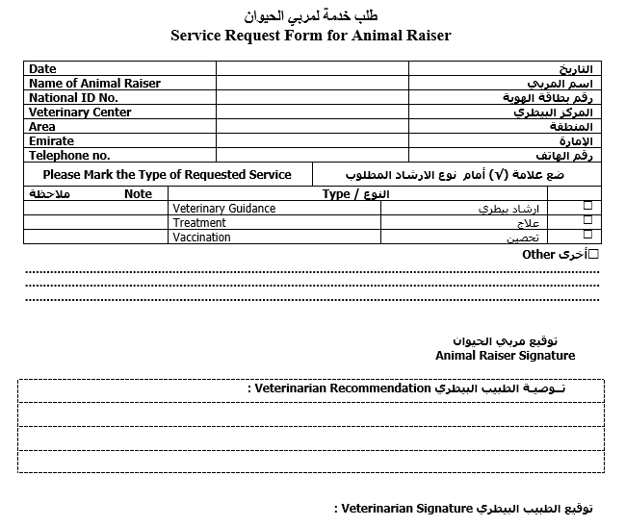

### Vice-Captain Card Issuance

**Service Description**

Through this service the fisher can appoint a local vice-captain to operate his/her boat and work on it on his/her behalf. A vice-captain card will be issued valid for 2 years from the date of issuance

**Steps**

1. Fill e-form
2. Review application and complete the procedure electronically
3. Issuance of vice-captain card

**Required Documents**

1. Copy of Emirates ID card OR passport for holders of a valid UAE passports only
2. Copy of passport
3. Personal photo
4. Certificate of Good Conduct and Behavior
5. Valid boat sailing license from the FTA
6. Medical fitness certificate to operate and sail a fishing boat
7. Certificate to prove the relationship between the vice-captain and the fishing boat owner (in the case of the first-to fourth-degree kinship only (to be issued by the Court. Alternatively, the relationship of kinship may be established on the basis of the data provided by their identity documents
8. Certificate approved by a specialized medical committee to prove the inability of the owner to manage and operate the fishing boat (in case of medical inability only)
9. Copy of the full family book of the heirs (in the case of minor heirs only)



## Permit Requirements

### Adopting Veterinary Raw Materials for Importation

**Service Description**

Through this service, veterinary raw materials are approved for allowing import in accordance with the conditions in force in the provisions of Federal Law No. 9 of 2017 on veterinary products.

**Steps**

1. Submit the application
2. Approve the material
3. Review the applications and complete procedure electronically

**Required documents**

**Raw materials for veterinary product:**

1. A preliminary invoice from the company that exported the raw materials stating the country of origin, the name of the manufacturer, the names of the materials intended to be imported, the quantity and shape, size and package of the import, the price and the name of the border port through which the import will take place.
2. An analysis certificate issued by the manufacturer bearing the specifications of the raw material, the operating number of the imported material, and the date of production and expiration
3. GMP Certificate of Good Manufacturing Practice issued by the competent authority in the country of origin
4. A certificate of conformity of the material for manufacture issued by the competent authority in the country of origin
5. The label in Arabic or English.
6. A health certificate stating that the veterinary raw materials of animal origin are free of BSE and pig derivatives

**Raw materials for feed additives:**

1. A preliminary invoice from the manufacturer / exporter of the veterinary raw materials stating the country of origin, the name of the manufacturer, the names of the materials intended to be imported, the quantity and shape of the package, the import price and the name of the border port through which the import will take place.
2. A certificate of good practice for manufacturing or its equivalent in the name of the factory, issued by the competent authority in the country of origin and valid.
3. The product analysis certificate issued by the manufacturer bearing the raw material specifications, the operating number of the imported material, and the date of production and expiration.
4. The label in Arabic or English.
5. If the raw materials are from animal origin, a certificate issued by the competent authority in the country of origin must be brought out as follows:
   1. The type of animal, the part used and its source.
   2. The animal products used in the manufacture of the product are taken from animals examined before and after slaughter.
   3. The product is imported from a country / region free of bird flu in the event that the feed contains poultry meat and its products, or the product has been processed thermally at a temperature of 70 ° C for at least 30 minutes or its equivalent.
   4. The product is imported from a country where BSE has not been registered, classified as having controlled or neglected risks for BSE - if the feed composition contains beef (provided that this feed is not used to feed ruminants).
   5. Animals were not fed on diets containing meat powders, bones, and other animal derivatives of ruminant animals, except for milk and its substitutes.
6. In the event that veterinary raw materials contain (substances containing or produced from genetically modified organisms) The identification card must be presented stating the following: (genetically modified under the ingredients with the same font size but with a different color) according to UAE practice No. (UAE.S / GSO 2142: 2011



### Apply for Release Permit (Fishing Tools and Equipment)

**Service Description**

Inspection shipment to be sure that it complies with the importation conditions for the releasing purpose

**Steps**

1. Fill e-form
2. e-payment
3. Issue the release permit electronically

**Required documents**

1. Original import permit
2. Certificate of origin
3. An approved original health certificate, to be replaced with a transaction certificate of completed processed waste (except for fishing supplies and equipment from health certificate)
4. Customs declaration or bill of lading
5. Purchase invoice / packing list
6. CITES certificate from the country of export (CITES-uncovered waste)

### Approve Disinfectants, Veterinary Equipment and Supplies, and Animal Care Supplies for Distribution

**Service Description**

Is the process of the adoption veterinary disinfectants, diagnostic materials, equipment, devices, supplies and animal care products for allowing import in accordance with the conditions in force in the provisions of Federal Law No. 9 of 2017 on veterinary products

**Steps**

1. Submit e-form
2. Review application and complete procedures
3. Adoption of the list of materials allowed to be imported by the state

**Required documents**

1. The label in Arabic or English.
2. Certificate of analysis and specifications of the product from the manufacturer, excluding veterinary equipment and supplies
3. A valid free sale certificate or equal certificate from the country of origin issued by the responsible authorities

### Issuance Import permit for Semen or Embryos

**Service Description**

Through this service, it is agreed to import the semen consignments or embryos for animals from outside the country, and obtain a valid permit for a period of 30 days from the date of issuance, and they are examined at the entry port and released after ensuring that they conform to the import terms and requirements

**Steps**

1. To obtain import permission
2. Fill out e-form
3. e-payment
4. Issue electronic permit
5. To release consignment
6. Fill out e-form
7. e-payment
8. Document checking
9. Physical checking
10. Issue electronic permit

**Required Documents**

**Import:**

1. No documents required

**Release**

1. Attested veterinary health certificate issued by the competent veterinary authorities and in accordance with the approved models with the countries of export
2. Certificate of origin approved and issued by the competent authority
3. A customs declaration showing the shipment data
4. Bill of lading shows the delivery data

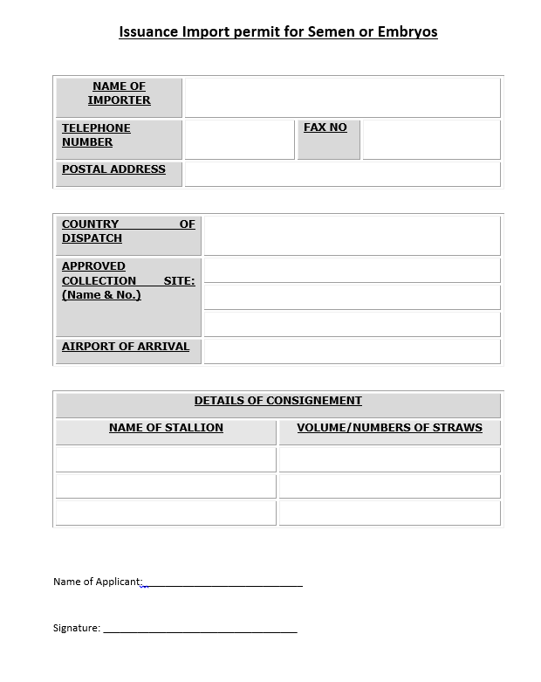

### Issuance of Re-export of Vegetable Feed Permission

**Service Description**

Request for issuing Re-export permit for Forage (green and dry Forage) imported from outside the country (Valid for one month from the date of issue)

**Steps**

1. Fill out e-form
2. E-payment
3. Review the application and complete the procedures electronically
4. Issue the permit electronically

**Required Documents**

1. Valid commercial license
2. Origin certificate
3. Copy of valid lease contract of the company or enterprise
4. Copy of Purchase bill
5. Copy of the customs declaration consignment imported



### Issue a Permanent or Temporary Horse import permit

**Service Description**

Through this service, it agreed to import horses permanently or temporarily from outside the country and obtain a temporary import permit that is valid for a period of ten days.

**Steps**

**Obtain Import permission**

1. Fill out e-form
2. E-payment
3. Issue the permit

**Release consignment**

1. Fill out e-form
2. E-payment
3. Physical examination and laboratory test
4. Issuing the permit

**Required documents**

**Import:**

1. A copy of the laboratory examination from the exporting country
2. Copy of the horse passport
3. Vaccination document
4. Copy of the owner’s passport / ID
5. No objection from the Emirates Arabian Horse Association in the event that the horse is Arab

**Release (Permanent importation):**

1. Import permit
2. attested veterinary health certificate issued by the competent veterinary authorities
3. A copy of the laboratory test issued by the United Arab Emirates

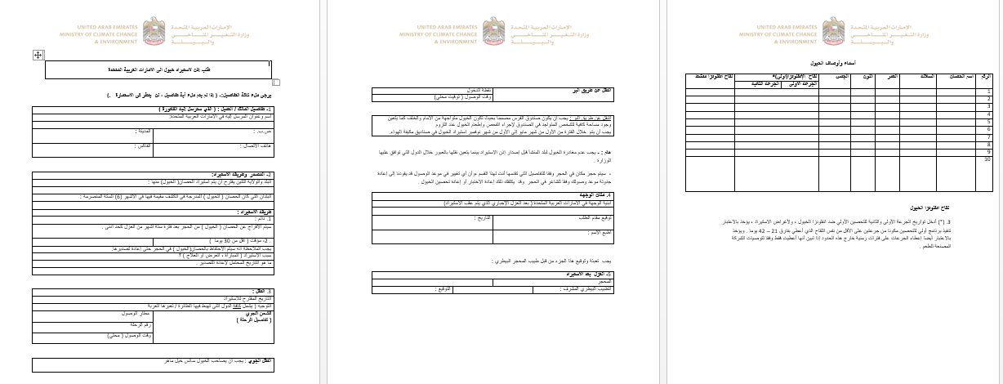

### Issue a Permit to Import Ozone Depleting Substances (ODS)

**Service Description**

Through this service is obtained permission to approve the import of consignment materials depleted ozone layer HCFCs to the State and then inspect the consignment at the port of entry and release it after confirmation of matching the required documents.

**Steps**

**Import permit**

1. Fill e-form
2. E-payment
3. Issue the import permit

**Release permit**

1. Create application
2. E-payment
3. Inspect and lab test consignment
4. Issue release permit

**Required documents**

**To Import:**

1. Material Safety Data Sheet (MSDS)
2. General Attachments) trade license)

**To Release:**

1. Copy of the customs declaration
2. Bill of lading (Shipping Policy)
3. Certificate of origin

### Issue a Permit to Import Pesticides

**Service Description**

Through this service, permission is granted to approve the import of pesticide consignments registered in favor of the importer at the Ministry. This consignment is then examined upon arrival in the country at the port of entry and released after ensuring that it complies with all import requirements.

**Steps**

**Import permit**

1. Fill e-form
2. E-payment
3. Issue the import permit electronically

**Release permit**

1. Fill e-form
2. E-payment
3. Inspect and lab test consignment
4. Issue release permit electronically

**Required documents**

**Import Permit**

1. No documents required

**Release Permit**

1. Copy of the customs declaration
2. Bill of lading (Shipping Policy)
3. Certificate of origin

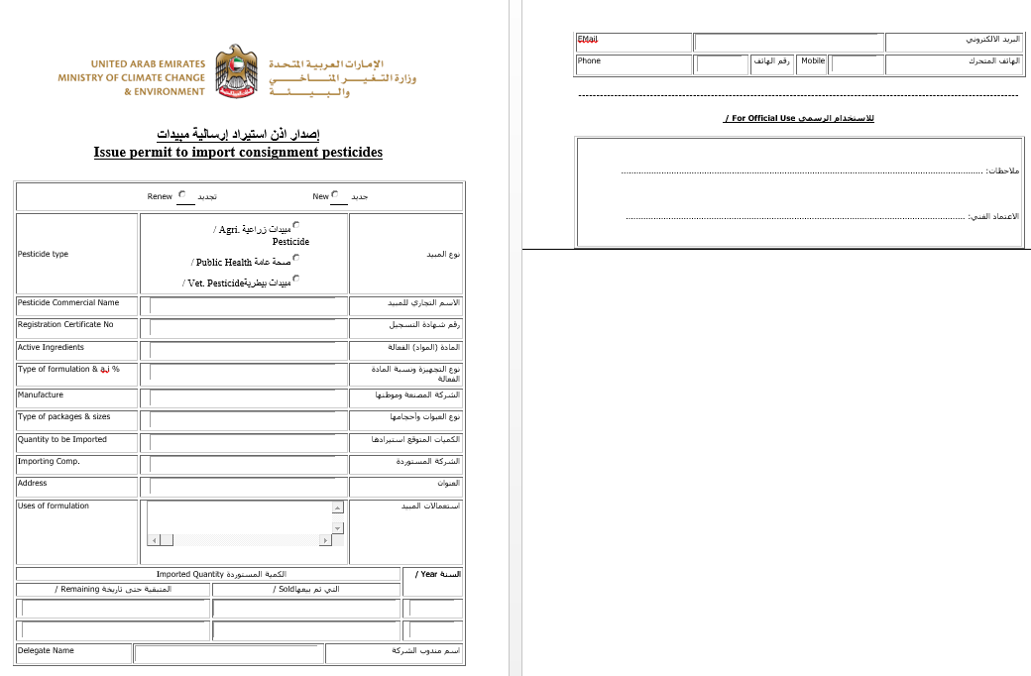

### Issue a permit to re-export ozone depleting substances (ODS)

**Service Description**

Through this service, will be approved the re-export Consumption of ozone-depleting substances HCFCs

**Steps**

1. Create the application
2. Pay fees
3. Issue the permit

**Required documents**

1. Material Safety Data Sheet (MSDS)

### Issue a Re-Export Permit (Aquatic Organisms Products)

**Service Description**

Through this service, a permit is issued to re-export imported aquatic products (fresh, frozen, dried, smoked or salted) fish, as well as other aquatic products such as crustaceans or mollusks (Valid for 1 month from the permit issuance date)

**Steps**

1. Fill e-form
2. e-payment
3. review the application and complete procedures electronically
4. issue electronic permit

**Required documents**

1. Packing list which lists the type and quantity of aquatic organisms products intended for re-export or the purchase invoice in case the importer and exporter names are not the same
2. Copy of the customs declaration from the customs authority at the port of entry which lists the aquatic organisms products’ type and quantity intended for re-export
3. For air and marine shipments, the following document is required:
4. Packaging certificate issued from a fish processing factory which lists the consignment information such as aquatic products’ type and quantity

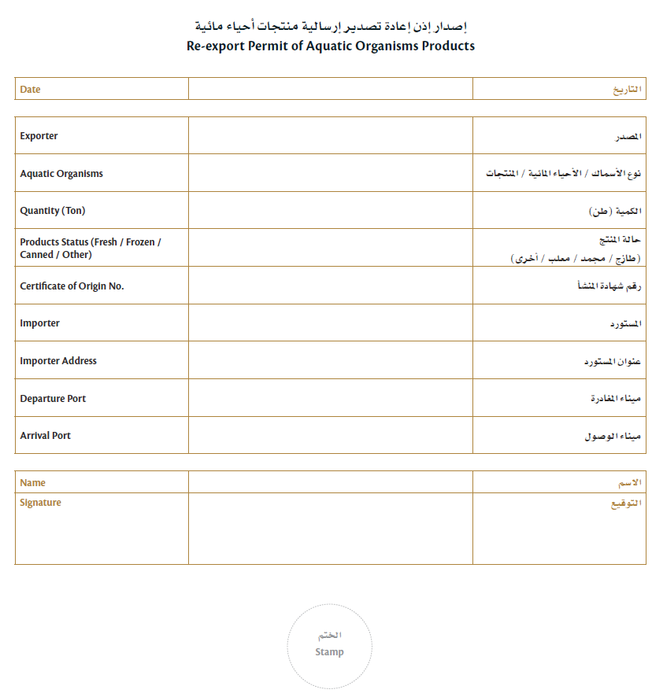

### Issue an agricultural consignment release

**Service Description**

Through this service, approval is obtained to release agricultural products, including cut flowers and vegetable products (fresh fruits and vegetables) and raw timber (timber that is not subject to the following manufacturing processes: coking, multi-mode, with a thickness of less than 6 mm), and fodder of plant origin. Inspection to these consignments will be done upon their arrival at the entry point and are released after ensuring that they comply with the all import requirements.

**Steps**

1. Fill e-form
2. e-payment
3. visual inspection and laboratory tests
4. Issue the electronic permit

**Required documents**

1. Origin certificate
2. Phytosanitary certificate issued the competent authority of the exporting country
3. Copy of the customs manifest, bill of lading or delivery authorization
4. List of contents or invoice

**Vegetable and fruit consignments:**

In addition to the above documents, you must attach:

1. Certificate of analysis for pesticide residues for plant products coming from exporting countries according to the circulars issue by the Department of Agricultural Development and Health

**Raw Wood consignments:**

In addition to the above documents, you must attach:

1. Heat Treatment Certificate (For woods), Or to be mentioned in the additional declaration clause in the phytosanitary certificate

### Issue an Export Permit (Local Aquatic Organisms’ Products)

**Service Description**

Through this service, a permit is issued to export a consignment of local aquatic products out of the UAE. This includes local wild fish, fish produced in aquaculture farms in the UAE, crustaceans, molluscs, and other aquatic organisms. (Valid for 1 month from the permit issuance date)

**Steps**

1. Fill e-form
2. E-payment of fees
3. Review the application and complete procedure electronically
4. Issue permit electronically

**Required documents**

1. Packing declaration which lists the type and quantity of aquatic organisms’ products intended for export For air and marine shipments, the following document is required:
2. Packaging certificate issued from a fish processing factory which lists the consignment information such as aquatic producrs’ type and quantity



### Issue an Export Permit of Hazardous Waste

**Service Description**

Through this service, a permit is approved for Export of hazardous waste in accordance with the Basel Convention for the Transboundary Movements of Hazardous wastes.

**Steps**

1. Fill e-form
2. e-payment
3. review documents and complete procedure electronically
4. issue online permit

**Required documents**

1. Valid Trade license activity in the same field
2. Valid Environmental permit
3. Contract (between exporter & importer)
4. Insurance
5. Movement Document
6. Notification Document

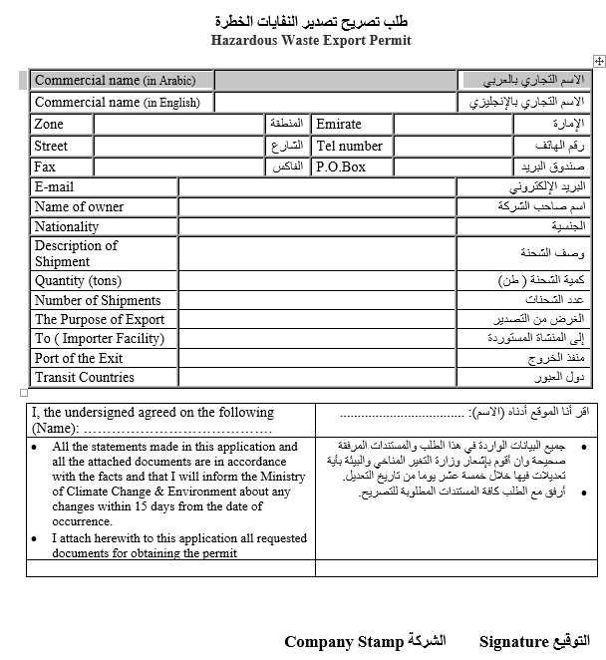

### Issue an Import Permit (Broodstock or Larvae)

**Service Description**

Through this service, a permit is issued to import broodstock or larvae of fish and live fish. At the entry port, the consignment will be inspected and will be released after confirming the data listed in the import permit of the consignment and ensuring that it meets the necessary technical requirements (valid for three months from issuance date)

**Steps**

**Import Permit**

1. Fill e-form
2. E-payment
3. Issue permit electronically

**Release consignment**

1. Fill e-form
2. e-payment
3. Inspect consignment and record electronically
4. 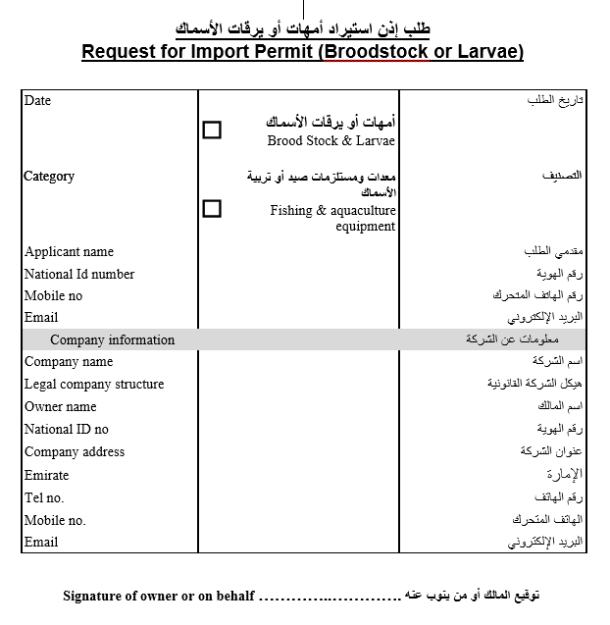Issue release permit electronically

### Issue an Import Permit for Animal Products or By-Products

**Service Description**

Through this service, it is agreed to import animal products or by-products from outside the country and obtain a valid import permit for a period of 30 days from the date of issuance. These imported animal products or by-products are examined at the entry port and released after ensuring that they comply with the import permit and the necessary technical specifications.

**Steps**

**Obtain import permission**

1. Fill e-form
2. e-payment
3. issue electronic permit

**Release consignment**

1. Fill e-form
2. e-payment
3. Document checking
4. Physical inspection
5. Release consignment permit issued electronically

**Required documents**

**Import:**

No documents required

**Release:**

1. Certificate of origin issued by the competent authority/or CITES certificate in case of CITES –products and by-products
2. A customs declaration showing the consignment data
3. Bill of lading showing the delivery data
4. In addition to the above documents, it is necessary to provide documents for some of the shipment according to the following:
5. For consignment of non-treated animal products and by-products: certified veterinary health certificate issued by the competent veterinary authorities and in accordance with the approved models with the exporting countries
6. For the consignment of animal products and by- products Treatment: Certificate of treatment (thermal, chemical or salts) issued by the competent authority



### Issue an Import Permit for Feed and Processed Animal Feed

**Service Description**

Through this service, an electronic import permit is obtained by approving the import of (Animal manufactured feed / feed additives / food supplements / pet animal food / Fish manufactured feed / raw materials for feed additives) Valid for 30 days from the date of issue and then those consignments will be checked upon arrival to the State at the port of entry and release and to ensure that it comply with all import conditions and specifications

**Steps**

**Obtain import permission**

1. Fill e-form
2. e-payment
3. issue e-permit

**Release consignment**

1. fill e-form
2. e-payment
3. review application and complete procedure electronically
4. Clinical exam and lab test
5. Issue release permit electronically

**Required documents**

**Import:**

No documents required

**Release:**

1. Certificate of origin approved and issued by the competent authority
2. A customs declaration or bill of lading indicating the consignment data
3. certificate of analysis for the product content

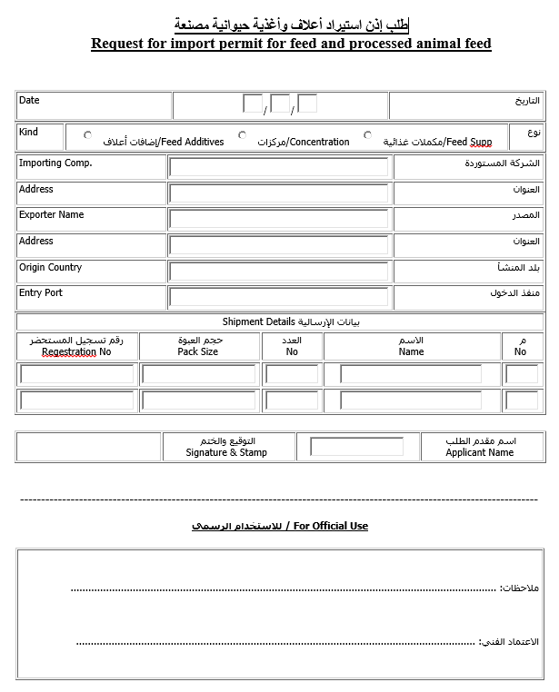

### Issue an Import permit for live animals, Birds and Ornamental fish

**Service Description**

Through this service, it is agreed to import live animals and birds and ornamental fish from outside the country and obtain a valid permit for a period of 30 days from the date of issuance and then examine this consignment when it reaches the country at the port of entry and release it after ensuring that it complies with all import requirements.

**Steps**

**Import Permission**

1. Fill e-form
2. e-payment
3. issue e-permit

**Release consignment**

1. Fill e-form
2. e-payment
3. Review application and complete procedure electronically
4. Clinical inspection and lab testing
5. Issue release permit

**Required Documents**

None



### Issue an Import Permit for Pets - Cats or Dogs

**Service Description**

Through this service, it is agreed to import companion’s animals - cats or dogs from outside the country and obtain an import permit valid for 30 days from the date of issuance and then examine these animals at the entry port when they arrive in the country and release them. Verifying that they comply with the import permission, conditions and specifications Necessary technical.

**Steps**

**Import permission**

1. Fill e-form
2. e-payment
3. issue e-permit

**Release consignment**

1. fill e-form
2. e-payment
3. vision inspection and complete procedure electronically
4. Issue e-permit

**Required documents**

**Import:**

No documents required

**Release:**

1. A customs declaration or bill of lading showing the delivery data
2. A document of immunizations or a passport with the required data
3. A certified health certificate issued by the competent veterinary authorities
4. In the event of importation from a high-risk country, a laboratory test certificate should be attached to the Antibody Titration Test for rabies issued by a laboratory approved by the competent authorities of the State of export, with the possibility of including the result of the laboratory test in the health certificate
5. In the case of importation of animals who were resident in the State, a copy of the Veterinary Health Certificate issued by the Ministry shall be required when the animal leaves the country





### Issue an Import Permit of Fertilizers or Soil Conditioners (Restricted)

**Service description**

Through this service, approval is obtained to import a consignment of fertilizers or soil conditioners (restricted), import authorization is valid for six months from the date of issue, and inspection to these consignments will be done upon their arrival at the entry point and are released after ensuring that they comply with the all import requirements.

**Steps**

**Import permission**

1. Fill e-form
2. e-payment
3. issue e-permit

**Release consignment**

1. fill e-form
2. e-payment
3. review the applications and complete procedure electronically
4. Visually inspect and lab test samples, complete procedure electronically
5. Issue e-permit

**Required documents**

**Import:**

No documents required

**Release:**

1. Invoice or product list
2. Origin certificate
3. Copy of the customs manifest or bill of lading
4. Certificate of analysis for each operation (shipment) issued by the factory or from a governmental laboratory or laboratory accredited by the competent authority in the country of origin proving the conformity of the shipment to the registration certificate



### Issue an Import Permit of Fertilizers or Soil Conditioners (Unrestricted)

**Service Description**

Through this service, approval is obtained to import a consignment of fertilizers or soil conditioners (unrestricted), import authorization is valid for six months from the date of issue, inspection to these consignments will be done upon their arrival at the entry point and are released after ensuring that they comply with the all import requirements

**Steps**

**Import permission**

1. Fill e-form
2. e-payment
3. issue e-permit

**Release consignment**

1. Fill e-form
2. e-payment
3. Review the applications and complete procedure electronically
4. Visually inspect and lab test samples, complete procedure electronically
5. Issue e-permit

**Required documents**

**Import:**

No documents required

**Release:**

1. Invoice or product list
2. Origin certificate
3. Copy of the customs manifest or bill of lading
4. Certificate of analysis for each operation (shipment) issued by the factory or from a governmental laboratory or laboratory accredited by the competent authority in the country of origin proving the conformity of the shipment to the registration certificate
5. A phytosanitary certificate for organic fertilizers, potting soil, growing media and any fertilizers containing organic materials stating that these fertilizers are free from weed seeds and pest as( fungi, bacteria, insects, nematodes and viruses) issued by competent authority in the country of origin



### Issue an Import permit of Pheromones, Attracting materials, Extruding materials, Additives and Materials with mechanical or physical in pest control

**Service Description**

Through this service, the importation of pheromones, attractants, nuisances, additives and materials with mechanical or physical effect in the pest control will be approved and the shipment checked before release.

**Steps**

**Import permission**

1. Fill e-form
2. e-payment
3. review the applications and complete procedure electronically
4. issue e-permit

**Release consignment**

1. Fill e-form
2. e-payment
3. Review the applications and complete procedure electronically
4. Issue e-permit for consignment

**Required documents**

**For import permit:**

No documents required

**For release permit:**

1. Copy of the customs declaration
2. Bill of lading
3. Certificate of origin
4. Certificate of composition of the material including active substances and their percentages of other inert substances from a governmental laboratory or from a laboratory accredited by Good Laboratory Standards (GLP).



### Issue import permit for non-manufactured feed for aquatic organisms

**Service description**

Through this service, an electronic permit is issued for import of non-manufactured feed for aquatic organisms valid for 3 months from the date of issuance. At the entry port, the consignment will be inspected and will be released after confirming the data listed in the import permit of the consignment and ensuring that it meets the necessary technical requirements

**Steps**

**Import permission**

1. Fill e-form
2. e-payment
3. issue e-permit

**Release consignment**

1. fill e-form
2. e-payment
3. Inspect consignment and complete procedure electronically
4. Issue e-permit

**Required Documents**

**To obtain the import permit:**

No documents are required

To request the release of the consignment:

1. Customs declaration or bill of lading
2. Purchase invoice
3. Copy of certificate of origin from the exporting country

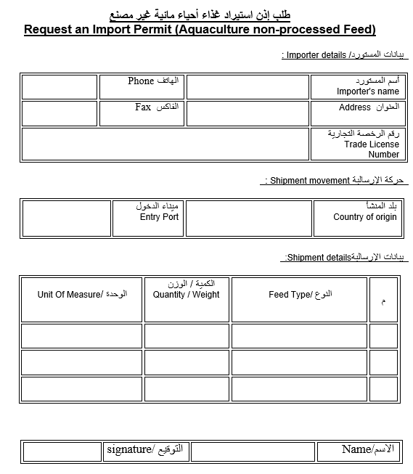

### Issuing an Import Permit for Disinfectants, Veterinary Equipment and Supplies, and Animal Care Supplies

**Service Description**

Through this service, an import permit is obtained to approve the importation of disinfectants and diagnostic equipment, equipment, veterinary equipment and supplies and animal care materials from outside the country, valid for 90 days from the date of issue. This check of the consignment at the port of entry upon arrival to the State and its release shall ensure compliance with the import permit and the necessary technical specifications and specifications

**Steps**

**Import permission**

1. Fill e-form
2. e-payment
3. review the applications and complete procedure electronically
4. issue e-permit

**Release consignment**

1. fill e-form (submit release request)
2. review the applications and complete procedure electronically
3. Visually inspect and lab test samples, complete procedure electronically
4. E-payment fee

**Required Documents**

**To Import:**

No documents required

**To Release:**

1. Import permit
2. Customs declaration
3. Bill of lading
4. purchase invoice
5. Certificate of origin
6. Certificate of analysis (disinfectants only)



### Issuing export permit of animal samples

**Service Description**

Through this service, an export permit is obtained to approve the export of animal samples for laboratory tests outside the country. The permit is valid for 30 days from the date of issue

**Steps**

1. File e-form
2. Check application, review and complete procedures
3. Issue the import permit electronically

**Required documents:**  None

**Issuing Import Permit for Veterinary Products**

**Service Description**

Through this service, an import permit is obtained to approve the importation of veterinary products from outside the country, valid for 90 days from the date of issue. This check of the consignment at the port of entry upon arrival to the State and its release shall ensure compliance with the import permit and the necessary technical specifications and specifications

**Steps**

**Import permission**

1. Fill e-form
2. e-payment
3. issue e-permit

**Release consignment**

1. fill e-form
2. e-payment
3. visually inspect consignment review the applications and complete procedure electronically
4. Pay fee electronically

**Required documents**

**To Import:**

**None**

**To Release:**

1. Import permit
2. Customs declaration
3. Bill of lading
4. purchase invoice
5. Certificate of origin
6. Operating analysis certificate from the manufacturer



### Issuing import permit of animal samples

**Service description**

Through this service an import permit is obtained by approving the importation of animal samples from outside the country, this permission is valid for 30 days from the date of issuance. These samples are inspected at the port of entry and released after confirming their compliance with the conditions and specifications

**Steps**

**Import Permit**

1. Fill e-form
2. Check application and complete procedure electronically
3. Issue import permit

**Release permit**

1. Virtual inspection of consignment
2. Issue release permit

**Required Documents**

**For import permit:**

No objection letter / certificate from the Veterinary Authority in the Exporting country stating that it has no objection to the exit of specimens and their undertaking that these samples have been withdrawn and processed under their supervision

**For release permit:**

No required document



### Issuing Import Permit of Veterinary Raw Materials

**Service Description**

Through this service, an import permit is obtained to approve the importation of veterinary raw material from outside the country, valid for 90 days from the date of issue. This check of the consignment at the port of entry upon arrival to the State and its release shall ensure compliance with the import permit and the necessary technical specifications and specifications

**Steps**

**To Import**

1. File e-form
2. e-pay fee
3. issue import permit

**To release**

1. E-file release request
2. E-pay fee
3. Check documents & virtually inspect consignment
4. Complete procedure electronically

**Required documents**

**To Import:**

None

**To Release:**

1. Import permit
2. Customs declaration
3. Purchase invoice
4. Certificate of origin
5. Certificate of analysis

### Release of Locally Manufactured Fertilizers

**Service Description**

Approval for the circulation of the fertilizers or agricultural soil conditioner manufactured locally after ensuring that they conform to the approved specifications

**Steps**

1. Fill e-form
2. e-payment
3. Review application and complete procedure
4. Issue e-permit

**Required Documents**

1. Certificate of analysis from an accredited laboratory in the country indicating the batch number and the date of production and the results of the analysis

## CITES

### Cancellation of Species Ownership Listed in CITES Appendices

**Service Description**

This service allows the cancellation of the ownership of live animal and plant species and their derivatives that listed in CITES Convention Appendices and delete it from the customer's account for the following cases: The death or destruction of specimen/ Loss or escape of specimen

**Steps**

1. Fill out the e-form
2. Review the application and Complete the process electronically
3. 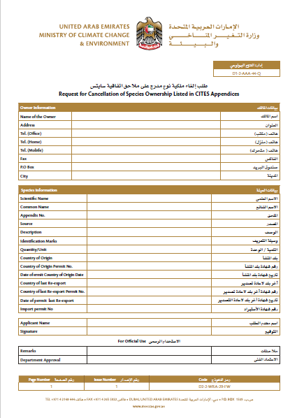Transfer the species or specimen from customer account to another account electronically

### Issue a CITES Export/Re-export Certificate

**Service Description**

This service enables individuals and companies to apply for the Export/Re-export CITES certificate for live animal and plant species and their derivatives that listed in CITES Convention Appendices. The validity of certificate is six months from the date of issuance.

**Steps**

1. Create the application electronically
2. E-payment
3. Review the application and complete the procedures electronically
4. Issuing the electronic certificate

**Documents Required**

**For re-export Species listed in Appendix I**

1. CITES certificate (Import) issued by the country of importation or preliminary approval to receive the species or product to be imported, and the species that bred in captivity are excluded
2. The customer shall comply with the provisions of Law No. 11 of 2002 on the regulation of international trade in endangered species of Fauna and Flora.

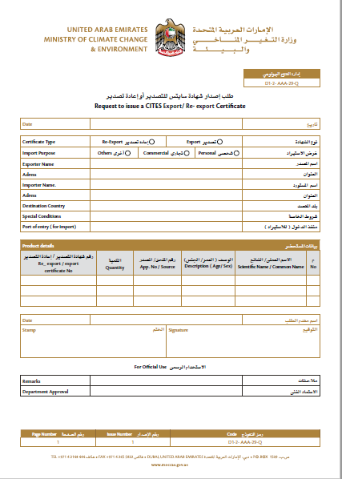

### Issue a CITES Import Certificate

**Service Description**

This service enables individuals and companies to apply for the import certificate for live animal and plant species and their derivatives that listed in CITES convention appendices. The validity of certificate is one year from the date of issuance, then check on the consignment when it arrives in the country at the port of entry and release it after ensuring that it complies with all import requirements

**Steps**

**Issue import cites certificates**

1. Fill out the e-form
2. E-payment
3. Review the application and complete the procedures electronically
4. Issuing the electronic import CITES certificates

**Release the consignment**

1. Fill out the e-form
2. E-payment
3. Review the application and complete the procedures electronically
4. Virtual examination and laboratory testing (if necessary)

**Required Documents**

**Species listed in Appendix I**

1. A preliminary approval letter OR CITES certificate of Export or Re-Export OR letter from a breeding center in the exporting (or origin) country including the identification marks such as Ring number OR microchip number. ) Not mandatory)

**Species listed in Appendix II/III**

1. CITES certificate of Export or Re-Export from the exporting country.
2. In the case of importing plants listed in Appendix II and industrially produced from countries certified by CITES, a copy of the phytosanitary certificate shall be attached indicating that the species is included in the CITES appendix as an alternative certificate for CITES certification.

**Treated Animal Wastes**

1. Certificate of export or re-export of CITES from the exporting country.
2. A certificate stating that the consignment has been treated in one of the ways recommended in the OIE to eliminate pathogens.

**In case of import to participate in exhibitions and circus**

1. No objection certificate from the sponsor or organization.
2. A copy of the export or re-export certificates from the exporting country, indicating the identification mark.
3. Approval from competent authority to organize exhibitions of live animals.

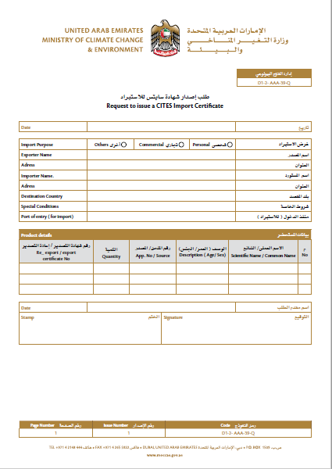

### Issue a Falcon passport in accordance with the Federal Law on CITES

**Service Description**

Through this service, the falcon owner can obtain a falcon passport valid for 3 years from the date of issuance, to use it in travel and hunting trips instead of using CITES certificates.

**Steps**

1. Create the application electronically
2. E-payment
3. Review the application and complete the procedures electronically
4. Issuing the Falcon passport

**Required Douments**

**For the falcon imported from outside UAE**

* A copy of the Falcon import CITES certificate issued by the Ministry or a copy of the export or re-export CITES certificate.

**Issue falcon passport for the falcon breed in the UAE**

* A certificate of captive breeding in UAE, with the identification marks Ring number (mandatory) OR microchip number (optional).

**Registration of unknown falcon or falcons that bred in private farms and houses**

* Attach the competent department approves the request in the Ministry, then shall register the falcon on the electronic system of the Ministry in “Ownership registration of species listed in CITES Appendices” service based on the identification ring numbers that approved.

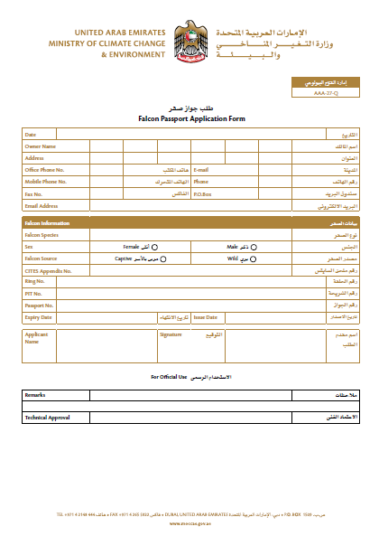

### Issue a to whom it may concern letter in accordance with the federal law on CITES

**Service Description**

Through this service, a certificate will be generated valid for one month from the date of issuance as for the following purposes: The shipment is not under CITES species / The facility is equipped to host the species that listed in CITES Convention Appendices.

1. **Steps**
2. Create the application electronically
3. E-payment
4. Review the application and complete the procedures electronically
5. Visiting the facility if necessary

**Documents Required**

* Request a certificate states that the shipment is not under CITES
* Certificate of origin for the materials for which the certificate required.
* The purchase invoice certified by one of the chambers of commerce in the UAE.

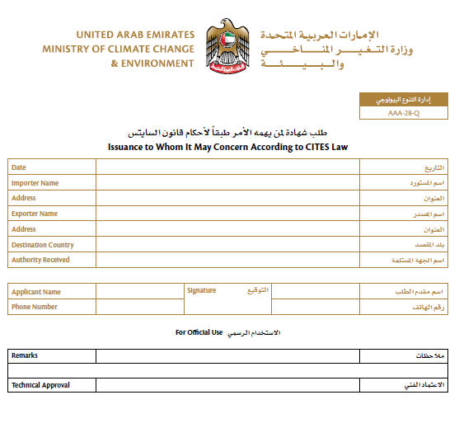

### Ownership Registration of Species Listed in CITES Appendices

**Service Description**

Through this service you can register the live animal and plant species and their derivatives that listed in CITES convention appendices for the species imported or for the species breed in UAE and include it in the customer's account in the electronic system

**Steps**

1. Fill out the e-form
2. Review the application and complete the procedures electronically
3. The spices registered and added to customer account balance electronically

**Documents Required**

**For the species imported from outside of UAE in 2018 for all species:**

One of the following documents or one of them:

* A copy of the species import certificate from the UAE, including the appropriate identification marks. Or A copy of the export / re-export certificate from the exporting country, including the appropriate identification marks.

**For the all species breed in UAE but didn’t registered in the electronic system:**

* A certificate of captive breeding in UAE, including the identification marks for each species.

**For the Falcons species bred in UAE for the following cases (individuals, unknown falcons, falcons breed in private farms and house) and also all species with no documents:**

* Attach the competent department approvals

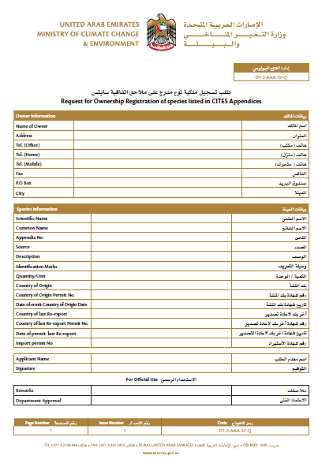

### Request for Falcon Identification Rings

**Service Description** Through this service, the identification rings will be given for falcons that bred in the UAE by the individuals and in breeding center licensed by the Ministry

**Steps:**

1. Create the application electronically
2. Review the application and complete the procedures
3. Deliver the identification rings

**Documents Required**

**For individuals:**

*Registration of unknown falcon or falcons that bred in private farms and houses:*

* Approval of the competent department.

**For breeding centers**

* No documents required

**For Business sector (Breeding center)**

* The Breeding center must have a valid activity license from the Ministry

**Individuals**

* The client must have an account on the Ministry’s electronic system.
* Allows the registration of (3) pairs of falcons per person during the year

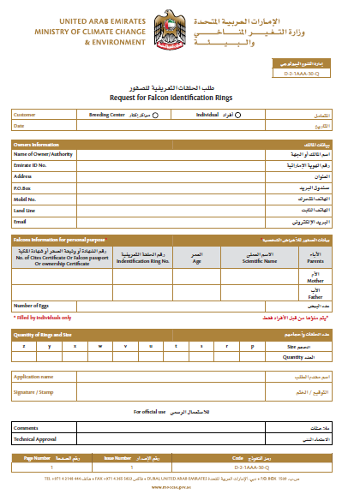

### Transfer Species Ownership Listed in CITES Appendices

**Service Description**

Through this service, you can transfer the ownership of live animal and plant species and their derivatives that listed in CITES Convention Appendices from a customer to another via the electronic system

**Steps**

1. Fill out the E-form
2. Review the application and complete the procedures electronically
3. Transfer the spices or specimen from customer account to another account electronically

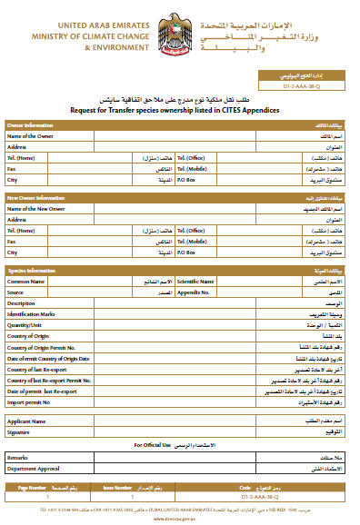**Required Documents:** None

## CERTIFICATES

### Approved of Phermions, Attracting materials, Extruding materials, Additives and Materials with mechanical or physical in pest control

**Service Description**

Through this service, Phermions, attractants, nuisances, additives and materials with mechanical or physical effect (not contains pesticides) are adopted in the pest control will be Approved for the purpose of importing and trading within U.A.E. These materials are certified once time for the same product and for the same company.

**Steps**

1. Apply the request
2. Pay the fees
3. Review the application and complete the procedures
4. Approval of the product and issue a certification

**Documents Required**

1. Authorization letter from the producing company stating no objection to trade the product in UAE
2. Certificate of composition of the material including active substances and their percentages of other inert substances from a governmental laboratory or from a laboratory accredited by Good Laboratory Standards (GLP).
3. A technical datasheet issued by the producing company showing the composition of the material, its specifications, the method of uses and the pests.



### Issuance of Good Manufacturing Certificate GMP

**Service Description**

Through this service, it is approved to issue a certificate of compliance of local veterinary products factories with good manufacturing rules

**Steps**

1. Submit the application
2. Pay the prescribed financial fee
3. Inspection visit
4. Pay the prescribed financial fee
5. Issuing the certificate

**Required Documents**

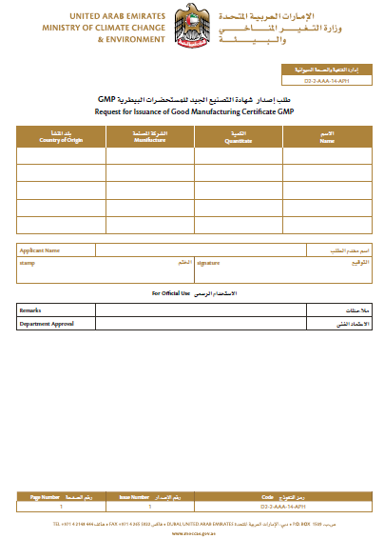None

### Issue a license to practice the profession of agricultural engineer and occupations related to agricultural activities

**Service Description**

Through this service, an electronic license for practicing the profession of engineer is valid for a period of one year, starting from the date of issuance

**Steps**

Fill out the E-form

1. E-payment
2. Review the application and complete the procedures electronically
3. Issuing the license electronically

**Documents Required**

1. A certificate of experience for non-citizens duly legalized
2. Personal image (jpg, png)
3. A copy of the scientific certificates
4. Copy of valid ID card
5. Copy of the passport on which the residence is fixed (for non-citizens)
6. A copy of the equivalence of scientific certificates from the Ministry of Education in the UAE
7. Valid identity card

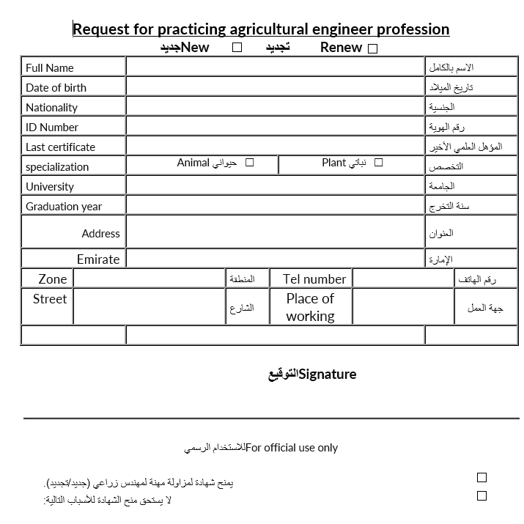

### Issue a Registration Certificate for a Fertilizer or a Soil Conditioner

**Service Description**

Through this service, customers get the approval for registering a fertilizer or a soil conditioner in which a registration certificate to be issued by the ministry for a period of five years from the date of issuance for the purpose of importing it or producing it locally and trading it in the markets.

**Steps**

1. Fill out the E-form
2. E-payment
3. Review the application and complete the procedures electronically
4. Issuing the certificate electronically

Documents Required

**For imported fertilizers:**

1. A certificate of registration or a letter of circulation (allowed to be used) issued by the country fertilizers competent (representative) authority. And in case that it is not required to be registered in the country of origin, then a letter stating that it is allowed to be used /or circulated issued by the competent (representative) authority of one of the OECD countries to be attached.
2. A certificate of analysis for the fertilizer/soil conditioner from a government lab or a lab accredited by the competent authority in the country of origin or from a lab accredited according to the ISO / IEC 17025: 2005.
3. A certificate from the manufacturer, or exporter proven the product safely on humans, animals, plants, the environment and soil.
4. A copy of the product original label (country of origin) in English and to be translated into Arabic (legalized)
5. The product technical data sheet/ Material Safety Data Sheet (MSDS)
6. The product proposed local label in Arabic and English
7. An authorization letter issued by the producing company to the local company to sell/circulate the product within the UAE

**For locally produced fertilizers:**

1. A certificate of analysis for the fertilizer/soil conditioner from the ministry labs or a lab recognized by the ministry in the UAE (local)"
2. A certificate from the manufacturer proven the product safely on humans, animals, plants, the environment and soil.
3. The product technical data sheet/ Material Safety Data Sheet (MSDS)
4. The product proposed local label in Arabic and English

**To register a fertilizer/soil conditioner as an organic farming input:**

In addition to the documents mentioned above, the following documents/conditions are required

1. A valid certificate issued by the Emirates Authority for Standardization and Metrology, or from a certifying body applying the (European or US or Japan) organic production standards, stating that the product is authorized for use in organic production
2. 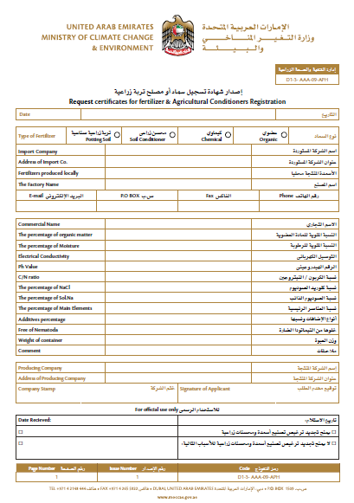A letter / declaration issued by the producing company stating that the products does not contain any GMOs and was not produced from any GMOs derived products

Issue a Veterinary Health Certificate for Exporting Equine Semen

### Request for a Veterinary Health Certificate for Exporting Equine Semen

**Service Description**

Through this service, a veterinary health certificate is obtained to export the semen of horses out of the country, valid for 10 days, starting from the date of issuance.

**Steps**

1. Fill out the E-form
2. E-payment
3. Visual Inspection
4. Issuing the electronic health certificate

**Documents Required**

* Certificate of analysis from an accredited laboratory analysis for the animals & semen
  + Equine Infectious Anemia
  + Equine Viral Arteritis
  + Contagious Endometritis
  + Any other test required by the exporting country

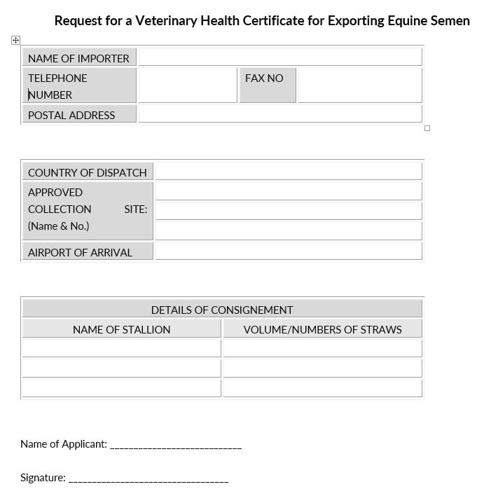

### Issue a Veterinary Health Certificate for Exporting or Re-Exporting Animal and Fish Products or byproducts and Manufactured Feed

**Service Description**

Through this service, a health certificate is obtained for exporting or re-exporting animal and fish products or byproducts and manufactured feed out of the country, valid for 30 days from the date of issuance

**Steps**

1. Fill out the E-form
2. E-payment
3. Physical examination and laboratory tests( if required)
4. Issuing the electronic health Certificate

**Required Documents**

1. Certificate of origin for shipment
2. A copy of a laboratory analysis certificate from a government or accredited laboratory (if necessary)
3. Purchase invoice and packing list

In addition to the above documents, it is necessary to submit documents for some of the shipment according to the following:

1. For consignments of animal and fish products or residues that fall under the CITES Agreement, the CITES Certificate shall be attached to the UAE as well as another certificate from the exporting country
2. For the consignment of aquatic products: the permit for export or re-export
3. For consignment of meat products: A copy of the health certificate issued by the government slaughterhouse where slaughter was carried out inside the country
4. For product consignment: Certificate of export validity of the product issued by the relevant local authority
5. Any documents required by the importing country

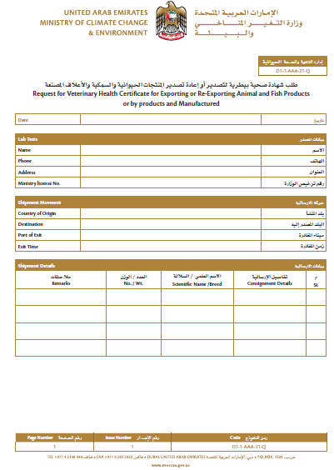

### Issue a Veterinary Health Certificate for Exporting or Re-Exporting Horses

**Service Description**

Through this service, a veterinary health certificate for horses is obtained after examining them for the purpose of exporting or re-exporting them outside the country, valid for a period of 10 days from the date of issuance.

**Steps**

1. Submit the application
2. Payment of fees
3. The visual examination and ensuring that the export conditions are met
4. Issuing the health certificate

**Required Documents**

1. A copy of the owner's passport / ID
2. Copy of the passport of the horse
3. Reports of laboratory tests required from the importing country
4. Documentation of vaccination given to horses or mention of vaccinations in the health certificate
5. Import permit from the exporting country

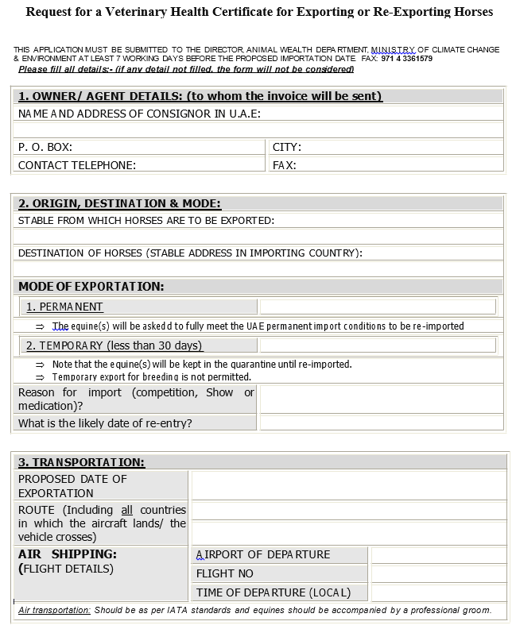

1. 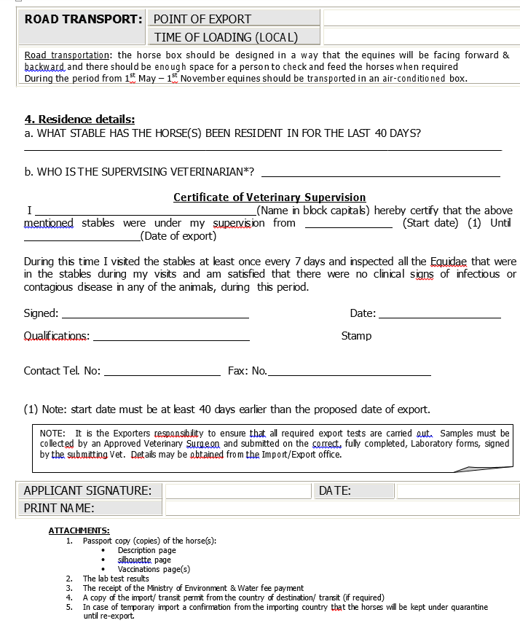

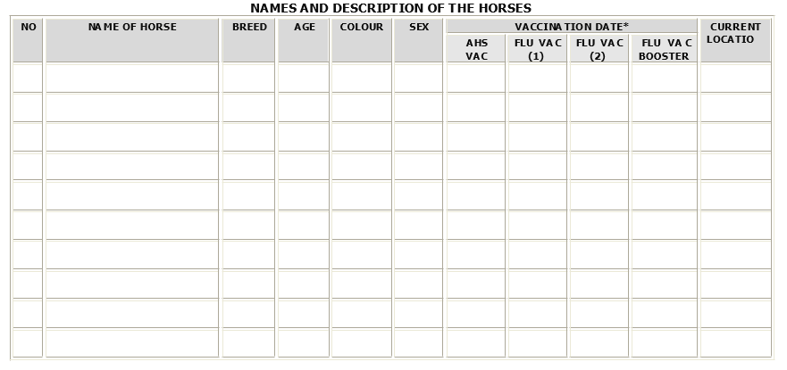

### Issue a Veterinary Health Certificate for Exporting or Re-Exporting Live Animals

**Service Description**

Through this service, a veterinary health certificate for live animals is obtained after examining them for the purpose of exporting or re-exporting them outside the country, valid for 30 days from the date of issuance

**Steps**

1. Fill out the E-form
2. E-payment
3. Physical Examination and laboratory tests
4. Issuing the electronic health Certificate

**Required Documents**

1. A certificate of origin for the consignment, excluding the following consignments unless they are required from the importing country:
   * Animals of Gulf origin exported to the GCC countries
   * Dogs & Cats
   * Falcons
2. Copy of the import / approval permission issued by the importing country, except for companion animals
3. Any documents / reports for additional tests requested by the importing country

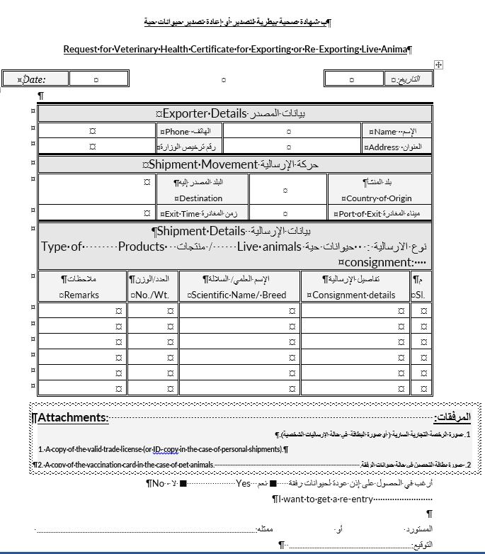

### Issue an Phytosanitary Certificate for Export or Re-Export

**Service Description**

A phytosanitary certificate is obtained for the export or re-export of plants or plant products outside the country (valid for two weeks from the date of issue)

**Steps**

1. Fill out the E-form
2. E-payment
3. Visual inspection and laboratory tests (if required)
4. Issuing the certificate electronically

**Required Documents**

1. Origin Certificate
2. Invoice and table of contents
3. Any other documents/certificates required by the importing country

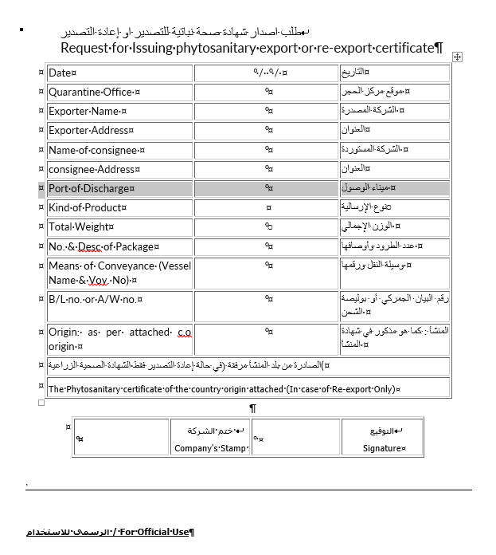

### Issue certificate of heat treatment facility approval

**Service Description**

Accreditation of Heat Treatment Facility used for packing and carrying goods (wooden pallets, wooden boxes, wooden frames, wooden shelves) according to the permitted treatment methods in the country (valid for one year from the date of issue))

**Steps**

1. Fill out the E-form
2. E-payment
3. Review the application and complete procedures electronically
4. Inspection visit

**Required Documents**

* Copy of valid commercial, industrial or craft license

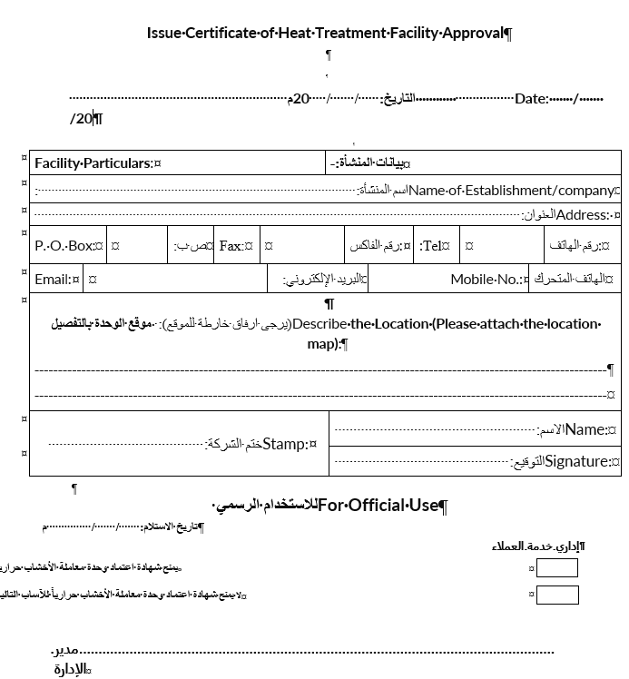

### Issue license to re-export aquatic organisms

**Service Description**

Through this service, a license to re-export imported aquatic organisms is issued. Aquatic organisms include (fresh/frozen/smoked/dried/salted) fish, as well as crustaceans and molluscs. (License valid for 1 year from the issuance date)

**Steps**

1. Fill out E- forms
2. Electronic payment of service fee
3. Review the application and complete the procedures electronically
4. Issue the license electronically

**Required Documents**

* Copy of a valid trade license
* Declaration or a certificate issued from the competent authority declaring that the applicant has the necessary means to store, preserve, and transport aquatic organisms which meet the health requirements determined by the competent authority in the concerned emirate.

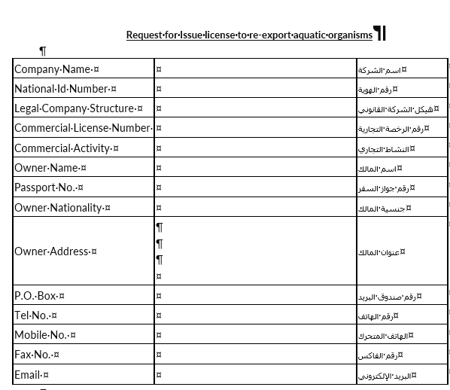

### Issue Pesticide Registration Certificate

**Service Description**

Through this service, a pesticide will be registered by the Ministry (valid for five years or until the expiry date of the registration certificate in the country of origin). Including Fermions, Attracting materials, Extruding materials, Additives and Materials with mechanical or physical contain a pesticide.

**Steps**

1. Fill out E- forms
2. Electronic payment of service fee
3. Laboratory examination is held
4. Certificate is issued and handed over to the customer

**Required Documents**

**First, Chemical Pesticide Registration**

Registered pesticide in the country of origin:

1. Certificate of registration of the pesticide in the country of origin issued by the registration authority in English or translated into English (legal translation).
2. Other registration certificate for the pesticide in a country other than the country of origin of the same plant issued by the registration authority in an Organization for Economic Cooperation and Development (OECD) member country in English or translated into English. This certificate may be dispensed upon the decision of the Scientific Committee for Pesticides after studying the feasibility of using these pesticides on economic pests in the UAE.
3. Certificate of the pesticide composition, including active substances, their percentages and percentages of other inert substances from a governmental laboratory registered by the registrar authority or from a laboratory accredited by the Registrar authority, shall apply the Good Laboratory Practice (GLP) standards. If the trade name of the pesticide is not the same in the registration certificates of one of the Organization for Economic Cooperation and Development (OECD) member countries, a further certificate for this pesticide shall be attached, including the active substances and their percentages and percentages of other inert substances from a governmental laboratory of the registration authority or from a certified laboratory by registration authority and applying the Good Laboratory Practice (GLP) Standards.
4. Letter of authorization of the establishment from the producing company in the registration and marketing of the pesticide in the UAE.
5. A copy of the pesticide labels for the registration certificates provided in English (or translated into English legal translation) and a copy translated into Arabic
6. A copy of the proposed local pesticide package label in all the data in Arabic and English, according to the data provided in item (5) above.

**Unregistered pesticide in the country of origin:**

1. Two registration certificate for the same pesticide from two of the Organization for Economic Cooperation and Development (OECD) member countries, both issued by the registration authority in English or translated into English (legal translation).
2. Certificate of the pesticide composition, including active substances, their percentages and percentages of other inert substances from a governmental laboratory registered by the registrar authority or from a laboratory accredited by the Registrar authority, shall apply the GLP standards. If the trade name of the pesticide is not the same in the registration certificates of one of the Organization for Economic Cooperation and Development (OECD) member countries, a further certificate for this pesticide shall be attached, including the active substances and their percentages and percentages of other inert substances from a governmental laboratory of the registration authority or from a certified laboratory by registration authority and applying the Good Laboratory Standards (GLP).
3. Letter of authorization of the establishment from the producing company in the registration and marketing of the pesticide in the UAE.
4. A copy of the pesticide labels for the registration certificates provided in English (or translated into English legal translation) and a copy translated into Arabic.
5. A copy of the proposed local pesticide package label in all the data in Arabic and English, according to the data provided in item (4) above.

**Second, Registration of biocides:**

1. Certificate of registration of the pesticide from the country of origin in a member country of the Organization for Economic Co-operation and Development (OECD) issued by the registrar or the authorized authority in English or translated into English (legal translation).
2. Certificate of the pesticide composition, including active substances, their percentages and percentages of other inert substances from a governmental laboratory registered by the registrar authority or from a laboratory accredited by the Registrar authority, shall apply the Good Laboratory Practice (GLP) standards.
3. Letter of authorization of the establishment of the company produced in the country of origin by adoption in the registration and marketing of the pesticide in the State.
4. A copy of the pesticide labels for the registration certificates provided in English (or translated into English legal translation) and a copy translated into Arabic
5. A copy of the proposed local pesticide package label in all the data in Arabic and English, according to the data provided in item (4) above.

**Third, Registration of organic pesticides:**

1. Valid organic product certificate issued by a certification body adopting European, American or Japanese organic production standards stating that the pesticide is licensed for use in organic production.
2. A certificate from the producing company stating that the pesticide has not entered into the synthesis of any genetically modified substances and did not use any materials resulting from genetically modified organisms during its production process.
3. Certificate of the pesticide composition, including active substances, their percentages and percentages of other inert substances from a governmental laboratory registered by the registrar authority or from a laboratory accredited by the Registrar authority, shall apply the Good Laboratory Practice (GLP) standards.
4. Letter of authorization of the establishment of the company produced in the country of origin by adoption in the registration and marketing of the pesticide in the State.
5. A copy of the pesticide labels for the registration certificates provided in English (or translated into English legal translation) and a copy translated into Arabic
6. A copy of the proposed local pesticide package label in all the data in Arabic and English, according to the data provided in item (5) above.

**Fourth, Registration of pesticides ready to use:**

Pesticides Manufactured in one of a Member State of the Organization for Economic Cooperation and Development (OECD):

1. Certificate of registration of the pesticide from the country of origin issued by the registration authority in English or translated into English (legal translation).
2. Certificate of the pesticide composition, including active substances, their percentages and percentages of other inert substances from a governmental laboratory registered by the registrar authority or from a laboratory accredited by the Registrar authority, shall apply the Good Laboratory Practice (GLP) standards.
3. Material Safety Data Sheet (MSDS) of pesticides.
4. A copy of the pesticide labels for the registration certificates provided in English (or translated into English legal translation) and a copy translated into Arabic
5. A copy of the proposed local pesticide package label in all the data in Arabic and English, according to the data provided in item (4) above.
6. Letter of authorization of the establishment of the company produced in the country of origin by adoption in the registration and marketing of the pesticide in the State.

**Pesticides filled with factories authorized by a factory registered in the Organization for Economic Cooperation and Development (OECD) Member States:**

1. Certificate of registration of the pesticide from the country of origin issued by the registration authority in English or translated into English (legal translation).
2. Certificate of the pesticide composition, including active substances, their percentages and percentages of other inert substances from a governmental laboratory registered by the registrar authority or from a laboratory accredited by the Registrar authority, shall apply the Good Laboratory Practice (GLP) standards.
3. Material Safety Data Sheet (MSDS) of pesticides.
4. A copy of the pesticide labels for the registration certificates provided in English (or translated into English legal translation) and a copy translated into Arabic
5. A copy of the proposed local pesticide package label in all the data in Arabic and English, according to the data provided in item (4) above.
6. Two Letter of authorization from the producer company in one of the member countries of the Organization for Economic Cooperation and Development (OECD):
   1. The establishment of the registration and marketing of the pesticide.
   2. The plant with the authorization to fill the pesticide.

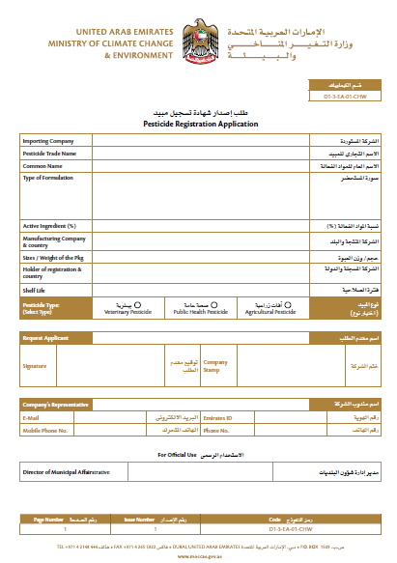

### Issue Registration Certificate of Veterinary Product Companies

**Service Description**

Through this service, the registration of foreign manufacturers of veterinary products is approved through a veterinary warehouse licensed by the Ministry in order to allow the registration, import and circulation of its products in the country.

**Steps**

1. Submit the application
2. Pay the prescribed financial fee for the application
3. Study and review the documents
4. Pay the prescribed financial fee for the registration

**Required Documents**

1. Provide a file that includes the following basic information:
2. Type and activity of the company.
3. Number of factories owned by the company and its addresses.
4. The company's relationship with each of these factories and the extent of their legal, technical and commercial responsibility.
5. A duly authorized power of attorney from the factory stating that the Agency has been granted to the authorized agent in the United Arab Emirates.
6. Certificate of registration of the company in the country of origin in force. Date of establishment duly certified. It is clear that the veterinary products produced by the company are authorized to sell freely in the country of origin.
7. A valid certified certificate issued by the relevant authorities in the country of the establishment confirming its commitment to the good practice of GMP including proof of the periodic inspection by the competent authorities. Certificate from the competent authorities of the country of origin (duly certified) that the company follows the principles of good practice for the manufacture of veterinary preparations.
8. A certified list of the company with the names of the countries registered with it, accompanied by copies of registration certificates (manufacture side should be registration in 2 reference country : ( UNITED STATES, CANADA, AUSTRALIA, JAPAN, EUROPEAN MEDICINES (BELGIUM, DENMARK, GERMANY, SPAIN, FRANCE, IRELAND, ITALY, LITHUANIA, HUNGARY, NETHERLANDS, AUSTRIA, ROMANIA, FINLAND, SWEDEN, SWITZERLAND, NEW ZEALAND, CYPRUS, CZECH REPUBLIC, ESTONIA, FINLAND, GERMANY, GREECE, LATVIA, LUXEMBOURG, MALTA, POLAND, PORTUGAL, SLOVAKIA AND SLOVENIA) SAUDI ARABIA, SOUTH AFRICA, KOREA)
9. A list of the preparations produced by the factory.
10. Description of the company's research and development activities.
11. Provide a Site Master File.

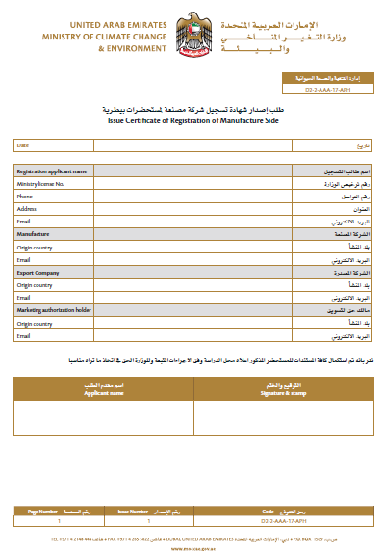

### Issuing a Free Sale Certificate for a Veterinary Product

**Service Description**

Through this service, obtained certificate stating that the veterinary product is sold freely in the country

**Steps**

1. Submit the application
2. Pay the prescribed financial fee for the application
3. Carry out an inspection visit
4. Issuing the certificate

**Required Documents**

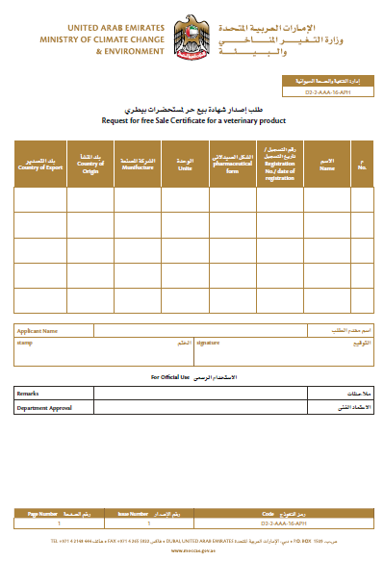None

### Issuing Registration Certificate of Veterinary Products

**Service Description**

Through this service, approved the registration of veterinary products through a licensed warehouse to allow its importation and circulation within the country after auditing the documents required by the Veterinary Products Registration Committee to ensure compliance with the terms and conditions through this service, obtained certificate stating that the veterinary product is sold freely in the country

**Steps**

1. Submit the application
2. Pay the prescribed financial fee for the application
3. Study and review the documents
4. Pay the prescribed financial fee for registration

**Required Documents**

1. Certificate of CPP or valid free sale certificate in the country of origin issued by the responsible and duly authorized authorities, stating the following:

* Name and address of the manufacturer.
* Number and date of registration of the veterinary product in the country of origin.
* Details of the veterinary product indicating that the drug or product to be registered in the UAE is identical to the name, composition and specifications of the marketed product in the country of origin.

1. If the trade name of the product to be registered is different from its trade name in the country of origin, it should be mentioned with reasons, provided that the certificate includes both names and that the composition and other specifications of the two names are identical.
2. Active and non-effective materials with their quantities.
3. The date of commencement of marketing in the country of origin.
4. The shelf life of the medicine and storage conditions.
5. Withdrawal period if available
6. Label / insert leaflet of the product in Arabic or English, should mention in the label for veterinary use only.
7. Certificate of analysis and specifications of the preparation of the manufacturer.
8. Certificate of analysis from the accredited authority in the United Arab Emirates (Ministry of Health & Prevention), & the products used for horses need to submit extra sample for Central Veterinary Research Laboratory (CVRL) test
9. Certificate duly certified showing the prices of the preparation as follows:

* Factory price in country of origin.
* Wholesale price in the country of origin.
* Selling price to the public in the country of origin.
* CIF prices continued to UAE ports
* Stability studies.
* Specifications of raw materials
* Manufacturing process and control during manufacturing.
* Method of analysis.
* Specifications of the final product.
* Specifications of packing materials.
* Studying bioequivalence (where required) in case the product is of similar species.
* Safety study and efficiency study in the case of veterinary vaccines

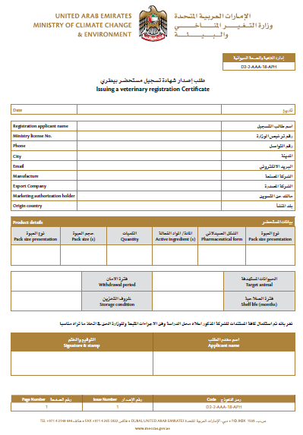

### Renew license to re-export aquatic organisms

**Service Description**

Through this service, a license to re-export imported aquatic organisms is renewed. Aquatic organisms include (fresh/frozen/smoked/dried/salted) fish, as well as crustaceans and mollusks. (License valid for one year from the previous license’s expiry date)

**Steps**

1. Fill out the E form
2. Electronic payment of fees
3. Review application and complete the procedures electronically
4. Issue the license electronically

**Required Documents**

* Declaration or a certificate issued from the competent authority declaring that the applicant has the necessary means to store, preserve, and transport aquatic organisms which meet the health requirements determined by the competent authority in the concerned emirate

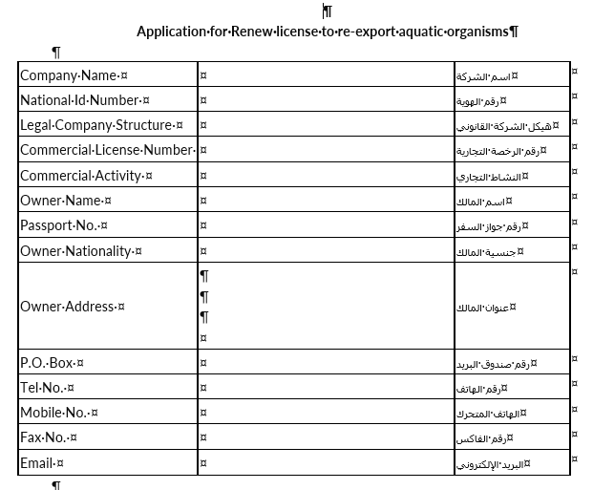

### Renewal registration certificate of veterinary product

**Service Description**

Through this service, approved the renewal of registration the veterinary products through a licensed warehouse to allow its importation and circulation within the country after auditing the documents required by the Veterinary Products Registration Committee to ensure compliance with the terms and conditions through this service, a license to re-export imported aquatic organisms is renewed. Aquatic organisms include (fresh/frozen/smoked/dried/salted) fish, as well as crustaceans and mollusks. (License valid for one year from the previous license’s expiry date)

**Steps**

1. Submit the application
2. Pay the prescribed financial fee for the application
3. Study and review the documents
4. Pay the prescribed financial fee for registration

**Required Documents**

1. Certificate of CPP or valid free sale certificate in the country of origin issued by the responsible and duly authorized authorities, stating the following:

* Name and address of the manufacturer
* Number and date of registration of the veterinary product in the country of origin.
* Details of the veterinary product indicating that the drug or product to be registered in the UAE is identical to the name, composition and specifications of the marketed product in the country of origin.
* If the trade name of the product to be registered is different from its trade name in the country of origin, it should be mentioned with reasons, provided that the certificate includes both names and that the composition and other specifications of the two names are identical.
* Active and non-effective materials with their quantities.
* The shelf life of the medicine and storage conditions.
* Withdrawal period if available
* Label of the product in Arabic or English.

1. Certificate duly certified showing the prices of the preparation as follows:

* Factory price in country of origin.
* Wholesale price in the country of origin.
* Selling price to the public in the country of origin.
* CIF prices continued to UAE ports

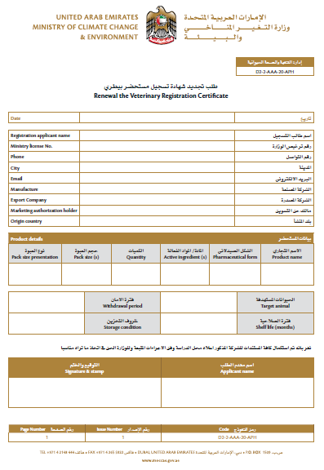

### Renewal a license to practice the profession of agricultural engineer and occupations related to agricultural activities

**Service Description**

Through this service, an agricultural engineer’s license, valid for a year, is renewed

**Steps**

1. Fill out the E-forms
2. E-payment
3. Issuing the electronic license

**Required Documents**

* Personal photo (jpg,png )
* Copy of the valid ID card (in case the previous identity card expires)
* Copy of passport with valid residence(for non-citizens -in case of expiry of previous residence)

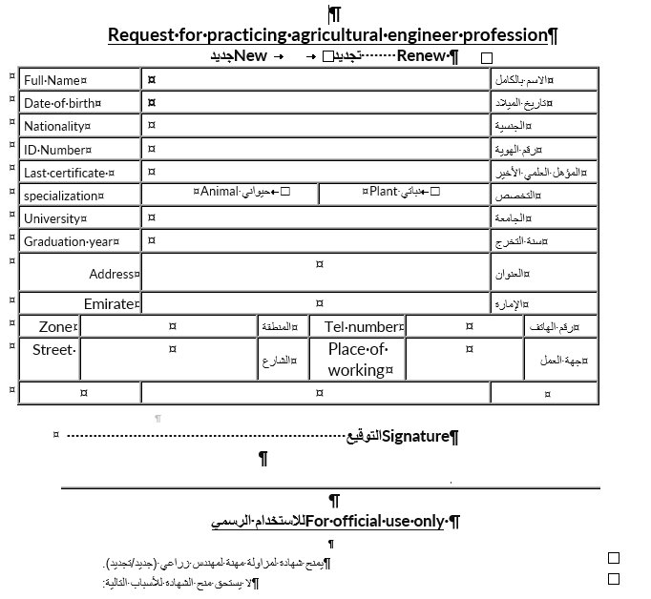

### Renewal of Good Manufacturing Certificate GMP

**Service Description**

Through this service, it is approved to renewal the certificate of compliance of local veterinary factories with good manufacturing rules

**Steps**

1. Submit the application
2. Pay the prescribed the financial fee
3. Inspection visit
4. Pay the prescribed the financial fee

**Required Documents**

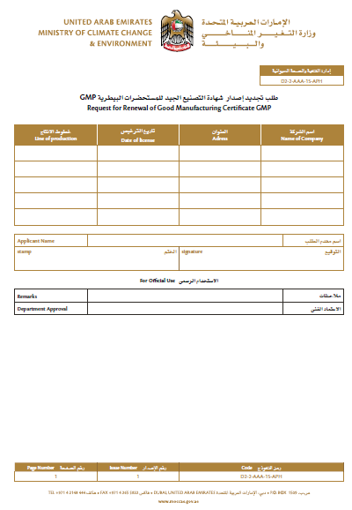None

### Renewal Registration Certificate of Veterinary Product Companies

**Service Description**

Through this service, the registration of foreign manufacturers of veterinary products is approved to renewal through a veterinary warehouse licensed by the Ministry in order to allow the registration, import and circulation of its products in the country.

**Steps**

1. Submit the application
2. Pay the prescribed the financial fee for the application
3. Study and review the documents
4. Pay the prescribed the financial fee for registration

**Required Documents**

1. A duly authorized power of attorney from the factory stating that the Agency has been granted to the authorized agent in the United Arab Emirates.
2. Certificate of registration of the company in the country of origin in force. Date of establishment duly certified. It is clear that the veterinary products produced by the company are authorized to sell freely in the country of origin.
3. A valid certified certificate issued by the relevant authorities in the country of the establishment confirming its commitment to the good practice of GMP including proof of the periodic inspection by the competent authorities. Certificate from the competent authorities of the country of origin (duly certified) that the company follows the principles of good practice for the manufacture of veterinary preparations.

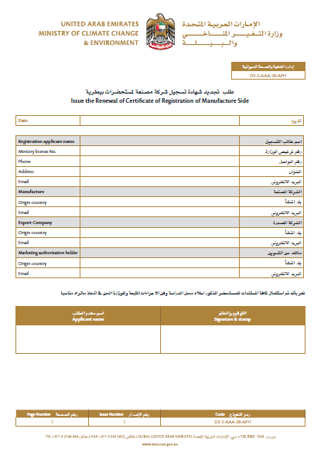

## Web App Features

|  |
| --- |
| **Development (Effort estimated for shaded region)** |
| Application basic setup |
| **Website** |
| **LICENSING** |
| Renew / New Fishing Boat License |
| New / renew Accreditation of food establishment to export outside UAE - New |
| Add or Replace Fishing Boat's Engine |
| Agricultural Extension Request |
| Change Fishing Method |
| Issuance / Renew of Aquaculture Farm Establishment License |
| Issue / renew a License for Manufacturing a Fertilizer/Soil Conditioner |
| Issue / renew a license of practicing animal activity |
| Issue / renew a Plant Nursery License |
| Issue / renew a Veterinary Establishment License |
| Issue / renew an Agricultural Activity License |
| Issue / renew an Export License (Local Aquatic Organisms’ Products) |
| Issue an Import Permit of Agricultural Consignment |
| Issue Renew Import License (Broodstock and Larvae/ Fishing Tools and Equipment) |
| Issue / renewal / preliminary approval license for animal production farm |
| Issue / renew / temp license for practicing the profession for veterinarians and assisting veterinary professions |
| Modification or Cancellation of Basic Data of Agricultural Holdings |
| Primary approval on licensing a veterinary facility |
| Registration of agricultural holdings |
| Issue / Renew Vice-Captain's Card |
| Replacement of Fishing Boat |
| Request Subsidies for Farmers |
| Request Subsidies for Fishermen’s |
| Sale of Fishing Boat's Body |
| New / renew Slaughterhouse Accreditation Outside UAE |
| Transfer Fishing Boat Ownership (including heirs) |
| Veterinary Extension Request |
| **PERMITS** |
| Adopting Veterinary Raw Materials for Importation |
| Apply for Release Permit (Fishing Tools and Equipment) |
| Approve Disinfectants, Veterinary Equipment and Supplies, and Animal Care Supplies for Distribution |
| Issue Import permit for Semen or Embryos |
| Issue of Re-export of Vegetable Feed Permission |
| Issue a Permanent or Temporary Horse import permit |
| Issue a Permit to Import Ozone Depleting Substances (ODS) |
| Issue a Permit to Import Pesticides |
| Issue a permit to re-export ozone depleting substances (ODS) |
| Issue a Re-Export Permit (Aquatic Organisms Products) |
| Issue an agricultural consignment release |
| Issue an Export Permit (Local Aquatic Organisms’ Products) |
| Issue an Export Permit of Hazardous Waste |
| Issue an Import Permit (Broodstock or Larvae) |
| Issue an Import Permit (Fishing Tools and Equipment) |
| Issue an Import Permit for Animal Products or By-Products |
| Issue an Import Permit for Feed and Processed Animal Feed |
| Issue an Import permit for live animals, Birds and Ornamental fish |
| Issue an Import Permit for Pets - Cats or Dogs |
| Issue an Import Permit of Fertilizers or Soil Conditioners (Restricted) |
| Issue an Import Permit of Fertilizers or Soil Conditioners (Unrestricted) |
| Issue an Import permit of Pheromones, Attracting materials, Extruding materials, Additives and Materials with mechanical or physical in pest control |
| Issue import permit for non-manufactured feed for aquatic organisms |
| Issue an Import Permit for Disinfectants, Veterinary Equipment and Supplies, and Animal Care Supplies |
| Issue export permit of animal samples |
| Issue Import Permit for Veterinary Products |
| Issue import permit of animal samples |
| Issue Import Permit of Veterinary Raw Materials |
| Release of Locally Manufactured Fertilizers |
| **CITES** |
| Cancellation of Species Ownership Listed in CITES Appendices |
| Issue a CITES Export/Re-export Certificate |
| Issue a CITES Import Certificate |
| Issue a Falcon passport in accordance with the Federal Law on CITES |
| Issue a to whom it may concern letter in accordance with the federal law on CITES |
| Ownership Registration of Species Listed in CITES Appendices |
| Request for Falcon Identification Rings |
| Transfer Species Ownership Listed in CITES Appendices |
| **CERTIFICATES** |
| Approved of Pheromones, Attracting materials, Extruding materials, Additives and Materials with mechanical or physical in pest control |
| Issue / renewal of Good Manufacturing Certificate GMP |
| Issue / renew license to practice the profession of agricultural engineer and occupations related to agricultural activities |
| Issue a Registration Certificate for a Fertilizer or a Soil Conditioner |
| Issue a Veterinary Health Certificate for Exporting Equine Semen |
| Issue a Veterinary Health Certificate for Exporting or Re-Exporting Animal and Fish Products or byproducts and Manufactured Feed |
| Issue a Veterinary Health Certificate for Exporting or Re-Exporting Horses |
| Issue a Veterinary Health Certificate for Exporting or Re-Exporting Live Animals |
| Issue an Phytosanitary Certificate for Export or Re-Export |
| Issue Certificate of Heat Treatment Facility Approval |
| Issue / renew license to re-export aquatic organisms |
| Issue Pesticide Registration Certificate |
| Issue / Renew Registration Certificate of Veterinary Product Companies |
| Issuing a Free Sale Certificate for a Veterinary Product |
| Issue / renew Registration Certificate of Veterinary Products |
| **External Integrations** |
| Dubai Economic Department |
| Sharjah Economic Department |
| Abu-Dhabi economic development |
| Ministry of Human Resources and Emiratization (Veterinarian License) |
| Ministry of Human Resources and Emiratization (Agricultural Engineer License) |
| MOCCAE smart inspection internal application regarding inspection step |
| MOF e-DHS payment getaway to allow the user to pay service fees/charges |
| Critical Infrastructure and Coastal Protection Authority for Fisher services for NOC letter |
| Mail / Exchange Server for sending SMS & email as template to the customers /staff based on configuration in the new digital services |
| Emirates ID as currently this integration is available for current eservices |
| Integration with current eservice regarding user profiles & logged users (SSO) and information/views required for other existing services like import requests, etc. |
| MOCCAE GIS integration related to location (store and display the map) |
| Payment gateway integration |
| Chat bot integration |
| **System Features** |
| Multi level approval service (workflow engine) |
| CMS for managing Site logo and foreign languages (Arabic & Urdu), Service name changes, events, news |
| Multi lingual website (Arabic, Urdu & English) |
| License Auto-renewal process ( Send renewal notification to customers) |
| License Auto-renewal management service |
| SLA management service (Escalations via dashboard and emails) |
| Customer Dashboard with SLA, Status, Notification messages, action items |
| Dashboard Admin with escalations, service status, SLA , advanced search, sorting, pagination etc. |
| Dashboard Employee with escalations, service status, SLA , advanced search, recent requests etc. |
| Advanced search |
| Federated Login (Emirates ID integration) |
| Multi factor authentication |
| Unified User Experience ( Avoid already saved and redundant information) |
| Pagination service |
| Wizard based service pages with attachments (includes License New / renewal / cancellation / save as draft / QR Codes / payment voucher) |
| Google Captcha |
| Customer management |
| Employee management |
| Audit Trail |
| Reports |
| Data migration |
| User registration / login/ forgot password / remember password / email verification |
| API Integration for mobile App |
| Rate the service, Feed back |
| Events and News (CMS) |
| FAQ |
| **Security** |
| Protection against injection attacks (SQL, CRLF) |
| URL encoding, Input validation |
| Cookie Encryption, Cookie replay attacks |
| Session hijacking prevention |
| Cross site scripting and session management |
| **Technology Stack Integration** |
| REDIS |
| Minio |
| Identity server |
| ELK stack |
| Tableau |
| **Other** |
| Train the trainer |
| End User training |

## Mobile App Features (Developed using Flutter)

|  |
| --- |
| **Development ( Effort estimated highlighted rows)** |
| Application basic setup |
| **LICENSING** |
| New / Renew Fishing Boat License |
| Accreditation / renew of food establishment to export outside UAE - New |
| Add or Replace Fishing Boat's Engine |
| Agricultural Extension Request |
| Change Fishing Method |
| Issue / renew of Aquaculture Farm Establishment License |
| Issue / renew a License for Manufacturing a Fertilizer/Soil Conditioner |
| Issue / renew a license of practicing animal activity |
| Issue / renew a Plant Nursery License |
| Issue a Temporary License of a Practicing the Profession for Veterinarians |
| Issue / renew a Veterinary Establishment License |
| Issue / Renew an Agricultural Activity License |
| Issue / renew an Export License (Local Aquatic Organisms’ Products) |
| Issue an Import Permit of Agricultural Consignment |
| Issue / renew Import License (Broodstock and Larvae/ Fishing Tools and Equipment) |
| Issue / renew a license for animal production farm |
| Issuing a license for practicing the profession for veterinarians and assisting veterinary professions |
| Modification or Cancellation of Basic Data of Agricultural Holdings |
| Preliminary approval to license an animal production farm |
| Primary approval on licensing a veterinary facility |
| Renew issuance license of practicing the profession for veterinarians and for the assistant vet |
| Replacement of Fishing Boat |
| Request Subsidies for Farmers |
| Request Subsidies for Fishermen’s |
| Sale of Fishing Boat's Body |
| new / renew Slaughterhouse Accreditation Outside UAE |
| Transfer Fishing Boat Ownership ( also to heirs) |
| Veterinary Extension Request |
| issue / renew Vice-Captain Card Issuance |
| **PERMITS** |
| Adopting Veterinary Raw Materials for Importation |
| Apply for Release Permit (Fishing Tools and Equipment) |
| Approve Disinfectants, Veterinary Equipment and Supplies, and Animal Care Supplies for Distribution |
| Issuance Import permit for Semen or Embryos |
| Issuance of Re-export of Vegetable Feed Permission |
| Issue a Permanent or Temporary Horse import permit |
| Issue a Permit to Import Ozone Depleting Substances (ODS) |
| Issue a Permit to Import Pesticides |
| Issue a permit to re-export ozone depleting substances (ODS) |
| Issue a Re-Export Permit (Aquatic Organisms Products) |
| Issue an agricultural consignment release |
| Issue an Export Permit (Local Aquatic Organisms’ Products) |
| Issue an Export Permit of Hazardous Waste |
| Issue an Import Permit (Broodstock or Larvae) |
| Issue an Import Permit (Fishing Tools and Equipment) |
| Issue an Import Permit for Animal Products or By-Products |
| Issue an Import Permit for Feed and Processed Animal Feed |
| Issue an Import permit for live animals, Birds and Ornamental fish |
| Issue an Import Permit for Pets - Cats or Dogs |
| Issue an Import Permit of Fertilizers or Soil Conditioners (Restricted) |
| Issue an Import Permit of Fertilizers or Soil Conditioners (Unrestricted) |
| Issue an Import permit of Pheromones, Attracting materials, Extruding materials, Additives and Materials with  mechanical or physical in pest control |
| Issue import permit for non-manufactured feed for aquatic organisms |
| Issuing an Import Permit for Disinfectants, Veterinary Equipment and Supplies, and Animal Care Supplies |
| Issuing export permit of animal samples |
| Issuing Import Permit for Veterinary Products |
| Issuing import permit of animal samples |
| Issuing Import Permit of Veterinary Raw Materials |
| Release of Locally Manufactured Fertilizers |
| **CITES** |
| Cancellation of Species Ownership Listed in CITES Appendices |
| Issue a CITES Export/Re-export Certificate |
| Issue a CITES Import Certificate |
| Issue a Falcon passport in accordance with the Federal Law on CITES |
| Issue a to whom it may concern letter in accordance with the federal law on CITES |
| Ownership Registration of Species Listed in CITES Appendices |
| Request for Falcon Identification Rings |
| Transfer Species Ownership Listed in CITES Appendices |
| **CERTIFICATES** |
| Approved of Pheromones, Attracting materials, Extruding materials, Additives and Materials with mechanical or  physical in pest control |
| Issuance of Good Manufacturing Certificate GMP |
| Issue a license to practice the profession of agricultural engineer and occupations related to agricultural activities |
| Issue a Registration Certificate for a Fertilizer or a Soil Conditioner |
| Issue a Veterinary Health Certificate for Exporting Equine Semen |
| Issue a Veterinary Health Certificate for Exporting or Re-Exporting Animal and Fish Products or byproducts and Manufactured Feed |
| Issue a Veterinary Health Certificate for Exporting or Re-Exporting Horses |
| Issue a Veterinary Health Certificate for Exporting or Re-Exporting Live Animals |
| Issue an Phytosanitary Certificate for Export or Re-Export |
| Issue Certificate of Heat Treatment Facility Approval |
| Issue license to re-export aquatic organisms |
| Issue Pesticide Registration Certificate |
| Issue Registration Certificate of Veterinary Product Companies |
| Issuing a Free Sale Certificate for a Veterinary Product |
| Issuing Registration Certificate of Veterinary Products |
| Renew license to re-export aquatic organisms |
| Renewal registration certificate of veterinary product |
| Renewal a license to practice the profession of agricultural engineer and occupations related to agricultural  activities |
| Renewal of Good Manufacturing Certificate GMP |
| Renewal Registration Certificate of Veterinary Product Companies |
| **Payment Gateway Integration / Emirates ID Integration** |
| **Bilingual (English, Arabic, Urdu)** |

## Document Verifications

|  |
| --- |
| **Document verification using UIPATH** |
| Inspection Report from CICPA |
| Inspection report related to hygiene regulations |
| Delisting certificate of marine engine |
| Purchase invoice of the boat engine |
| Trade License - Aquaculture farm |
| Environmental license (Approval) - Aquaculture farm |
| Industrial license from Ministry of Economy Fertilizer / soil conditioner |
| Veterinarian license |
| Payment receipts |
| Insurance policy |
| Preliminary approval (Plant Nursery) or commercial license |
| Site Lease (Plant Nursery) |
| Proof of ownership (Plant Nursery) |
| Trade License -Veterinary establishment |
| Passport |
| Phytosanitary certificate |
| Germination and purity examination certificate |
| bill of lading |
| Customs manifest (Declaration) |
| Delivery authorization |
| Origin certificate |
| Scientific certificates (Veterinary) |
| Employment Contract |
| Emirates Identity card |
| Boat sailing license |
| Industrial license (general) |
| Declaration certificate for storing and transporting aquatic organisms |
| Certificate of registration for slaughterhouse |
| Certificate for food safety management |
| Delisting certificate of maritime transport |
| Technical inspection report by CICPA |
| Salary certificate |
| Certificate of unemployment |
| Technical inspection certificate of fishing boat |
| Certificate of good conduct |
| Fishing License |
| Medical fitness certificate |
| Notification of inheritance |
| Agent appointment certificate issued by the Sharia Court |
| Medical inability certificate (Boat owner) |
| GMP certificate |

# APPLICATION ARCHITECHURE

## Service Classifications

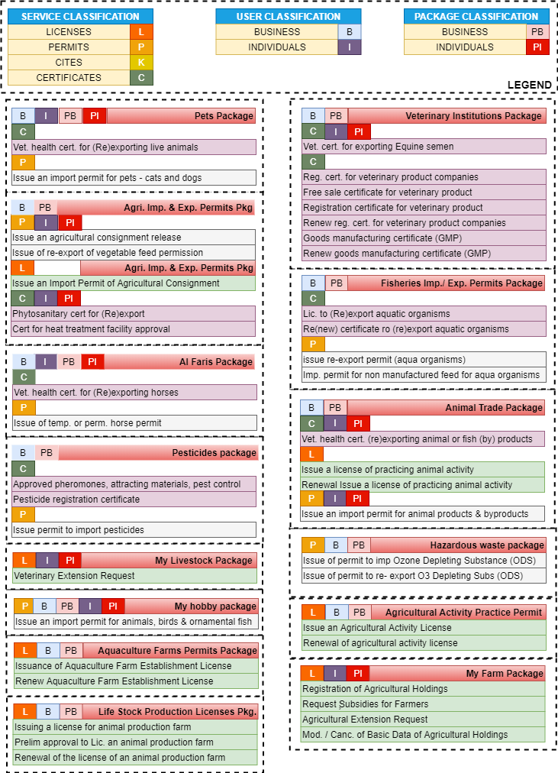

## Application Workflow

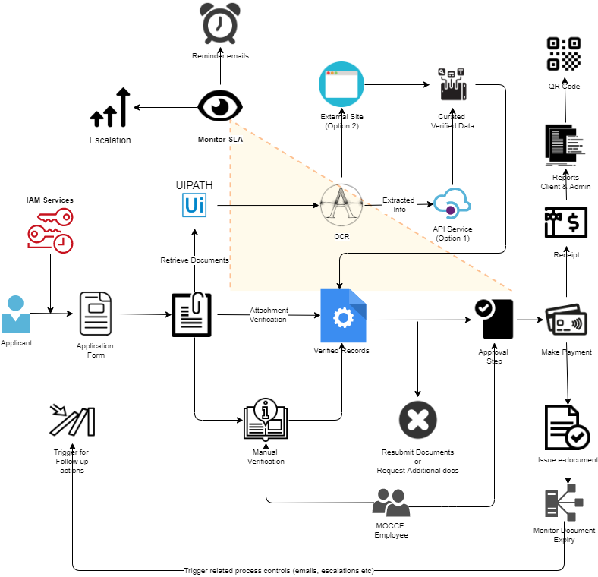

## Technical Architecture

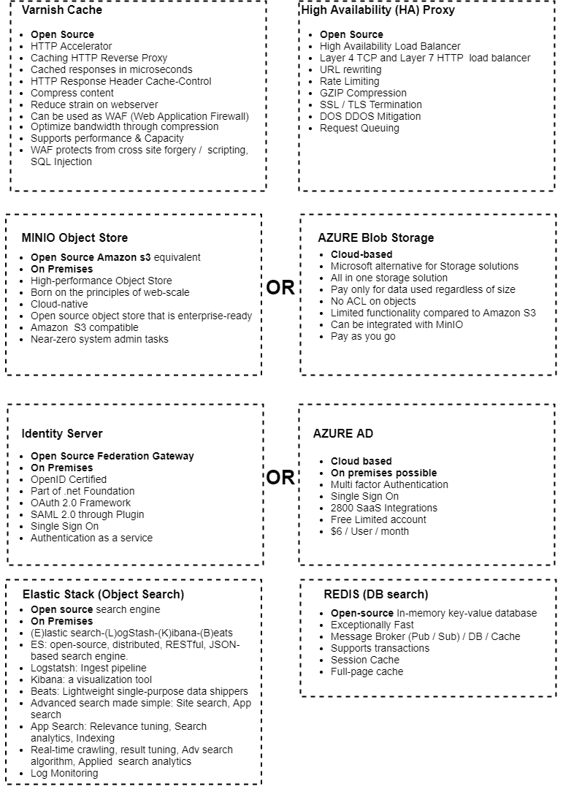

### Performance boost considerations

**Varnish and HA Proxy Layer**

**HAProxy**: Layer 7 traffic routing, first row of protection against DDOS (syn flood, slowloris, etc…), application request flow optimization

**Varnish:** Caching, compression. Could be used later as a WAF to protect the application

**Server:** hosts the application and the static content

**Traffic Flow**

Basically, the client will send all the requests to HAProxy, then HAProxy, based on URL or file extension will take a routing decision:

* If the request looks to be for a (pseudo) static object, then forward it to Varnish  
  If Varnish misses the object, it will use HAProxy to get the content from the server.
* Send all the other requests to the App Server. If configured properly, there should be only dynamic traffic here.

Varnish is not used as the default option in the flow, so as to avoid caching dynamic content as it could lead to somebody’s personal information sent to everybody…  
Furthermore, in case of massive misses or purposely built request to bypass the caches, it will prevent Varnish from hammering the App Servers as HAProxy protects them with a tight traffic regulation between Varnish and App Servers.

**Static Traffic flow**

* The client sends its request to HAProxy which sees that it is asking for a static content
* HAProxy forward the request to Varnish. If Varnish has the object in Cache (a HIT), it forwards it directly to HAProxy.
* If Varnish doesn’t have the object in cache or if the cache has expired, then Varnish forwards the request to HAProxy
* HAProxy randomly chooses a server. The response goes back to the client through Varnish.

In case of a MISS, HAProxy prevents Varnish to flood the servers. Furthermore, since Varnish sees only static content, its HIT rate is over 98%… So the overhead is very low and the protection is improved.

**Dynamic Traffic**

* The client sends its request to HAProxy
* HAProxy chooses a server based on cookie persistence or Load-Balancing Algorithm if there is no cookie.

The server processes the request and send the response back to HAPRoxy which forwards it to the client

**ElasticSearch**

Elasticsearch is a search engine based on the Lucene library. It provides a distributed, multitenant-capable full-text search engine with an HTTP web interface and schema-free JSON documents. Elasticsearch can be used to search all kinds of documents. It provides scalable search, has near real-time search, and supports multitenancy. Elasticsearch is distributed, which means that indices can be divided into shards and each shard can have zero or more replicas. Each node hosts one or more shards, and acts as a coordinator to delegate operations to the correct shard(s). Rebalancing and routing are done automatically. Related data is often stored in the same index, which consists of one or more primary shards, and zero or more replica shards. Once an index has been created, the number of primary shards cannot be changed.

**MinIO**

**MinIO** is a cloud storage server compatible with Amazon S3, released under Apache License v2. As an object store, MinIO can store unstructured data such as photos, videos, log files, backups and container images. The maximum size of an object is 5TB.

## Network Topology

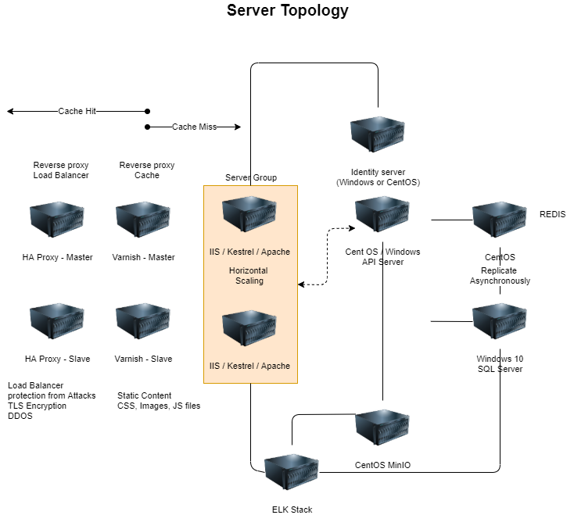

## Security Architecture

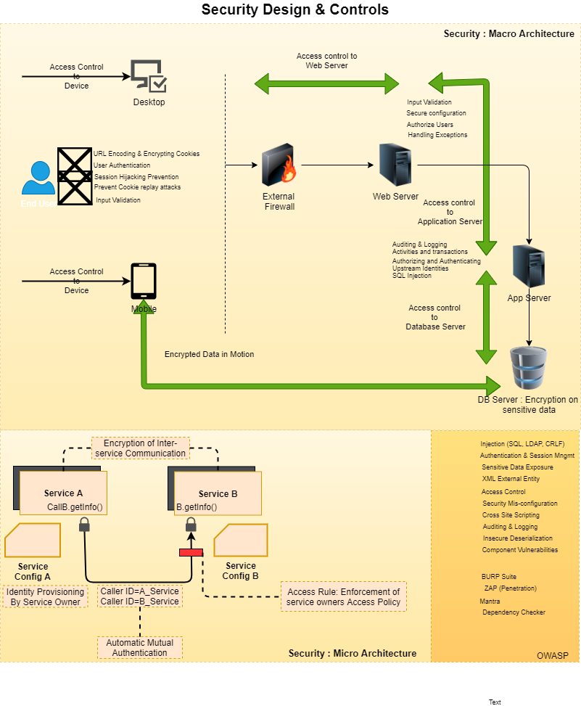

## Quality Assurance

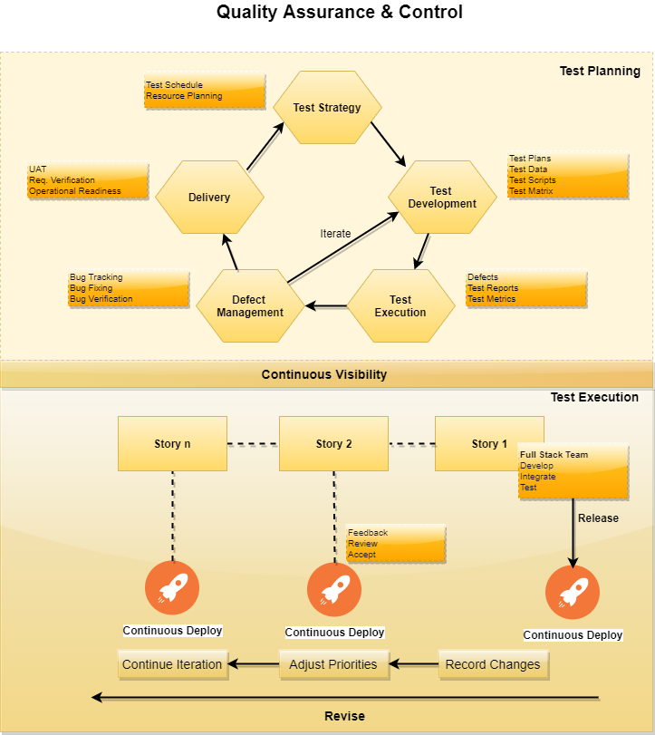

## Release and Deployment Process

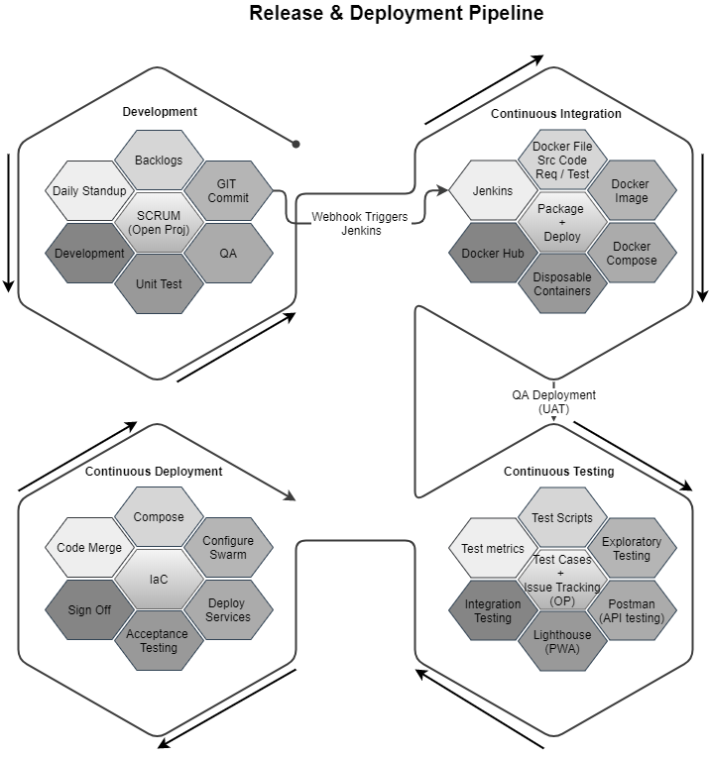

## NON-FUNCTIONAL REQUIREMENTS (OTHERS)

|  |  |
| --- | --- |
| **Requirements** | **Details** |
| User Experience and  UI Design | * The application will be developed in English and Arabic * The layout and graphical components will be created considering the usability factors |
| Performance | * Application will allow users to have smooth and quick access to the information or services they require. |
| Security | * Web security standards shall be followed. |
| Scalability | * Website shall be designed with the ability to add new services without impacting usability |
| Usability | * Website shall be user centric and its design shall be strongly influenced by user journeys. The designs and wireframes developed shall be technically executable |
| Accessibility compliance | * WCAG 2.0 compliance * TRA compliant * UN standards compliant |

## Design Phases

|  |  |  |  |
| --- | --- | --- | --- |
| Phase | Task | Activity | Deliverables |
| Discovery & Planning | Stakeholders Workshop | * Stakeholders workshop using Go To meetings * Understand and analyze wish list from stakeholders and put them into perspective * Brainstorm ideas, identify challenges, expected KPI’s and benchmarks | Vision document (Feedback, pain points, analysis & design) |
| Research (Customer Insights) | * Perform user interviews based on user segments identified in the research phase * Benchmark based on competition; perform high level audit of website and services | * Interviews / workshop output reports |
| Requirement Collection & Analysis | Gathering the requirement and analysis | * Holding stakeholder/business owners workshops via Go to Meeting calls for each service * Document the business workflow and rules * Analysis requirement | * Approved Business requirements |
| UI / UX Design | Prototype | * Provide 3 prototype designs | 3 prototypes |
| Functional Design | HLD & LLD | **High-Level Design (HLD**   * Brief description and name of each module * An outline about the functionality of every module * Interface relationship and dependencies between modules * Database tables identified along with their key elements * Complete architecture diagrams along with technology details.   **Low-Level Design(LLD)**   * Functional logic of the modules * Database tables, which include type and size * Complete detail of the interface * Addresses all types of dependency issues * Listing of error messages. | * High-Level Design (HLD) document * Low-Level Design(LLD) document |
| Execution Phase | Development | * Develop the digital services , workflow engine, business rules and mobile app | * Digital services Deployment on staging * Mobile app deployment |
| Quality Control & Security testing | * Vendor QA shall testing the changes and provide all report of different type of testing | * Test cases, Test results ,defects report * Performance testing report * Internet browsers compatibility test report |
| UAT Signoff | * Vendor should prepare for UAT test cases and manage the sessions end to end | * UAT test cases * with UAT signoff document comments if any |
| Go Live | * Prepare for deployment and announcements for Go Live | * Training sessions * Training material * Go live approval document |
| Closure Phase | PIR | * Fix all issues reported after go live and provide list of issues with status and project closure sign off document | * Signoff document of project closure * listed in All technical documents Deliverables section * Latest Source code * to IT team KT technical session * One year Warranty & support |

## TECHNICAL CONFIGURATIONS

### DEVELOPMENT ENVIRONMENT

* ASP.net or .Net core
* MySQL or MSSQL
* HTML 5 / CSS 3
* MinIO, Redis, Elastic Search, KeyCloak (All Open Source)

### RECOMMENDED WED HOSTING PACKAGE - DEDICATED

* Operating System: Windows Server
* CPU: 2 cores
* Domains: Unlimited
* Disk Space: 200 GB
* Monthly Bandwidth: 50 GB
* IIS
* .Net SDK, ASP.net

### BROWSER

The application developed shall be compatible with the browsers listed below:

* Internet Explorer 11
* Mozilla Firefox 50 or above
* Chrome 50 or above

### HARDWARE DEVICES

#### Mobile device with the following specs

* The device should support LTE / Wi-Fi 802.11 a/b/g/n/ac
* The device should have 3 GB RAM and above memory

#### Web Server

We recommend the specification mentioned below for the best output:

* Microsoft Windows Server 2016 with IIS 7.5 +
* Processor: 4.20 GHz Intel Core i7-7700 or equivalent
* Memory: 16GB
* Disk Space: 1 TB of free disk space

### TECHNICAL STANDARDS

* Testing Devices

Google Pixel     Android 7

Motorola Moto G Turbo Edition -   Android 6

* OS Version

Android: Android KitKat and above

IOS: IOS 9+

### TECHNICAL GUIDELINES

These guidelines provide instructions and conditions that will be adhered to during the development of the mobile application.

* API will be used, as the case may be, in realizing the features and functionalities mentioned.
* The client will finalize the functional requirements and UI/UX before the commencement of the project.
* Verbat will be testing the app in the mentioned devices only. Testing on devices other than the ones mentioned under the “Technical Standards “will have to be specified and provided by the client at the beginning of the development phase.
* The client will have to provide the details of the testing devices they are using before the start of development phase.
* Client should provide the relevant Developer's Account credentials before the development phase. In case Verbat needs to create the developer id, additional charges will be incurred by the client.
* The duration mentioned in the project timeline is for the development and testing; any delay or time taken by the review team to respond will not be Verbat’s responsibility.
* Any clarification required from client needs to be addressed within 02 business days.
* The apps will be developed / created within the guidelines of respective play store.
* Verbat will strictly follow the guidelines provided by the respective stores.
* Verbat will inform the client if any of the client requirements / request deviate from it.
* Customization of the features of the app will be susceptible to the limitation imposed by the respective platform/ store.
* Once development commences, the test device/screen sizes will not be susceptible to change. Any change requested by the client will have to go through change management.
* OS version support will be limited to the ones mentioned in the technical specifications. Further support will have to go through change management.

## PROJECT DELIVERY

### AGILE METHODOLOGY

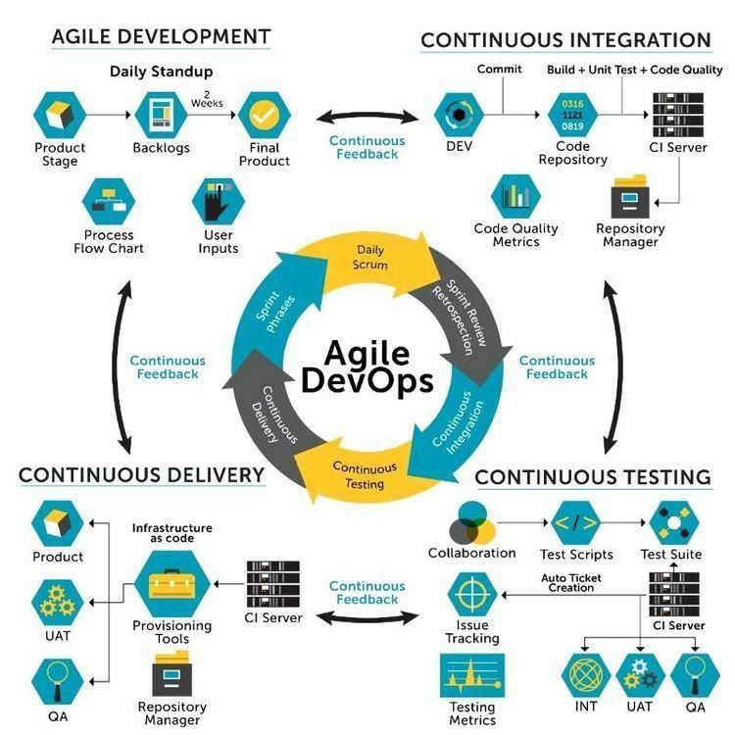

Verbat’s philosophy has been to deliver products that allowed clients to be intimately involved with the development activity. As early as 2005 Verbat had adopted the agile development practices into its pipeline for software development. This allowed clients to closely observe the product being developed. It created a tight feedback loop that allowed us, along with our clients to better understand the requirements and build a right sized and proportional product.

With the advent of next generation applications and tools that support a wide range of activities related to development, deployment and integration; the feedback loops became tighter and coupled, while at the same time it allowed us to create applications that were decoupled. Thus giving us the capability to have greater flexibility in development and deployment.

While development broke down the barrier between developers and management, Devops broke the barrier between software developers and operations teams. Our development and operations teams work under a single silo. While our Scrum teams are cross functional, in our quest to adopt better integration with operations, we have realized that Devops is not just a set of tools and processes, but a mindset and culture. We have fostered a culture collaboration and communication. Our scrum teams and Devops teams share a symbiotic relationship and they work united towards a common goal.

As a company, we have adopted the following tenets in our Devops philosophy

**Speed:** i.e. Move at a high velocity so as to innovate faster for customers and adapt to changing markets better, and grow more efficient at driving business results.

**Rapid Delivery:** Increase the frequency and pace of releases so we can innovate and improve products faster and thus respond to customers’ needs and build competitive advantage.

**Reliability:** Ensure the quality of application updates and infrastructure changes so we can reliably deliver at a more rapid pace while maintaining a positive experience for end users.

**Scale:** Operate and manage infrastructure and development processes at scale.

**Improved Collaboration:** Build more effective teams under a DevOps cultural model, which emphasizes values such as ownership and accountability. Developers and operations teams collaborate closely, share many responsibilities, and combine their workflows.

**Security:** Move quickly while retaining control and preserving compliance. We adopt a DevOps model without sacrificing security by using automated compliance policies, fine-grained controls, and configuration management techniques.

Please see below an illustration of our technology stack. The tools of the trade that allow us to practice an Agile and Devops centric framework

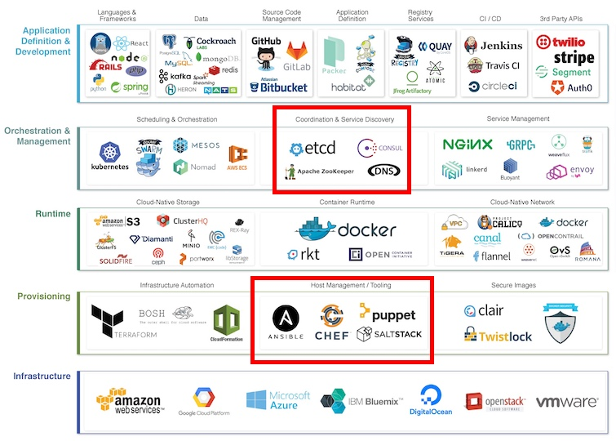

### PROJECT MANAGEMENT

The Verbat development center strictly follows industry standards on quality. Our project management process is governed by the Verbat Quality Management system and is verified through internal audit programs.

Verbat will dedicate a project leader for the proposed implementation. Furthermore, Verbat proposes the client to identify one project manager (*CSPM – Client-Side Project Manager)* who will be driving all activities undertaken by the client, and will be the single point of contact for Verbat.

### ROLES & RESPONSIBILITIES

Verbat will assign its own dedicated Project Lead (*VPL – Verbat Project Lead*) for the client. The VPL will be responsible for planning and management of all activities related to the project. Furthermore, the VPL will work closely with CSPM, on all periodic status updates and will ensure high level visibility and comfort on the progress of the project.

### DELIVERY ACTIVITY SUMMARY

|  |  |
| --- | --- |
| Activities | Description |
| Proof of Concept | Working Model of the project with two languages. |
| Detailed Requirement Analysis | Verbat team to conduct detailed study of requirement for the phase. If clarification is required, the team will reach out to Client for more information and/or time for discussions. |
| DB Design | DB design for central and test DB. |
| Software Requirement Specification document (SRS), | Once the requirement analysis is completed, Verbat team will submit the SRS document for approval |
| UI/UX Design, Prototyping | Based on the SRS, Verbat UX/UI team will work on the UI/UX of the screens and submit prototype for approval |
| Functional Specification Document (FS) With solution architecture | Once the UI/UX is approved, Verbat shall submit an FS document for approval. |
| Development | Actual system development starts based on the FS. This involves detailed design and software development of Web Application. |
| Testing | Test Planning, test plan creations, internal, integration testing and user acceptance testing. |
| Deployment | Deploying the latest build in the Verbat Test Server |

### PROJECT IMPLEMENTATION PLAN

Verbat will be providing the solution in a stand-alone fixed bid approach which ensures minimum viable solution for quick wins with core focus on the long-term business objective and outcome. Once the implementation is over, Verbat will initiate the application maintenance process (*once the maintenance contract is signed*) which continues to extend after the implementation.

### DELIVERABLES

* Business Requirement Specification
* Project schedule
* Requirement Traceability Matrix
* Communication management plan
* Software Requirement Specification Document (SRS)
* Prototype Design
* Functional Specification Document (FS) with final architecture
* Test plan, test scenarios, Test cases, Defect report,
* Fully Developed & Tested Application
* Latest source Code
* Technical documentation
* User manuals, Deployment document

### ESTIMATED DELIVERY TIME

The timeline estimated for delivering the application will be as below:

* Working days to complete the proof of concept on completion of resource mobilization.
* Working days to complete the SRS & prototype of Language Translation Application.
* Working days to complete the development.

| **Activity** |
| --- |
| Contract Signoff (T0) |
| Proof of Concept-Allocate Resource |
| Proof of Concept-Complete |
| Proof of Concept- Approval (T1) |
| Detailed Requirement Gathering |
| Software Requirement Specification Document (SRS) |
| SRS Approval (T2) |
| System UI/UX Prototype-Complete |
| System UI/UX Prototype-Approval (T3) |
| Functional Specification (FS) |
| FS Approval (T4) |
| Development Phase-Complete |
| Perform QC (Unit Testing and Integration Testing) |
| System ready for UAT |
| UAT Acceptance on Verbat production server (T5) |

*Note:*

* *The above-mentioned timeline is in Working Days.*
* *Upon project confirmation, Verbat requires a lead time of minimum () working days for resource mobilization for proof of concept.*
* *Resource mobilization will be initiated post the confirmation of the project along with LPO, signed*

*proposal and advance payment.*

* *The initiation of the UI/UX/Prototype development is dependent on the confirmation of SRS.*
* *The above-mentioned timeline for development is post-confirmation of FS.*
* *Documentation submitted after project initiation and system study supersedes any proposal or documentation submitted during initial requirement gathering / discussion / negotiation.*
* *Project plan will be submitted post the confirmation of project with necessary payments.*
* *Any delay in getting the approvals of deliverables from client will cause change in timelines and the revised timelines will be updated in weekly status reports shared with client after the project commencement.*
* *All approvals and queries regarding the client requirement and any queries which may hinder the project advancement at any stage should be answered by the client within () business days from the time of initiation, failing which, the time delay will get added to the actual effort and timeline estimated.*

### DEPLOYMENT DETAILS

* Cloud server for hosting the application will be the responsibility of the client.
* Verbat will deploy the application on client’s cloud server after the client conducts the necessary acceptance testing.

*Note:*

* *Hosting the application at Verbat’s production server (hosting charges) will call in for additional charges. In the event, client wants to procure SSL, the same can be provided by Verbat at additional cost.*
* *Only deployment of the application will be the responsibility of Verbat, any additional installation will be charged separately.*

### RELEASE PLANNING

* Client will be informed about the release date and time through email.
* Client performs the UAT

### RISK CONTINGENCY PLANNING

Verbat has identified various risk factors associated with this assignment and understands the impact of these risk factors on the project schedules. The objective of this section is to highlight for both Verbat and client, the risk factors, to analyze the impact of the risks on project execution, and to propose strategies to control and reduce the impact of the risk factors. These various risks, which could arise during the project, are tabulated below along with mitigation implementation.

| **Type of risk** | **IMPACT** | Risk Mitigation | Risk Handling |
| --- | --- | --- | --- |
| Scope Creep | **H** | Functions and features will be detailed in system requirement document and will go through client approval. Once this document is approved, all changes will go through the change management process for impact assessment. | Proper change management procedure will be implemented |
| Delay in client feedback | **H** | The plan is prepared with sufficient lead-time for reviews and approvals.  The client will advise us on all dates connected to the document review and approval. | The request for feedback will be escalated if not attended to at the right time so that the schedules are not affected. Deemed acceptance criterion is finalized up-front and will be followed |
| Non-availability of necessary software, frameworks, database instances and infrastructure at client’s hosting environment (If hosting support is provided by Verbat) | **M** | Client will be informed in advance on these requirements. | Possible impact to schedule |
| Manpower attrition | **L** | All efforts will be made to ensure that all initiatives are process dependent. To mitigate risk Verbat/Client will train a person to ensure all back-ups are in place. | A new person will be appointed as early as possible, provided the required project-specific training and mentoring is in place - to minimise impact of attrition on the project |

*H-High, M-Medium, L-Low, NA-Not Applicable*

## PROJECT ASSUMPTIONS

The project solution and technology are created from the initial understanding of the requirement shared with Verbat through mails and meetings. The proposed solution is based on the following assumptions:

### OBJECTIVES

* The requirement is to develop 2 web sites for the client. The project involves development of such sites with a focus on usability and accessibility. The ultimate aim of the site is to maximize user experience.

### DESIGN

* Client to provide Verbat with the branding guidelines.
* Color theme shall be provided by the client.
* Client shall provide licensed images and logos in specified size & format.
* Client shall provide the text and associated images for the proposed application. Text should be provided in digital format preferably in MS Word 2013 or above
* Verbat is free to use custom-made template for design, if required.
* The application designed for mobiles will be in portrait mode

### DEVELOPMENT

1

Client shall procure the following services - Google Translation Services. (If required)

* Additional charges may be incurred for archiving and encryption services (depending on the requirements).
* Peers making use of translation services are likely to experience a latency which is directly proportional to the bandwidth of their network connection.
* The application requires a fast internet connection for real time communication.
* Document Viewer feature shall be available only for PDF documents. This functionality cannot be provided for Microsoft word documents.
* If required, client is responsible for procuring plugins for viewing PDF documents in preview mode
* UI path is not a sure shot method for scanning and recognizing text in pictures taken at an angle or are shaky. It works well when the documents share a common format and are consistent in its layout
* Client is responsible for providing Arabic and English translations of content in a timely manner.
* API for chat bot integration shall be provided by client
* Client shall be responsible for providing the API to integrations with all government entities
* Client is responsible for acquiring license / keys to deploy in IOS & Android store
* Client is responsible for all costs associated with UIPath implementation

# **OUT OF SCOPE**

With the ever-evolving digital market, the requirement should be clear to both the parties involved, hence the importance of mentioning the out of scope details of the project. Following are considered to be out of scope while creating this proposal:

* Purchase of images, fonts
* Any language other than English
* Migration of existing data / Database migration
* Content writing / proof reading / Data Replication / Manual data entry
* Content or image procurement or uploading or editing
* Native iOS App Development / Android App development
* Developer account creation and Maintenance (*IOS and Android Store*)
* Adding new features to the application other than mentioned in the functional specifications. Such requests will be handled via change management. For Change management details, please refer to section titled “Change Management” in the Proposal. (*refer page no: 33*)
* Annual Maintenance Contract (*Bug fixing, debugging, enhancements*) – Please refer to section titled “Maintenance and Support”, unless contracted for. (*refer page no: 34*)
* Hosting Infrastructure and Maintenance (*web and email hosting*), unless contracted for.
* Backup solution and Disaster recovery unless contracted for.
* Physical deployment on-site / installation of the application in devices and physical connection, installation of system.
* Integration with third-party, if any, other than mentioned in the functional specifications
* Hardware Integrations / procurement and purchase
* Procurement of SMS gateway / payment gateway / email gateway
* Integration of SMS gateway / payment gateway
* SSL Purchase and installation, if any
* Plugin/template purchases, if any
* API purchases
* OS other than mentioned in the Hardware Interface
* Relevant / related software libraries
* Mobile offline access or operations
* Verbat shall develop no more than 3 e-services. Additional e-services are out of scope until agreed upon otherwise.
* It is assumed that these services are part of the main domain.
* Verbat does not own a Usability lab and hence shall not be providing such services
* Verbat shall not be responsible for the management of the eservices sub domain. Any development related to it is out of scope
* The client shall be responsible for delivering the Arabic content on time. Client is expected to notify Verbat on time with regards to corrections related to grammar or typos.
* The web site shall not be tested for IE 11 or its predecessors.
* Browsers covered for testing are Chrome, Edge, Firefox and Opera

# **CHANGE MANAGEMENT**

Any addition which comes out of the project scope, upon and after the launch of the website will be considered as change management. Verbat recommends the following change management procedures for the same:

* Changes will be implemented only after raising a change request.
* Change requests will be studied and an impact analysis will be performed on the existing work flow.
* Upon assessment of the impact, effort estimation will be calculated and raised as an additional requirement.
* The change request will be initiated only after receiving a formal approval from the client for the additional changes raised.
* Changes which are out of scope will be charged @ per man day rate.

Activities for change scheduled

Modules checked in

Unit testing done

Change request accepted

Informed of the Action

Implementation of changes

Modules checked out

Activities planned and scheduled

Effected modules identified

New system released with change request

Changes made & documented

System

Need for change recognized

User submits change request

Evaluate for cost, schedule & effort

Change control authority

yes

No

## MAINTENANCE & SUPPORT

* Maintenance contracts by default are supported as per the basic SLA terms.
* AMC with Basic SLA is charged at % of the total project value. Additional Effort/change management request will be added towards Total Value of the Project to determine the AMC value.
* Maintenance support is limited to providing application support for ensuring the consistency of the look-and-feel, bug fixes and user issues i.e. maintenance and support of the existing features of the application.
* Support does not in any way cover providing technical or other support to the end users or hardware support. The maintenance agreement does not include functionality changes or feature additions which are handled as change requests which will be charged per man day rate. AMC does not include server support, maintenance and application deployment.
* AMC charges will cover Off-Site Support and Debugging. Support includes E-mail, telephone and video conference (if required). In the event, the application is hosted with the client or if it is a client server development; necessary remote desktop connectivity should be provided for carrying out maintenance activities.
* All maintenance support will be executed by Verbat off-site team. In the event of any need for on-site work, all expenses incurred for such trips (flights, accommodation, meals transportation) will be payable to Verbat by client.
* Gap in AMC - In case if the client does not opt an AMC for a year and wants to renew it after that period, % of the AMC amount for the year for which AMC is not taken will also be payable if the client wishes to renew the AMC contract.

|  |  |  |  |  |
| --- | --- | --- | --- | --- |
| **SLA Type** | **Max Response Time** | | **Max Resolution Time** | **Target** |
| Basic | 1 working day | 3 working days | | Request / incident / problem tickets |

*Note:*

* *Time zone applicable as per India Time Zones (3:30 GMT to 12:30 GMT, Monday to Friday)*
* *Please note that the AMC support shall start only after all the necessary sign-offs (AMC Document) to this effect have been given.*
* *It is not mandatory that the client should opt for an AMC. The client will still be supported on an ad-hoc basis on an agreed man-day rate.*
* *AMC Payment Terms: 100% to be paid as advance.*

AMC Option: Client can opt for time and material based Annual Maintenance, the details of which will be shared post the completion of project.

# **TERMS AND CONDITIONS**

## ACCEPTANCE CRITERIA

* UAT (User Acceptance Test) sign off should take place within Days from the first release of the application and the acceptance confirmation needs to be mailed to Verbat failing which Verbat will consider the project as approved by the client.
* Any comments and reasons for rejection need to be documented and the same needs to be sent as an email from the official e-mail id of client to Verbat on or before days from the first release.
* Timeframe for acceptance for any further release will be mutually agreed and finalized between client and Verbat depending on the UAT Comments

## WARRANTY

* Verbat shall provide a bug ﬁx warranty at no additional cost for 30 days from the date of acceptance of the project, for correction of any errors in the developed application that may be attributed to Verbat.
* However, this does not cover modifications by Client, or use of the application on an environment other than the proposed environment, or other circumstances outside Verbat’s reasonable control. In such cases Verbat reserves the right to charge for its services.
* All error corrections will be executed by Verbat offsite team. In the event of any need for on-site work, all expenses incurred for such trips (flights, accommodation, meals, transportation) will be payable to Verbat by Client.

## SOURCE CODE & INTELLECTUAL PROPERTY RIGHTS

* Upon completion of the Project and 100% completion of the payment, the client will have access to the source code except for proprietary codes, developer tools and third-party applications etc.
* The solution offered will be the intellectual property of the client and will be made available to the client on an “unlimited license” basis.
* No person or organization, other than Verbat or any person authorized by Verbat in writing, has permission to modify/change the software solution to be eligible to get continued support from Verbat as per the support terms defined under this document.
* Verbat accepts no liability or damages of any kind arising out of use or non-use of the software delivered. The responsibility of testing of software lies with the client.

## GENERAL TERMS AND CONDITIONS

* Offer Valid for 30 calendar days from the date of submission of the Proposal.
* An average of 20 working days are assumed in a month.
* All the development activities will be carried out from our off-shore development center in India.
* All the documentations will be provided in English.
* Third party components may be used to develop this application.
* The scope of the project is to develop the application as detailed in the scope of the project and mentioned in this proposal. Any changes or additions will have to go through our change management process.
* This proposal is derived and concluded from either the RFQ /RFP/data shared via email / information transferred during an initial requirement analysis meeting / tele-conversation. Verbat reserves the right to change the terms of this proposal if the final terms (including the costing), features & functionalities and timelines are changed during the course of the project. Hence any fees quoted / timeline committed in this proposal may not be considered as final unless agreed upon and signed by both parties.
* Web Application will be best viewed only in the environment mentioned in the section Browser Compatibility.
* Mobile app will be best viewed only in the environment mentioned in the section Hardware Interface.
* All source codes and other project artifacts will adhere to the Verbat document templates and internal coding standards.
* The documents delivered to the client include the ones mentioned under ‘Deliverables’ and these will adhere to Verbat’s internal document standards.
* Acceptance criteria shall be based on the clauses which were mutually discussed between Verbat and client at the Requirement Analysis phase. The same will be documented and approved by both parties through official emails.
* In the event that the Client requires any extension of the proposed acceptance schedule, the associated effort and cost of such extension will be mutually reviewed.
* If the project needs to be put on Hold / Stopped, a minimum notice period of 1 week is required along with the duration of the holding period. Thereafter Verbat will make a final decision based on the request.
* If deployment is done in the client’s server, Verbat will not be held responsible for any performance issues arising due to hardware malfunctions.
* The Client is responsible for all data-backups in case the application is not hosted on the Verbat server.
* All source codes will only be delivered or uploaded on the production server after the due payments are made to Verbat.

## GENERAL ADMINISTRATIVE, TECHNICAL & FUNCTIONAL ASSUMPTIONS

* Detailed system study is required before the start of the project.
* During the requirement gathering phase, authorized personnel from the Client’s side are expected to be available for discussions and finalization of the HLD (High Level Design), before the development commences.
* Type of reports, formats if under the scope of the project, need to be specified by the Client before the project sign off.
* Workflows if under the scope of the project, need to be specified/ confirmed by client before project signoff.
* Verbat assumes that all sign-offs from the Client will be provided within the agreed and specified timeframe.
* Client will provide all the necessary contents, both text and imagery, before starting the project in the format suggested by Verbat (if any).
* The client should provide the relevant information and data, well in advance of the execution of the related activity. Non- availability of this information or data may lead to an interruption of work, which may result in a delay in delivery as well as additional costs to the client.
* The Client should possess a server with the technical specifications recommended by Verbat for the proposed application.
* The Client will be provided with a one-time training (train the trainer) on how to use the application via a video conference (maximum of 4 hours). Additional training requests will be charged at cost to the client.
* Cost of all third-party components to be borne by the client.
* Application will support in three languages which are supported by Google Text to Speech API.

# **FINANCIALS**

## Curriculum Management Application

|  |  |  |
| --- | --- | --- |
| Sl. | Description | Amount (USD) |
| 01. |  | XXXX USD |

*Note:*

* *The above cost is exclusive of VAT applicable in UAE*
* *The above cost includes the cost of third-party service of non-translated calls.*
* *The above cost does not include third-party API purchases.*
* *The above estimate is based on the initial understanding of the requirement grounded on the details shared by client via meetings and tele-conversations. If Verbat finds during the requirement gathering phase that the actual requirements uncovered are different form the original, this might affect the estimates provided and Verbat shall exercise rights to renege on the contract. Clarifications/Changes in the scope during system study/ analysis may call in for additional effort and timeline.*
* *For feature additions, please refer section titled “Change Management “.*
* *LPO to be raised in the name of “Verbanet Technologies LLC” for project initiation*

## PAYMENT TERMS

* % of the proof of concept as advance.
* % of proof of concept on delivery of POC
* % of Language Translation Application as advance.
* % of Language Translation Application on completion of:
* SRS
* Prototype
* % on completion of development in UAT release of the Web Application on Verbat server/Mobile build.
* % of Language Translation Application to be paid on UAT Signoff.

*Note:*

* *Payment should be made within 7 days from the date of invoice.*

### MODE OF PAYMENT

Wire transfer to our bank account

|  |  |  |
| --- | --- | --- |
| Particulars | **Option 01** | **Option 02** |
| Bank Name | Commercial Bank of Dubai | Emirates NBD |
| Account Name | Verbanet Technologies LLC | Verbanet Technologies LLC |
| Account Number | 1000305555 | 1011492858201 |
| Swift Code | CBDUAEAD | EBILAEAD |
| IBAN Number | AE840230000001000305555 | AE61 0260 0010 1149 2858 201 |
| Bank Address | Al Qusais Branch, P.O Box 2668, Al Qusais | Mamzar Branch, Dubai |

*Note:*

* *Bank charges incurred during wire transfer to be borne by the client.*
* *Any local taxes / VAT applicable to be borne by the client.*
* *Client invoices will include VAT charges in addition to the application cost.*

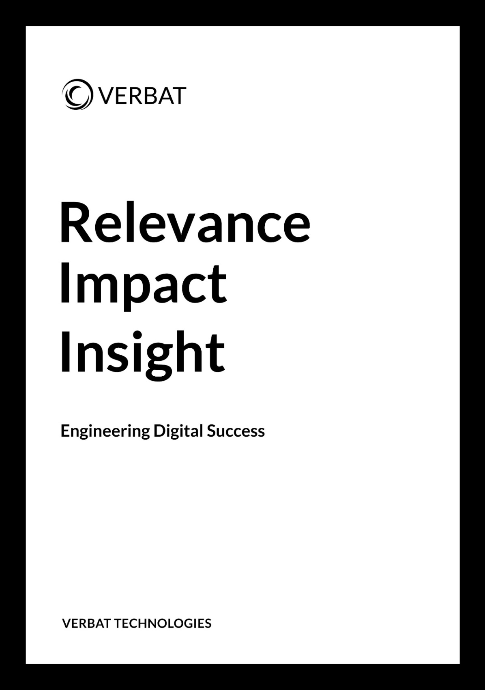

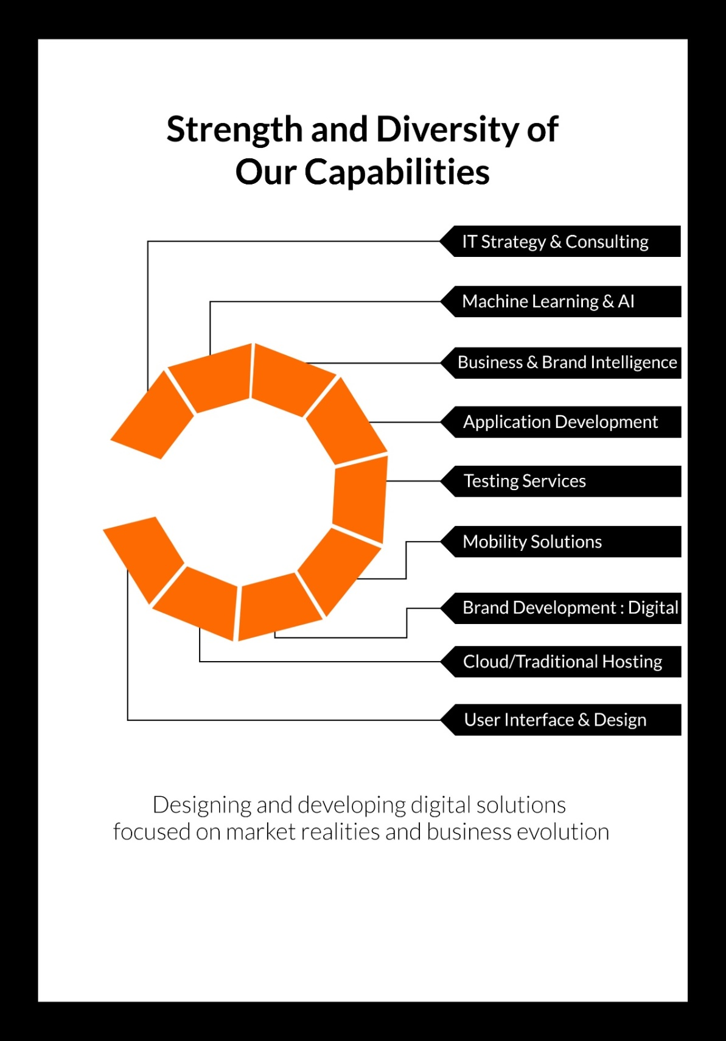

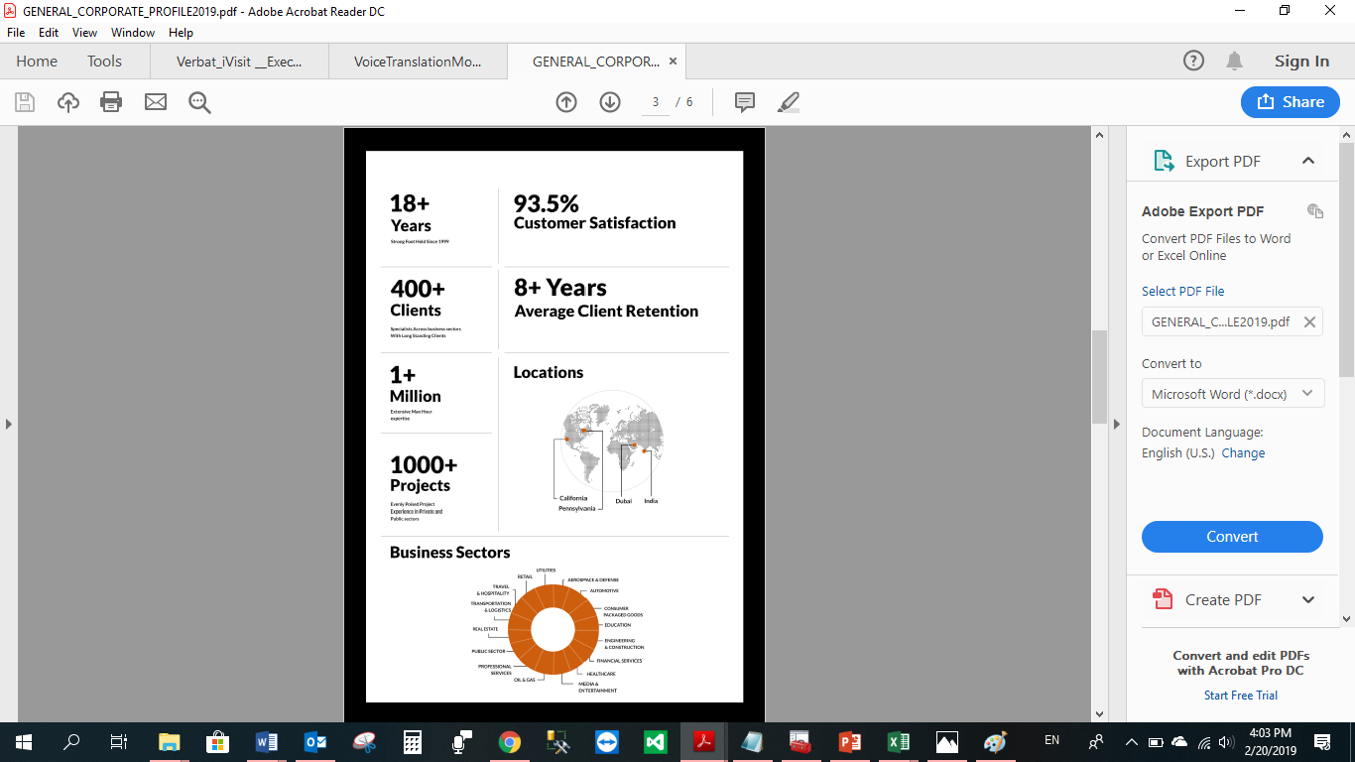

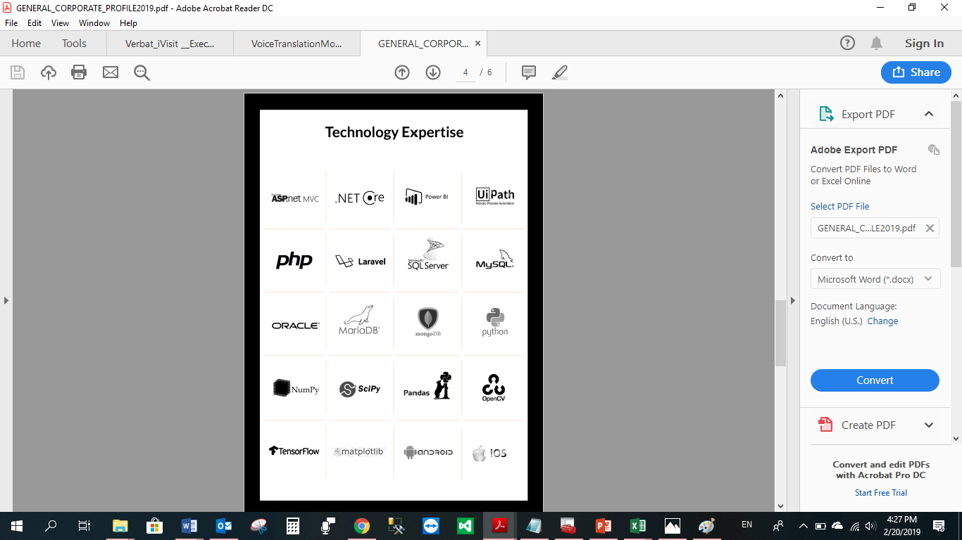

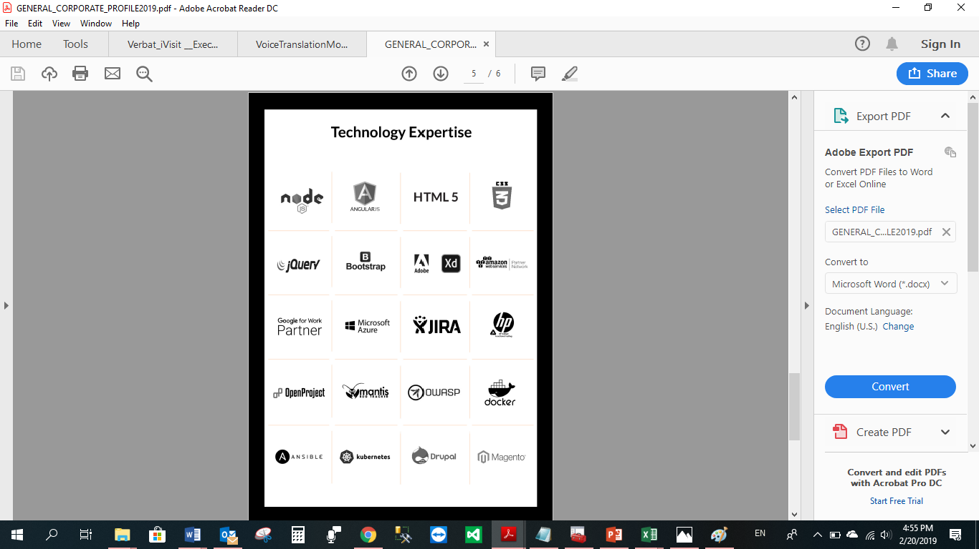

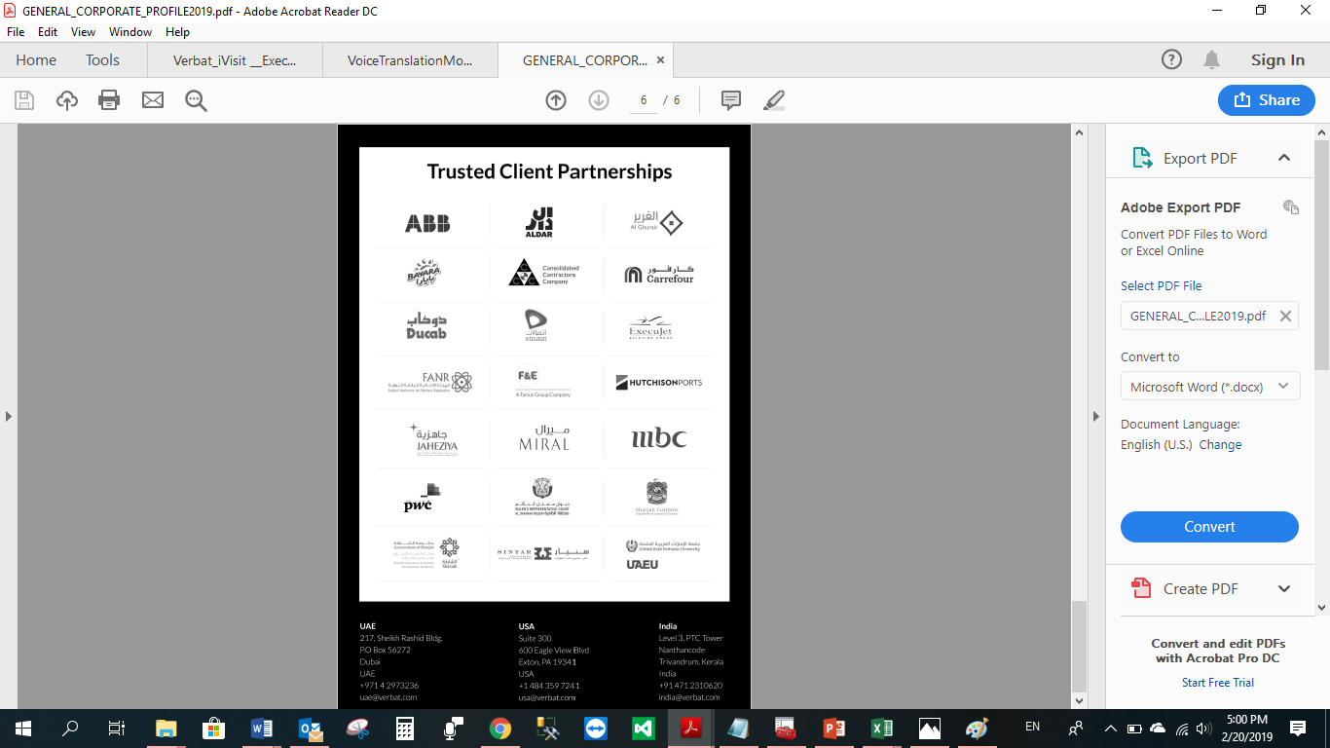

**WITH OUR**

**SINCERE THANKS.**

CONFIDENTIALITY NOTICE:

This Proposal is conﬁdential and contains proprietary information and intellectual property of Verbanet Technologies LLC. Neither this proposal nor any of the information contained herein may be reproduced or disclosed under any circumstances without the express written permission of Verbanet Technologies L.L.C (hereby known under its brand name of Verbat in the United Arab Emirates). 2019. All Rights Reserved.